 | ASIA-PACIFIC TELECOMMUNITY
 | The 3rd Meeting of the APT Conference Preparatory Group for WRC-15 (APG15-3) |  | Document  APG15-3/INF-03
 | 09 – 13 June 2014, Brisbane, Australia |  | 31 May 2014

GSM Association (Hong Kong)

IMT-FSS Coexistence Scenarios IN C-Band

- Introduction
Additional spectrum allocations to the mobile service and identification of additional frequency bands for IMT will be addressed at WRC-15 under Agenda Item 1.1. JTG 4-5-6-7 is conducting compatibility/sharing studies in relation to this agenda item. The GSMA has proposed a number of suitable frequency ranges to be considered as potential candidate bands for IMT (see Document 4-5-6-7/88), including “C-band” frequencies in the range 3.4 4.2 GHz.
There are existing allocations on co-primary basis to the Fixed Satellite Service (FSS) (space-to-Earth) in frequency ranges between 3.4 - 4.2 GHz in all Regions and to mobile service in the band 3.5-4.2 GHz in Regions 2 and 3. Further, it should be noted that WRC-07 allocated the 3 400-3 600 MHz frequency band to mobile services and identified it for IMT in certain countries. Up to today, GSMA is not aware of any recorded case of cross-border interference between mobile system and fixed satellite service in neighbouring countries.
Studies in JTG 4-5-6-7 use the I/N criterion, that may be suitable to trigger coordination with specific large dish FSS installations. However the use of the same criteria for large dishes that are part of international broadband FSS end-to-end links and for ubiquitous small dishes used for broadcast type services is very much worse case. Indeed, GSMA believes that in practice detailed coordination will give rise to much shorter separation distances.
Such an approach is to look at the specific services and assess how their performance could be affected by the introduction of certain types of IMT networks. This contribution takes a look at the potential for digital TV via satellite and IMT network to co-exist on a national level. It considers system specific link budgets for broadcasting service, and assesses the sharing feasibility using real broadcasting satellite standard and parameters, associated with genuine terrain data.
The scenario of this study is based on the concept that the C-band for IMT would in reality only be required in dense urban areas, and would still allow the whole of the FSS band to be used in rural areas. This scenario was also explored from an economic view by Frontier Economics for the Asia-Pacific market.
This study calculates, for some example cities in Asia, what would be the required separation zone between an IMT micro-cell network in an urban area and ubiquitous FSS (TVRO) receivers in the surrounding area operating on the same frequency.

The study shows that, under realistic but conservative assumptions, a separation distance of 2.5-3.5 km would typically be required. This is in contrast with the much larger separation distances that have been calculated in JTG 4-5-6-7, which would preclude this scenario, and prevent the national administration from providing the benefits discussed at relatively little risk. Also, this separation distance could be one way to address in-country real interference cases between WiMAX and FSS, as described in JTG sharing studies. More details on the study can be found in the annex of this contribution.

- Proposal
The potential of sharing of the band 3.4-4.2 GHz on a national level is demonstrated through this paper. This would provide flexibility to maximize the efficient usage of the band, and the bandwidth and time of its application is at the discretion of the national regulator. The national regulatory matters should be kept distinct from the international radio regulations under consideration at WRC, however, in order to benefits from this flexibility and the associated economy of scale, administrations would need to support identification of all or part of 3.4-4.2GHz for IMT in WRC-15 Agenda Item 1.1.

ANNEX
Urban IMT vs Rural FSS DTH in C-Band

- Introduction
Satellite delivered TV services in C-band are a valuable part of the mix of telecommunications services to many parts of the world. In regions of high rainfall, where wired and cellular network infrastructure is expensive to install, C-band satellite is a proven solution.
In developed areas terrestrial cellular IMT infrastructure can provide a much wider range of services – including streamed video – at high quality, low cost to the consumer and in a spectrally efficient way.
The study presented in this document looks at the potential for C-band satellite and certain types of IMT network to co-exist on a national level – maintaining the unique benefits of both. The aim is to provide national Administrations with a method for assessing the types of system they can license together – to the benefit of their citizen consumers.
The approach taken is to look for conditions under which co-existence would be possible. This is in contrast to the approach of JTG 4-5-6-7 which concentrates on worst case assumptions and protection of generic FSS services to regulatory levels – essentially searching for cases where coexistence is impossible.
Our approach here, if carefully applied, will lead to benefits for the national economy, for consumers and to a significant increase in the efficient use of the radio spectrum.
We have found that not only is there a significant difference in the size of the exclusion zones found by the JTG method and those we find here, but also that a separation of 2.5 -3.5 km would safeguard the majority of the FSS receivers in the cases we studied. In some cases - mainly open areas of high ground - there could be a chance of interference effects at larger separation distance, but these are very small areas and could be dealt with on a case by case basis by the regulator.

1.1 Outline of Analysis
We have looked at interference levels between an IMT Micro Cell Outdoor base station and a 1.8M FSS earth station receiving DVB-S2 services from a real satellite.
The IMT station is deployed anywhere in a defined region in several city centres. This region we may refer to as the licensed area for IMT operation and we have chosen a circular region of 5 km in radius.
We then calculate a contour within which the FSS earth station would not be protected from interference. We calculate this contour under two sets of assumptions
- Where the interference level is limited to a generic allowance that is applied across all types of FSS installation and FSS service- this is the I/N method
- Where the interference level is limited by the overall performance of the specific FSS service and installation, taking into account the required signal to noise ratio and the impact of other sources of interference- this is the C/I method
The two approaches are discussed in detail in Section 3
The figure below illustrates the sharing scenario we are looking at
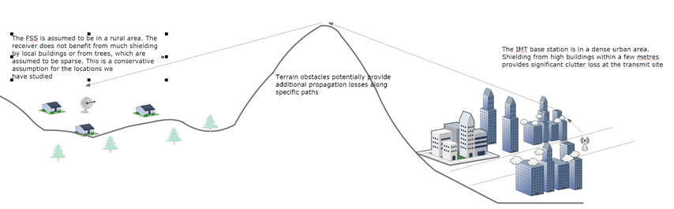
Figure 1 – micro cell outdoor IMT base station potentially interfering with an FSS dishes in an urban area – the question is, what separation distance is actually required to the allow the FSS to receive DVB-S2 services
- I/N Threshold vs Link Performance Assessment
The approach taken in JTG 4-5-6-7 is a safety first method that is suited to identifying ‘potential’ interference cases and works against the goal of spectrum sharing and spectral efficiency. It takes a universal I/N threshold and applies this to all satellite services currently offered in C-band (including TV reception as well as FSS). As the I/N threshold has to cover all services and all deployments it means that if there is only one case where sharing is not possible, all options are closed.
In satellite coordination it has long been acknowledged that I/N thresholds – universally applied – is not an efficient way to manage the regulatory environment for spectrum sharing. In the I/N methodology of JTG 4-5-6-7 there is little distinction between large dishes requiring very high a availability and small dishes, ubiquitously installed that may not need 99.999% availability.
A more practical approach is to look at the specific services and to assess how their performance could be affected by the introduction of certain types of IMT networks. In this paper we are looking at the DVB-S2 standard for video, used for digital TV via satellite.
In this standard there are number of options for modulation that lead to different requirements for carrier to noise ratios. The reference link budget we will use is discussed in the section below.

2.1 Satellite Link Budget
Vinasat at 132° East provides DVB-S2 based services in the 3400-3600 MHz band using 8-PSK with H-264 MPEG 4 video compression. Assuming a 2/3 FEC rate this system requires 6.6 dB signal-to-noise ratio. [Ref 1]
The coverage of this satellite is illustrated in the figure below
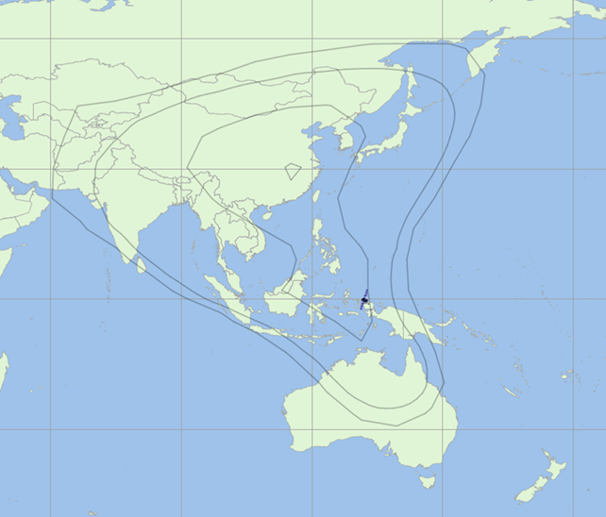
Figure 2 – Vinasat C-band downlink coverage: -1 dB, -2 dB and -3 dB contours are shown
In this band the ITU-R filing indicates that the satellite has a maximum power density in a 36 MHz channel of -64.8 dBW/Hz. This equates to a maximum power of 10.7 dBW or an EIRP of 47.7 dBW in 36 MHz. Other channels have comparable power densities.
A typical G/T of 14 dB together with peak receive gain of 34 dBi implies a system temperature of 110K (clear sky)
A simple link budget, in the absence of interference can be derived as below for an availability of 99.8%
DVB-S2 downlink .Link Calculation
Frequency | 3.5 | GHz
Carrier | 36M
Frequency Source | User specified
Bandwidth | 36.0 | MHz
Transmit Power | 10.7 | dBW
Transmit Peak Gain | 37.0 | dBi
Transmit Relative Gain | -0.857906 | dB
Path Loss | 194.72746 | dB
Freespace | 194.679618 | dB
676 dry | 0.043284 | dB
676 water | 0.004509 | dB
618 rain | 0.000049 | dB
Receive Peak Gain | 34.174688 | dBi
Receive Relative Gain | 0.0 | dB
Receive Feeder Loss | 0.0 | dB
C (signal strength) | -113.710678 | dBW
N | -130.732405 | dBW
C/N | 17.021728 | dB
Table 1 – Simple Link Budget for Vinasat DVB-S2 downlink to a test point in Vietnam
Note that the achieved C/N is more than 10 dB better than the ratio required by the DVB-S2 service. This is a sensible and significant margin and of course is subject to degradation from the theoretical value in real systems.
In the next section we consider how much of this margin could be available, within the scope of national spectrum management, to potential interference from IMT.

2.2 Allowance for Interference and the derivation of a C/I Target
The C-band FSS network needs some margin to allow for various link impairments. In theory, when these impairments are allowed for, the remaining margin could all be used to accommodate interference from IMT, although it would be reasonable to leave some margin in the link.
In planning a satellite link, the engineer would normally take into account impairments from the following sources
- Intra systems adjacent channel interference
- Intermodulation products
- Adjacent FSS satellite interference
- Interference from other services
These factors are accounted for by expressing their allowance as a ratio, C/X. These can then be used to calculate an impaired C/N+I, starting from the known carrier level and the un-impaired C/N from Table 1
Our proposed values for the allowances are:
In satellite coordination a C/I_{ASI} target of 22.2 dB is common and achievable for adjacent satellites at 2-3° separation. This is the single entry value and in a crowded geostationary orbit it is usual to assume that there will be a satellite on each side of the wanted system contributing a similar amount of interference. There will also be many more satellites but at widely separated locations each contributing significantly lower interference.
A simple approach is to allow for 2.5 interferers at the C/I level of 22.2 dB
For interference from other sources (terrestrial microwave for example) we would normally expect the allowance to be smaller than that from FSS, but if we take the conservative assumption that it is the same, our link budget should be a safe one.
For adjacent channel and intermodulation we will use values for C/I of 30 dB.
In JTG 4-5-6-7, the maximum long term interference from IMT is limited to an I/N of -13 dB. Theoretically, if the IMT interference could use the remaining margin in the DVB-S2 link budget (Table 2) the I_{IMT}/N could be as high as +8.7 dB. This is 21.7 dB higher than the JTG l as shown in long term threshold.
For good engineering reasons we will not use all this margin, allowing for a contingency, and consider a C/I_{IMT} target of 12 dB – corresponding to I/N of 5 dB, many dBs better than the JTG thresholds BUT still allowing the DVB-S2 link budget to close.
This 12 dB C/I target is sensitive to all of the details discussed above and the type of service being modelled. However we feel that, as the target that an administration would like to achieve when planning efficient spectrum sharing between these two systems, this is a typical value and can be safely used in an initial assessment.

Downlink DVB-S2 link budget
Calculated carrier level (98.2% availability) | -113.711 | dBW
Noise temperature | 170 | K
bandwidth | 36 | MHz
Calculated Noise Value | -130.73 | dBW
un-impaired C/N | 17.01956 | dBW
Interference Allowances
Adjacent satellite single entry C/I | 22.2 | dB
Calculated adjacent satellite I | -135.911 | dBW
number of entries | 2.5
Calculated Aggregate adjacent satellite I | -131.931 | dBW
Aggregate adjacent FSS C/I | 18.2206 | dBW
Intra systems, adjacent channel C/I | 30 | dB
Calculated adjacent channel I | -121.139 | dBW
Carrier to intermodulation C/Im | 30 | dB
Calculated IM interference | -143.711 | dBW
Other system C/I | 18.2206 | dB
Calculated other system I | -131.931 | dBW
total I from impairments other than IMT | -126.551 | dBw
Impaired C/N+I no IMT | 12.84072
C/N+I Target | 6.6
Margin | 6.240724
Proposed IMT C/I | 12 | dB
calculated I - IMT | -125.711 | dBW
total I including IMT | -123.1
C/N+I total | 8.698284
margin | 2.098284
Table 2 – DVB-S2 downlink link budget and target for single entry C/I when sharing with an IMT network

2.3 IMT Network Parameters
The parameters for an outdoor micro cell base station are summarised below. This is the type of system we would expect to be deployed in the scenario under consideration
Base station characteristics / Cell structure | Micro cell outdoor / Micro urban
Antenna height | 6 m
Sectorization | single sector
Downtilt | n.a.
Antenna pattern | omni
Antenna polarization | linear
Below rooftop base station antenna deployment | 100 %
Maximum base station output power (5/10/20 MHz) | 35 dBm
Maximum base station antenna gain | 5 dBi
Maximum base station output power (EIRP) | 40 dBm
Average base station activity | 50 %
Average base station power/sector | 37 dBm
Channel Bandwidth used | 10 MHz
Table 3 – Parameters for the outdoor micro cell IMT base station

- Analysis Method
The analysis proceeds by calculating the interference from a single IMT base station at maximum power into a theoretical test point at multiple locations on a grid around the city centre.
The base station can be located anywhere within a ‘licensed’ area in the city centre and we calculated the interference from the least favourable location within the license area. The license area we have used is a circle with 5 km radius around the centre of the city.
Having calculated the interference level at each test point location we derive the C/I level and the I/N level under JTG 4-5-6-7 assumptions. The software then extracts contours from the grid at the threshold values and displays these on a map.
The output is a map showing areas where the FSS would experience interference in both cases.

3.1 Propagation Model
The satellite wanted link is calculated using free space loss, plus Recommendations ITU-R P.676 and P.618.
For the interfering signal we have used Recommendation ITU-R P.452-15. We have included clutter at the IMT end of the link based on dense urban parameters of the Recommendation. At the receive end the baseline is to consider areas of sparse housing with the lowest clutter loss – this is yet a further conservative assumption. The addition of sub-urban or dense forest clutter – which would be appropriate in many cases – would further improve the results overall.
Clutter categories and associated parameters are in the Table below, reproduced from Recommendation 452 and the two sets of parameters we are using are highlighted.

Clutter (ground-cover) category | Nominal height, h_{a}  (m) | Nominal distance, d_{k}  (km)
High crop fields  Park land  Irregularly spaced sparse trees  Orchard (regularly spaced)  Sparse houses | 4 | 0.1
Village centre | 5 | 0.07
Deciduous trees (irregularly spaced)  Deciduous trees (regularly spaced)  Mixed tree forest | 15 | 0.05
Coniferous trees (irregularly spaced)  Coniferous trees (regularly spaced) | 20 | 0.05
Tropical rain forest | 20 | 0.03
Suburban | 9 | 0.025
Dense suburban | 12 | 0.02
Urban | 20 | 0.02
Dense urban | 25 | 0.02
High-rise urban | 35 | 0.02
Industrial zone | 20 | 0.05
Table 1. Nominal clutter heights and distances from Recommendation ITU-R P.452-15

3.2 Availability Target
In order to achieve the 99.8% availability the simulation should strictly consider the independent statistical processes that lead to fade on the wanted link and to fade/enhancement of the interfering signal level. We could develop a Monte-Carlo simulation that models this and extract the 99.8% level.
We should, if being very accurate, not simply put a value of 99.8% into the Recommendation P.452 propagation model. However, for simplicity this is what we have done in the simulations. This is another conservative assumption.
Given that we have derived the criteria based on 99.8% availability of the wanted link, this amounts to an assumption that the wanted link is faded at the same time as the interfere is enhanced – whereas the two processes are uncorrelated. So we are again erring on the safe side. However, given that the fading on the wanted link is small this is not a bad approximation.
- Results

4.1 Hanoi
Figure 3 shows contours of C/I (12 dB) and I/N (-13 dB) around the centre of Hanoi in Vietnam.
Under the fixed I/N assumptions the area enclosed by the red contour would be sterilised. Under the approach based on C/I needed to allow DVB-S2 reception to 1.8m dishes the area inside the black contour would be affected.
The black contour implies a minimum separation distance of around 2.5 km whereas the red implies around 17.5 km.
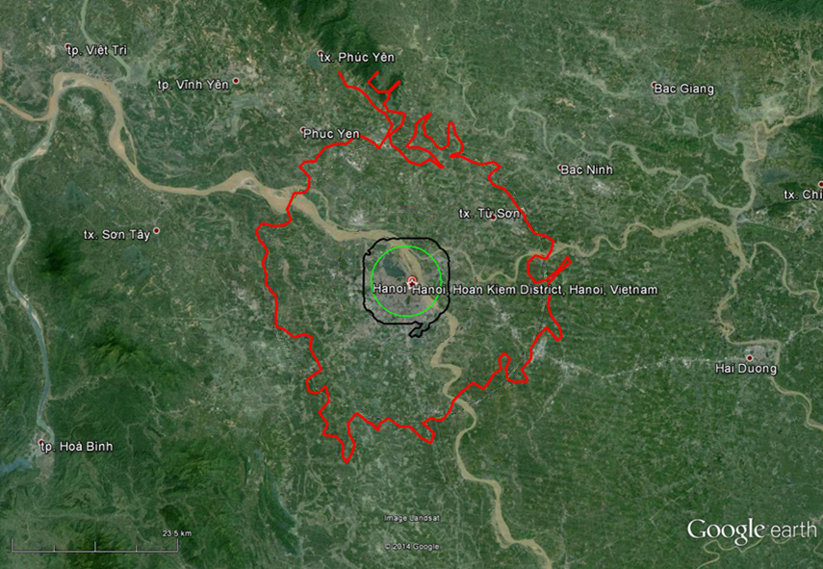
Figure 3 – C/I (black contour) and I/N (red contour) based exclusion zones for single entry micro cell outdoor base station deployed anywhere in the dense urban centre of Hanoi . The green circles have a radius 5 km from the centre of the proposed IMT License area

4.1.1 Comparison to Strict JTG Results
The figure below adds the contour that would be found under the strict constraints of JTG analysis, and is the sort of figure used to support the headline outputs from JTG. This is the blue contour in the figure below.
JTG would assume 5° elevation for the satellite which implies 5° off axis towards the horizontal and hence a gain (32-25log(theta)) of 14.5 dB in the interference calculation. The generic result of JTG would also assume smooth earth terrain and a link temperature of 100K.
The difference between the blue and black contours is dramatic.
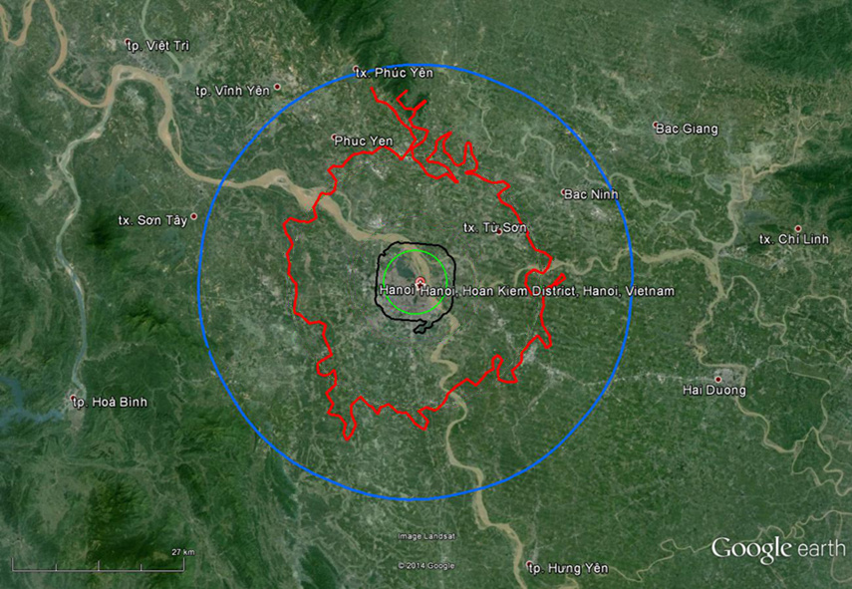
Figure 4 – The blue contour is the generic long term I/N threshold from JTG 4-5-6-7 for micro cell outdoor. It has a radius of around 35 km which correspond to a minimum separation of around 30 km.

4.2 Kuala Lumpur
The same Vinasat satellite could provide coverage to Malaysia, at between -1 and -2 dB from peak gain. Therefore, the analysis presented above is valid for the area around Kuala Lumpur and we can repeat the simulations there. The satellite elevation at KL is around 54°.
The terrain around KL has higher relief than the relatively flat area around Hanoi. As a result the contours are less regular and in some regions (to the west for example) terrain shielding is dominant and reduces the I/N separation distance significantly. On the other hand there are small areas at larger separation where both the I/N increases and the C/I falls below the threshold.
The contours are shown in the figure below:
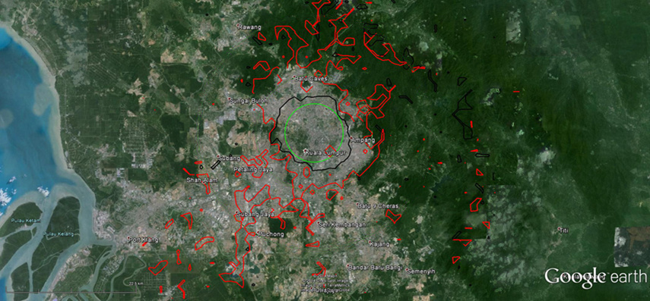
Figure 5 - C/I (black contour) and I/N (red contour) based exclusion zones for single entry micro cell outdoor base station deployed anywhere in the dense urban centre of Kuala Lumpur. The green circles have a radius 5 km from the centre of the proposed IMT License area
Despite these contours being less regular than the ones around Hanoi, there is a clear difference between the I/N exclusion zone and the C/I zone. The C/I exclusion zone is again around 2.5 km although some areas to west show lower levels of C/I on high ground.
However, it would be sensible to deal with these areas on a case by case basis, rather than sterilise an area of radius 30km+. Perhaps there are no villages in those areas, perhaps our pessimistic assumption mean that service will be possible, perhaps the regulator can find other ways to deal with any issues which arise.

4.3 Bangladesh
The same Vinasat satellite could provide coverage to Bangladesh, at between -1 and -2 dB from peak gain. Therefore, the analysis presented above is valid for the area around Bangladesh and we can repeat the simulations there. The satellite elevation is lower at around 34°.
The exclusion contours are shown in the figure below:

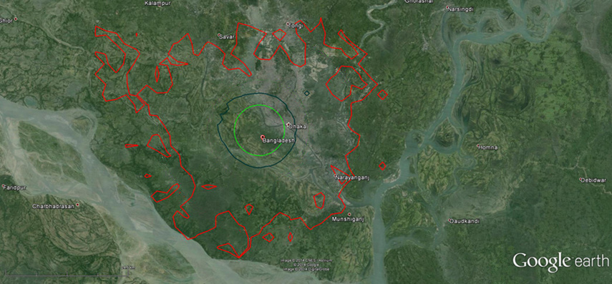
Figure 6 - C/I (black contour) and I/N (red contour) based exclusion zones for single entry micro cell outdoor base station deployed anywhere in the dense urban centre Bangladesh. The green circles have a radius 5 km from the centre of the proposed IMT License area
These contours show the same sorts of gross features as Hanoi and KL. The C/I exclusion contour is up to 3.5 km from the licensed IMT area – we begin to see the effect of the earth station antenna roll-off in the north west, due to the lower elevation of the satellite from this area.
- Conclusions
An approach to planning the coexistence of urban IMT and rural FSS C-band TV to 1.8 metre dishes produces results that are in stark contrast to the headline minimum separation distances that JTG 4-5-6-7 finds.
We have found that in three areas it would be possible to operate micro cell outdoor IMT networks and small dish FSS receivers using a DVB-S2 service, with a separation distance of only 2.5-3.5 km. This means the IMT could operate in a dense urban centre and the FSS in the remoter rural areas or even sub-urban areas.
The difference is due to the way the question is posed. In JTG the question is ‘are there any FSS services that could theoretically suffer interference from any IMT network?’ In this study the question is ‘are there FSS services that can in practice share with any IMT networks?’
Direct to Home TV is an important part of the “FSS” business model, providing a large part of the revenue earned at C-band and also providing an important service to end users where other means of delivery are un-economic or even impossible to install. This study demonstrates that it is reasonable that, in some countries, DTH TV via C-band satellite could co-exist on a national level with micro cell IMT networks – each providing service to its target market.
The regulatory regime that is proposed in JTG 4-5-6-7 would preclude this scenario, and prevent the national administration from providing the benefits discussed at relatively little risk.
- References

1 - (reference http://www.satellite-calculations.com/Satellite/Downlink.htm , accessed 14th May 2014)

The Frontier Economic study included in GSMA submission 343 to JTG 4-5-6-7 shows the benefits exceed costs by approximately eight times, would increase government revenue by $52 billion, and create in excess of 100,000 new jobs.
Sharing studies between IMT-Advanced systems and geostationary satellite networks in the fixed-satellite service in the 3 400-4 200 MHz and 4 500- 4 800 MHz frequency bands in the WRC study cycle leading to WRC-15, Attachment 3 of Annex 11 of JTG 4-5-6-7/584

