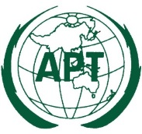 | APT/ITU Conformance and Interoperability Event 2015
 | 7 – 8 September 2015, Bangkok, Thailand

Provisional agenda of the Conformance and interoperability Event

- Opening

- Conformance and Interoperability Testing and Showcasing

  - IMS/NGN interworking
  - Future Transport Network
  - M2M/IoT/e-Health
  - FTTH (GPON and GEPON)
  - IPTV/internet TV
  - NGN E2E service
  - SDN/NFV
  - Transition from existing network to NGN/Future Networks

- Conformance and Interoperability Workshop

- Panel Discussion

- Closing

____________

