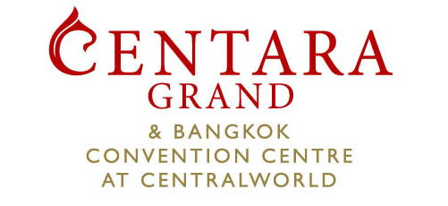
The 21st Meeting of APT Wireless Group (AWG-21)
Asia-Pacific Telecommunity

During 3 – 7 April, 2017

Centara Grand at CentralWorld – Hotel Reservation Form

(Confirmation will be sent back when we receive the detailed information of credit card guaranteed)

Attention to Pathaipischa Isarangkun na ayuttaya Assistant Sales Manager

999/99 Rama 1 Road Putumwan Bangkok 10330 Thailand Tel 66-2 100 1234 ext 6258 Fax 66-2 100 6200 Email cgcwreservation@chr.co.th ; pathaipischais@chr.co.th; sroipetchki@chr.co.th

Room Rates Room Type Single Occupancy Double Occupancy
Superior and Deluxe World Room THB 3,400 net THB 3,800 net
Premium world THB 5,600 net THB 6,000 net
The above rates are inclusive of breakfast and internet in room.

- Rates quoted are inclusive of 10% service charge and 7% VAT
- Cancellation Policy: If cancel their reservation by notifying the hotel 72 hours before the arrival date. In the event that cancellation is not notified to the hotel, a penalty fee of 1 night charge will be deduct from credit card or prepaid deposit.
- No Show Policy: If you fail to attend (no show), the hotel reserves the right to charge your credit card for 1 night stay

First Name:

Family Name:

Organization:

Address:

City: | Country:

Telephone: | Fax: | Email:

Please put the no. of room(s) required and the no. of guest (s) in the selected room type
Superior World or Deluxe World Room ____Room (s) ____Person (s)
Premium world ____Room (s) ____Person (s)
Arrival Date: | Flight No. | Arrival Time:

Departure Date: | Flight No. | Departure Time:
Airport Transfer by:
Mercedes Benz E220 CDI (3 guests maximum)  Arrival (THB 2,500 net/car/way)  Departure (THB 2,500 net/car/way)
Toyota Commuter (5 guests maximum)  Arrival (THB 2,500 net/van/way)  Departure (THB 2,500 net/van/way)
All reservation is required to be guaranteed by a major credit card
Credit Card Company: | Card No.
Name of Cardholder: | Expiry Date:
Signature of Cardholder:
For Hotel Use Only
Booking Ref No. | Received by: | Date:
Please submit this form within March 3, 2017

