 | ASIA-PACIFIC TELECOMMUNITY
The 27th Meeting of the APT Wireless Group
(AWG-27)
 | 22 – 30 March 2021, Virtual/Online Meeting | 30 March 2021

Source: AWG-27/OUT-06

questionnaire ON how to measure oTA TEST FOR 5G USER EQUIPMENT in APT countries

1. Introduction

Recently, the demand for accrediting new antennas system has been increasing rapidly due to the usage of 5G communication for high data rates. A multiple-array beamforming technology has been implemented for focusing the RF signal and efficient transmission. Therefore, OTA testing measurement is highly required for integrated antenna device and facilities.

Currently, the OTA testing methodology for mmWave 5G user equipment is specified in 3GPP TR 38.810 containing Direct Far Field (DFF), Indirect Far Field (IFF) and Near field to far field transform (NFTF) testing methods. Among the three types of testing methods, the IFF is widely used in the industrial and government fields. However, the IFF requires huge long measurement time depending on the test conditions such as different isometric angles. In this test, the antenna beam is fixed in the maximum radiation direction. Even if the beam pattern control is incorrectly set, it takes about 200 hours(in the case of 1 degree unit measurement) to determine the problem.

On the other hand, the NFTF method using multiple probes can be shortened to 20 extra to measure the entire 3D radiation pattern. Therefore, it is easier to judge whether the beam pattern direction declared by the manufacture is properly set, enabling more accurate 5G device testing.

A. IFF (Indirect far field)
There is an IFF method, also known as Compact antenna test range (CATR) method to compensate for these DFF problems, as shown in Figure 2. It consists of a parabolic reflector, a double-shift feed horn antenna, a DUT positioner, and a CATR.

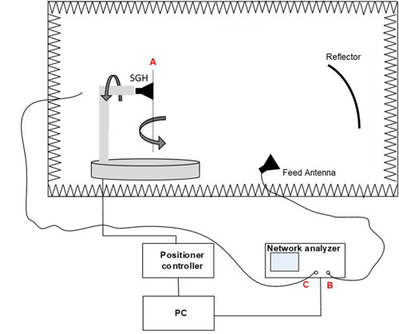
Figure 1. IFF (Indirect far field) measurement method

The advantage of this method is that the reflector is used so that the DUT can be tested in a distant plane wave condition with a distance of less than 2D²/λ. It also has much smaller space and lower path loss than the DFF method. However, it has the disadvantage that feed horn antennas are needed depending on the frequency band to be measured.
B. NFTF (Near Field to Far Field Transform)
The NFTF method is a method of constructing a distant environment within a small chamber, as shown in Figure 3. This method uses the near field to far field transformation function to transform measured data at close range into measured data at long distances using high speed Fourier transformation.
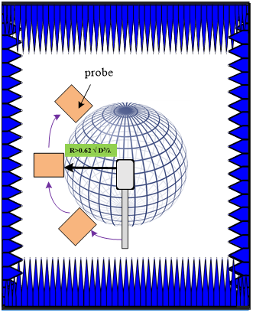 | 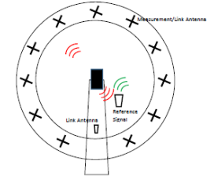
Figure 2. Near Field to Far Field Transform (NFTF) measurement method

The NFTF reduces test time compared to the CATR method. It also has the advantage of being able to conduct measurements in a much smaller space compared to conventional measurement methods. However, the results measured at close range should be converted to distant fields, where discrepancies in measurement and measurement environments could result in large errors. Also, commonly used probe antennas have a very narrow frequency range. Therefore, the disadvantage is that a separate antenna probe is required for each FR2 frequency band.

However, the IFF requires huge long measurement time depending on the test conditions such as different isometric angles. In this test, the antenna beam is fixed in the maximum radiation direction. Even if the beam pattern control is incorrectly set, it takes about 200 hours(in the case of 1 degree unit measurement) to determine the problem.

Table 1. Examples of IFF measurement results of TRP
(only one frequency band and one specific case)

Isometric angle of measurement | Measurement time | Frequency | Chamber | TRP
2° | 50 hours | 26.55 GHz | CATR*  (IFF) | 20.29 dBm
5° | 8 hours |  |  | 20.19 dBm
10° | 2 hours |  |  | 23.20 dBm
15° | 1 hours |  |  | 25.48 dBm
*CATR : Compact Antenna Test Range
Table 2. Total OTA measurement time in mmWave 5G system

OTA measurement time (mmWave)
Tx | Rx
20 days | - days

On the other hand, the NFTF method using multiple probes can be shortened to 20 extra to measure the entire 3D radiation pattern. Therefore, it is easier to judge whether the beam pattern direction declared by the manufacture is properly set, enabling more accurate 5G device testing.

Besides time constraints, there are many other challenges for OTA testing of 5G devices and systems, such as lack of antenna connectors at mmWave band, complicated and expensive system resource requirement for testing electrically large 5G devices, time-consuming array diagnosis and calibration for massive-MIMO and mmWave system. Therefore, new testing solutions are needed to resolve the challenges in the testing systems.

There are several methods and issues such long measurement time to be solved on OTA measurements. Therefore it would be beneficial for APT members to share experience on OTA measurement.

2. Objective of the Questionnaire:

To survey and study OTA test methodologies for various 5G user equipments.

3. Rapporteur of the Questionnaire:

Nam Kim (Republic of Korea)

4. Responsible Group:

WG-TECH/SWG-IMT

5. Meeting at which the Questionnaire was approved:

AWG-27 Document: AWG-27/OUT-06

6. Target Responder:

APT Members

7. Deadline for Responses:

APT Members are encouraged to respond at AWG-28, with possibilities to further add or update information at AWG-29.

Questionnaire Part

Question 1: Institution/Company Information and Profile

Name of the institution :
Name of contact person :
Mailing Address :
Phone :
Email Address :
My institution is (please choose) : Regulator / Operator / Vendor / Others <please describe your answer here>

Question 2: Does your country have an institution that can test 5G/AAS systems ?

Answer of Question 2:
- Yes ( )
- No ( )
- Unable to answer at this time ( )

Question 3: Describe your activities, issues(difficulties) on the OTA test, compliance items(for example, TX antenna system, mobile devices etcs), and future plan in mmWave in free style

Answer of Question 3:

Question 4: What is the contact point if there is an institution that can test the 5G/AAS system?

Answer of Question 4:

