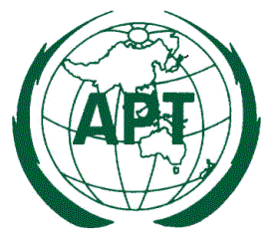

APT RECOMMENDATION ADOPTION FORM

To adopt an APT Recommendation, you are requested to indicate “YES” (in case you support) or “NO” (in case you do not support) in the “Adoption” column of the table. Please leave blank in case you do not have any comment. In case if you indicate “NO” for a particular Draft Recommendation, please indicate reason in the “Remarks” column.

Please return the completed form on or before 26 October 2022 to the APT Secretariat by email: aptawg@apt.int or fax +66 2 573 7479.

.
Table 1: Adoption of the Draft APT Recommendation

Title of Draft APT Recommendation | Source Document No. | Adoption  (YES/NO) | Remarks
Draft APT Recommendation on model(s) for FWS link performance degradation due to wind | AWG-29/OUT-25

The undersign authorizes the Asia-Pacific Telecommunity to count the adoption of the of APT Recommendation in the name of my Administration for which my Administration has indicated as supporting in the table above.

Signature: _ _ _ _ _ _ _ _ _ _ _ _ _ _ _ _ _ _ _ _ _ _

Name: _ _ _ _ _ _ _ _ _ _ _ _ _ _ _ _ _ _ _ _ _ _

Designation: _ _ _ _ _ _ _ _ _ _ _ _ _ _ _ _ _ _ _ _ _ _

Administration: _ _ _ _ _ _ _ _ _ _ _ _ _ _ _ _ _ _ _ _ _ _

Country: _ _ _ _ _ _ _ _ _ _ _ _ _ _ _ _ _ _ _ _ _ _

Telephone: _ _ _ _ _ _ _ _ _ _ E-mail: _ _ _ _ _ _ _ _ _ _ _

_______________________

