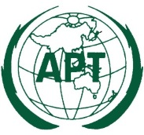 | ASIA-PACIFIC TELECOMMUNITY
 | APT Conference Preparatory Group for WRC-15 (APG-15)

APT Coordination Meetings during RA-15/WRC-15

AGENDA OF THE 3rd APT COORDINATION MEETING FOR WRC-15
13:15 – 13:50 Hours, 5 November 2015
Venue: Room C, ITU Tower Building

- Approval of agenda

- Issues for the coordination for AI 10: List of the proposed AIs for WRC-19

- Report from the AI Coordinators and issues for consideration

  - COM 4: AI 1.1, AI 1.4, AI 1.16, AI 1.18, GFT

  - COM 5: AI 1.6, AI 1.8, AI 1.9.2, AI 1.10, AI 1.11, AI 1.14, AI 9.1 (Issues 9.1.2, 9.1.3, 9.1.5, 9.1.8)

  - COM 6: AI 8, AI 9.1.6

- Any other issues for consideration

- Next coordination meeting

- Closing

____________

