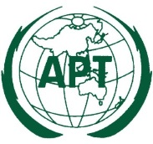 | ASIA-PACIFIC TELECOMMUNITY
 | APT Conference Preparatory Group for WRC-15 (APG-15)

APT Coordination Meetings during RA-15/WRC-15

AGENDA OF THE 11th APT COORDINATION MEETING FOR WRC-15
12:30 – 13:50 Hours, 24 November 2015
Venue: Room C, ITU Tower Building

- Opening remarks

- Report from the AI Coordinators and issues for consideration

  - COM 4: AI 1.1, AI 1.5

  - COM 5: AI 1.6, AI 1.9.1, AI 1.10

  - COM 6: AI 10

- Any other issues for consideration
  - Preparation for CPM19-1

- Next coordination meeting

- Closing

____________

