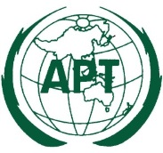 | ASIA-PACIFIC TELECOMMUNITY | Document:
 | The 2nd Meeting of the APT Conference Preparatory Group for WRC-19 (APG19-2) | APG19-2/OUT-35
 | 17 – 21 July 2017, Bali, Republic of Indonesia | 21 July 2017

Working Party 1
Invitation for contributions to the APG19-3 meeting FOR PROVIDING INFORMAtion on the spectrum usage of current and future rstt

At the APG19-2 meeting, it was agreed by the meeting that comprehensive information on the spectrum usage of RSTT is very important to facilitate consideration on which frequency band(s) could be harmonized to support RSTT within existing mobile service allocations, in accordance with Resolution 236 (WRC-15).

Therefore, it was discussed and agreed by the meeting to invite APT Members to contribute to the APG19-3 meeting for providing information on the spectrum usage of current and future RSTT, by filling the embedded Excel sheet to this document and preparing a contribution document to the APG secretariat one month before the opening date of APG19-3, due to the time requirement for compiling those information in advance.

Embedded document: 1. (Double click for opening)

____________

