

**APT REPORT**

**on**

**SMART GRID IN APT REGION**

No. **APT/ASTAP/REPT-16**

Edition: March 2015

Source Document: ASTAP-25/OUT-13

**Adopted by**

**The 25th APT Standardization Program Forum (ASTAP-25)**

**02 – 06 March 2015, Bangkok, Thailand**

Table of Contents

1. Scope 3

2. Terms and Definitions 3

3. Concept and importance for Smart Grid 6

4. Related standardization activities in ITU 9

5. Use cases including interests and needs on Smart Grid from the APT member countries 11

6. Analysis of study items for APT member countries 24

7. Reference Documents List 24

Appendix I Feedbacks on questionnaire from APT member countries 25

1. Feedback from Japan 25

2. Feedback from Hong Kong, China 26

Appendix II Questionnaire sent to APT member countries 28

1.Backgrounds 28

2.Questionnaire 28

3. Appendix: General description on smart grid 29

# 1. Scope

This report describes the introduction of Smart Grid realized by ICT, international standardization activities, and use cases so that countries in the APT region can refer to plan deployment Smart Grid solutions for their own countries.

The concrete scope of the report is as follows:

- Introduction of concept and importance of ICT concerning Smart Grid

- Introduction of Smart Grid-related international standardization activities

- Introduction of use cases on Smart Grid in the APT region

- Analysis of further study items for the APT region

# 2. Terms and Definitions

## **2.1 Definitions**

**Advanced Metering Infrastructure (AMI) [1]**

An AMI is the infrastructure relating to electric metering and communications, including meters capable of two-way communication. Currently, utilities are focusing on developing an AMI to implement residential demand response and to serve as the chief mechanism for implementing dynamic pricing. It consists of communications hardware and software and associated system and data management software that creates a two-way network between advanced meters and utility business systems, enabling collection and distribution of information to customers and other parties, such as competitive retail suppliers or the utility itself. An AMI provides customers real-time (or near real-time) pricing of electricity and it can help utilities achieve necessary load reductions.

**Aeolian Vibration [9]**

An aeolian vibration is the periodic motion of a conductor induced by the wind predominantly in a vertical plane, of relatively high frequency of the order of ten or tens Hz and small amplitude, of the order of the conductor diameter.

**Cloud computing system [2]**

A cloud computing system is a paradigm for enabling network access to a scalable and elastic pool of shareable physical or virtual resources with self-service provisioning and administration on-demand

**Distributed Energy Resources (DER) [1]**

A DER refers to energy generation and energy storage facilities located at customer premises or power transmission and distribution systems.

**Dynamic Line Rating (DLR) [10]**

A DLR is a concept of technology that calculates the rating of an overhead transmission line based on the ambient conditions dynamically.

**Energy Conservation and Homecare Network (ECHONET) [5]**

The technical standards for HAN developed by the ECHONET Consortium in Japan. ECHONET means a network that will realize energy conservation and home healthcare.

**Energy Management System (EMS) [4]**

An application software suite that supports electric system operations, providing information and tools to operations and engineering staff to ensure reliable delivery of energy to customers. It is also known as a DMS(Distribution Management System) for the bulk power system and sometimes refers to a residential software system that coordinates the operation of smart residential appliances, which can control loads (smart thermostats, water heater controls, smart refrigerators, and laundry equipment), along with on-site power generation, such as solar photovoltaics) and electrical energy storage. In residential situations, it is commonly known as HEMS (Home Energy Management System).

**Energy Services Interface (ESI) [1]**

An ESI is a set of functions consisting of gateway functions and functions required for Smart Grid applications to control and manage the Smart Grid Services at customer premises.

**Electric Vehicle (EV) [1]**

The term EV includes all-electric vehicles or battery electric vehicles (BEVs), plug-in hybrid electric vehicles (PHEVs), and plug-in conversions of hybrid electric vehicles. A plug-in electric vehicle (PEV), which is sometimes referred to as a grid-enabled vehicle and also as electrically chargeable vehicle, is a motor vehicle that can be recharged from any external source of electricity and can work as a power providing system at the same time.

A PEV is a system that can be operated as an electrical power consuming and an electrical providing system at the same time like an energy storage system. A PEV contains an internal BMS and the operating function which are controlled and managed using a home energy management system. It is required that the control and management reflects the user’s PEV usage plan and dynamic price information.

**Home Area Network (HAN) [1]**

In smart grid applications, A HAN refers to networks in homes that interconnect energy devices, such as appliances, energy management system, plug-in electrical vehicle(PEV) chargers, energy sources, and other applications within a home environment that is on the home side of the electric meter. A HAN can be connected to a WAN by using gateways.

**Independent System Operator/ Regional Transmission Organization (ISO/RTO) [4]**

An ISO is an independent, federally regulated organization established to coordinate regional transmission in a non-discriminatory manner and ensure the safety and reliability of an electric system.  
A RTO is an independent organization (profit or non-profit) established for the purpose of operating the transmission assets and providing wholesale transmission services within a defined (usually multi-state) geographic region.

**Intelligent Electronic Device (IED) [4]**

A class of devices that provides protection, control, and/or monitoring capabilities for power system equipment

**Machine to Machine (M2M) [2]**

Machine-to-machine applications are enabled by the communication between two or more machines that requires limited or no direct human intervention.

**Management Platform (PF) [11]**

Management PF is a platform which has common functions providing the interface and the management for the home network applications, and the virtual device management and the resource management for the home gateway and the devices.

**Photo Voltaic (PV) System [1]**

A PV system uses one or more solar panels to convert sunlight into electricity. It consists of multiple components, including PV modules, mechanical and electrical connections and mountings and means of regulating and/or modifying the electrical output

**Remote Terminal Unit (RTU) [1]**

An RTU is a microprocessor-controlled electronic device that interfaces objects in the physical world to a distributed control system or SCADA system by transmitting telemetry data to the system and/or altering the state of connected objects based on control messages received from the system

**Smart Meter [1]**

A smart meter is a premise device to monitor and control electrical power usage of home devices based on “demand response (DR) information” from home devices.

**Smart Socket**

A smart socket is an electrical socket that monitors electric current and/or power consumption

**Supervisory Control and Data Acquisition (SCADA) [1]**

SCADA is a computer system that monitors and controls an industrial-, infrastructure-, or facility-based control process.

**Wireless Mesh Network (WMN) [6]**

A wireless mesh network is any wireless network where data is transmitted using mesh networking. That is, where nodes don't just send and receive data, but also serve as a relay for other nodes and each node collaborates in propagating data on the network.

**Wireless Sensor Network (WSN) [4]**

A wireless network of distributed monitoring devices or sensors that acquire and communicate information to a management center. Monitoring usually covers environmental or physical conditions, such as vibration, temperature, pressure, sound, or motion.

**X Energy Management System (xEMS)**

An xEMS is a generic name of the energy management systems in various domains such as an EMS in a building called BEMS and an EMS in a home called HEMS.

## **2.2 Abbreviations**

GPS: Global Positioning System

HVDC: High Voltage Direct Current

ISGAN: International Smart Grid Action Network [8]

RFID: Radio Frequency based Identification

SDO: Standards Development Organization

STB: Set Top Box

TTC: Telecommunication Technologies Committee [7]

UHV: Ultra High Voltage

V2G: Vehicle to Grid

VOD: Video on demand

# 3. Concept and importance for Smart Grid

## **3.1 Concept of Smart Grid**

The "Smart Grid" is a two way electric power delivery network connected to an information and control network through sensors and control devices. This supports the intelligent and efficient optimization of a power network. Based on NIST 7 domain model, ITU-T FG Smart defined a simplified domain model of smart grid from ICT perspective as shown in the following figure. This simplified domain model is composed of the following five domains.

* Grid domain (bulk generation, distribution and transmission)
* Smart metering (AMI)
* Customer domain (smart appliances, electric vehicles, premises networks (Home/ Building/ Industrial Area Network))
* Communication network
* Service provider domain (markets, operators, service providers)



Fig. 1. Simplified Smart Grid domain model from ICT perspective

Figure 1 shows five reference points from a network to four other domains, and between smart metering domain and customer domain. The samples of functions at each of these reference points are listed below:

* **Reference Point 1** – Between Grid domain and Network. This enables exchange of information and control signals between devices in the Grid domain and the Service providers domains, the examples of SCADA and other operations are listed below.
  + Transmission RTU in transmission systems to enable SCADA operations;
  + Transmission IED in transmission systems to interact with SCADA operations in the Service provider domain;
  + Plant control system to interact with SCADA and EMS in the Service provider domain;
  + Plant control system to interact with ISO/RTO wholesale market in market operations (e.g., the control signals of monitoring, reporting, and telephony between bulk storage domain and markets to enable wholesale markets operations control hence optimizing portfolios of sources);
  + Information and control signals and power generation information between Grid domain (Bulk generation) and Service provider domain (Control and Operations);
  + Grid domain (transmission sensors and measurement devices) to provide information from the transmission line to the Service provider domain (transmission operation, protection and control) for dynamic line rating, transmission line maintenance information, monitoring, reporting, and SCADA;
  + Information exchange and coordination between Grid domain (generation) and Service providers domain (transmission operations and control);
  + Distribution sensors and measurement devices provide distribution system information for use by DER.
* **Reference Point 2** - Between Smart metering domain and Network. This enables the following exchange of metering information and interactions through operators and service providers in the Service provider domain towards customers in the Customer domain.
  + Management of meters and retrieval of aggregated meter readings from AMI head-end/controller in Operations and Service provider domains;
  + Interaction with customer energy EMS to exchange pricing, data related to demand and response use case, including load schedding information, and any relevant information enabling automation of tasks involved in better use of energy;
  + Billing in the Service provider domain to interact with the meter in the Customer domain.
* **Reference Point 3** – Between Customer domain and Network This enables the following interactions between operators and service providers in the Service provider domain and devices in the Customer domain.
  + A HAN may be established to provide communication between the Customer EMS and smart appliances and intelligent devices;
  + It communicates over this Reference point either through a secure energy service gateway or through public Internet;
  + The Energy Services Interface (ESI) / HAN gateway interacts with the metering/ billing / utility back office in the Service provider domain (Operations);
  + It interacts with the load management system / demand-response management system in the Service provider domain (Operations);
  + Customer EMS interacts with energy service provider in the Service provider domain;
  + Billing in Service provider domain interacts with customers in the Customer domain;
  + Customer EMS interacts with distribution management system in the Grid domain;
  + Customer EMS interacts with aggregator/ retail energy provider in provider domain;
  + Monitoring and control information exchange for distributed generation and DER at the Customer domain;
  + Devices in the Customer domain, including customer EMS, energy service gateway in the home, and customer appliances and equipment interact with Smart meter.
* **Reference Point 4** – Between Service provider domain and Network. This enables communications between services and applications in the Service provider domain to all actors in others domains to perform all Smart Grid functions illustrated above.
* **Reference Point 5** – Between Smart metering and Customer domain. Through energy service gateway.
  + Smart meter interacts with devices, including customer EMS, energy service gateway in the home, and customer appliances and equipment;
  + Smart meter interacts with the billing in the service provider domain;
  + Smart meters form a metering network to ensure reliable communication to the meter head-end through this Reference point.

## **3.2 Importance of Smart Grid in the ICT perspective**

Concepts and roles for Smart Grid from the ICT perspective

# 4. Related standardization activities in ITU

This clause provides a brief idea of current activities of ITU as the international standard body.

### **4.1 Focus Group on Smart Grid (FG Smart)**

FG Smart was established based on ITU-T TSAG (Telecommunication Standardization Advisory Group) agreement at its meeting in Geneva, 8-11 February 2010 with the following scope.

* Identify potential impacts on standards development;
* Investigate future ITU-T study items and related actions;
* Familiarize ITU-T and standardization communities with emerging attributes of smart grid, and
* Encourage collaboration between ITU-T and smart grid communities

FG Smart produced the following five deliverables as output of the activity, and concluded in December 2011.

* Use cases
* Requirements
* Architecture
* Terminology
* Overview

In each deliverable, some results of gathering relevant information, basic investigation and gap analysis of current standardization activities are summarized. Details of FG Smart can be viewed on ITU-T Web site (<http://www.itu.int/en/ITU-T/focusgroups/smart/Pages/Default.aspx> ).

### **4.2 JCA Smart Grid and Home Networking (JCA-SG&HN)**

Establishment of JCA-SG&HN was approved at the TSAG meeting held in Jan 2012 as a successor activity of FG Smart replacing the existing JCA-HN. The scope of JCA-SG&HN is as follows.

* The scope of this JCA is the coordination, both inside and outside ITU-T, of standardization work concerning all network aspects of Smart Grid and related communication as well as Home Networking.

From July 2012, JCA-SG&HN has been in the early stage of discussion and has just initiated a study on allocation of the standardization goal to current Questions/Study Groups in ITU-T or other SDOs.

### **4.3 Other relevant existing activities in ITU-T/ITU-R**

Currently, there are various activities for recommendations of technologies that could be applied to Smart Grid. Table 1 lists the current ITU-T Study Groups’ activities and Table 2 lists the ITU-R activities directly related to Smart Grid.

Table 1 Current ITU-T Study Groups’ activities directly related to Smart Grid

|  |  |  |
| --- | --- | --- |
| **Items** | **SGs and aspects** | |
| (1) M2M | FG M2M | Service Layer use cases, requirements, APIs and protocols for healthcare and other application |
| SG13 | Q.2/13 Requirements for NGN evolution (NGN-e) and its capabilities including support of IoT and use of software-defined networking  Q.3/13 Functional architecture for NGN evolution (NGN-e) including support of IoT and use of software-defined networking Q11/13 Evolution of user-centric networking and services, and interworking with networks of the future including Software-Defined Networking |
| SG15 | Q1/15 Coordination of access and Home Network Transport standards |
| SG16 | Q25/16 IoT applications and services |
| (2) Smart metering | SG15 | Q15/15 Communications for Smart Grid |
| (3) Vehicle communication | CITS | Collaboration on ITS Communication Standards <http://www.itu.int/en/ITU-T/extcoop/cits/> |
| SG16 | Q27/16 Vehicle gateway platform for telecommunication/ITS services /applications |
| (4) Access and Home networking | SG9 | Q5/9 Functional requirements for residential gateway and set-top box for the reception of advanced content distribution services  Q9/9 Requirements for advanced service capabilities for broadband cable home networks |
| SG13 | Q11/13 Evolution of user-centric networking and services, and interworking with networks of the future including Software-Defined Networking |
| SG15 | Q1 and Q2/15 Optical systems for fibre access networks  Q4/15 Broadband access over metallic conductors  Q18/15: Broadband in-premises networking |
| SG16 | Q21/16 Multimedia framework, applications and services |
| (5) Energy saving network | SG13 | Q.16/13 Environmental and socio-economic sustainability in future networks and early realization of FN  Q11/13 Evolution of user-centric networking and services, and interworking with networks of the future including Software-Defined Networking |
| (6) Smart Grid | SG15 | Q15/15 Communications for Smart Grid |
| (7) Security | SG17 | Q6/17 Security aspects of ubiquitous telecommunication services |

Table 2 Current ITU-R activities directly related to Smart Grid

|  |  |  |
| --- | --- | --- |
| **Items** | **SGs and aspects** | |
| (1) Smart Grid power management systems | WP 1A | Spectrum engineering techniques |

# 5. Use cases including interests and needs on Smart Grid from the APT member countries

This clause is to introduce case studies of either government pilot projects or private efforts from industries. Through sharing successful use-cases, APT member countries will have ideas on ways to promote the Smart Grid using ICT and to derive requirements on ICT/telecommunication networks in APT member countries.

## **5.1 Japan**

### **5.1.1 Implementation of Energy Management System**

After stopping nuclear power plant operations due to the Great East Japan Earthquake, the reduction of electric power consumption has become an urgent issue to address the low capacity of electric power supply. Regarding efforts on the customer side regarding this issue, EMSs in various domains (so called xEMS) have been attracting attention as key technology. By applying xEMS, it is expected that consumers will be able to achieve visualization and optimization of energy consumption themselves.

(1) xEMS on Cloud Computing System

It is considered an especially important point that the functionality of xEMS will be implemented on a cloud computing system. By this implementation, it will be expected that consumers will be able to easily install xEMS functionality and perform optimized control in a wider area (a so called community) as well as in each household, building, factory, and so on.

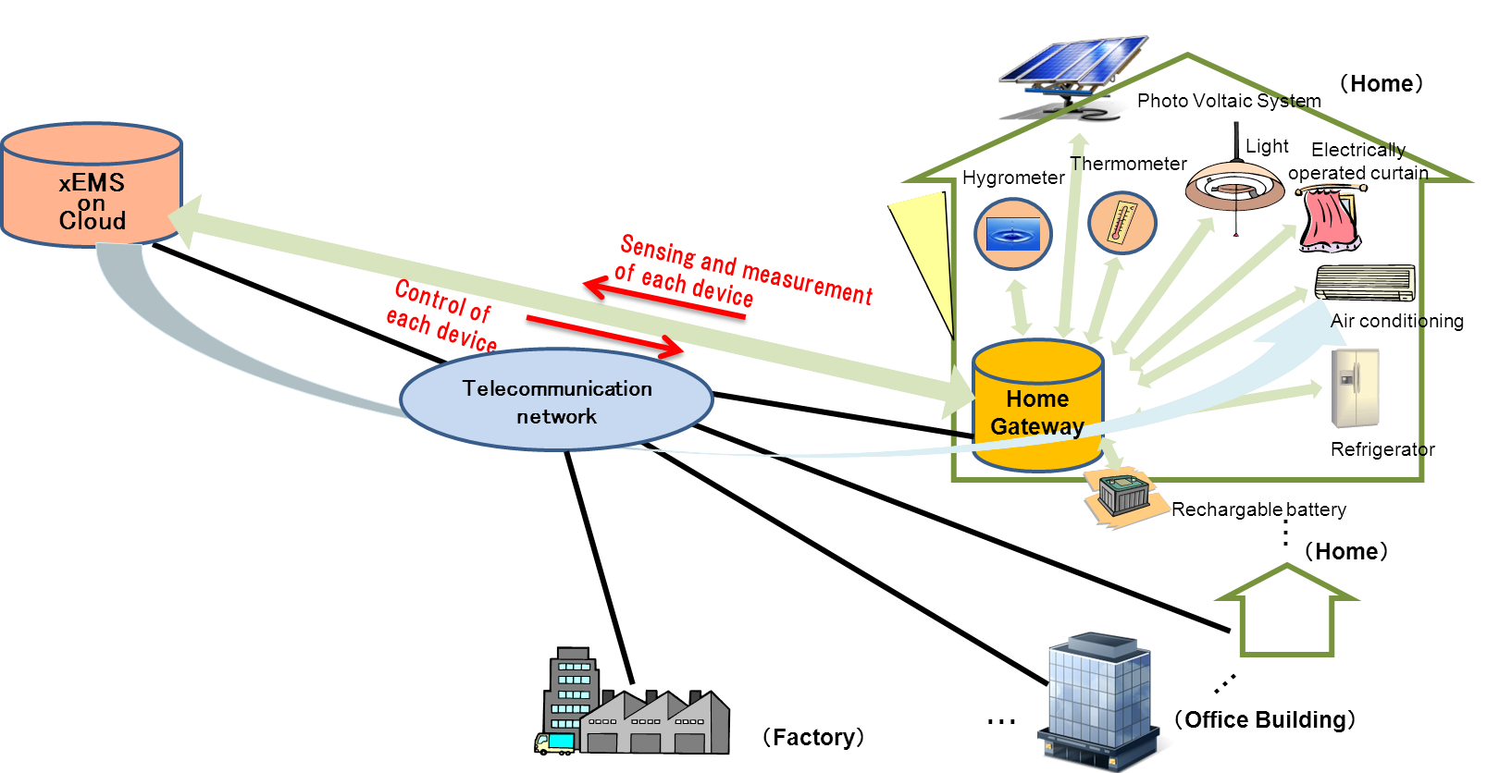

Fig.2 xEMS on Cloud Computing System

(2) xEMS on Local Controller

The system configuration in which xEMS resides on a local controller can be an alternative to realize xEMS. These kinds of systems are often provided as a set of smart home electronics, factory automation systems or building management systems. It seems normal to introduce these types of xEMS in the early stage, because they can be used even before cloud computing services of xEMS are provided. Also, they can be introduced even without stable communication network services.

In Japan, various types of vendors have already provided these kinds of products, and demonstrate trials at showcase houses. Fig.3 Illustrates an example of Smart House trial and showcase using HEMS on local controller. In the smart house, in addition to many kinds of home products, such as Air conditioner, Lightings, IH cooking heater, Ventilation system, Electric blinds and so on, power generator and batteries, such as Solar power system and Electric Vehicle, are controlled by a HEMS controller to stabilize and reduce the total power usage in the house.

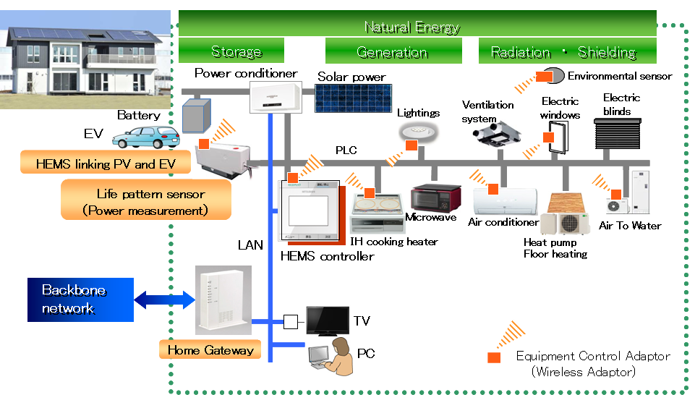

Fig.3 Example of Smart House with HEMS on Local Controller

### **5.1.2 Standardization**

### **5.1.2.1 Ensuring Interoperability**

In order to achieve xEMS on a cloud computing system, standardization is necessary at each point between xEMS on the cloud computing system and electric devices or sensors in consumer houses or buildings at each network protocol layer. ECHONET Lite standardized by ECHONET Consortium is one such major effort in Japan regarding HAN. Fig.4 shows the area that ECHONET Lite covers.

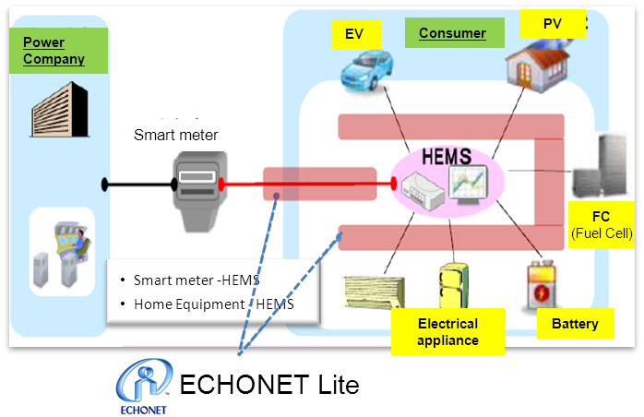

Fig.4 ECHONET Lite

ECHONET Lite corresponds to layer 5 and 6 in the 7-layer model, and the network and physical layers are originally out of the scope of ECHONET Lite. As an assist in the implementation of a HAN system using ECHONET Lite, TTC has created implementation guidelines for appropriate suits of ECHONET Lite and lower layer technologies. Fig.5 shows the relationship between ECHONET Lite and lower layer technologies mentioned in TTC’s guidelines.

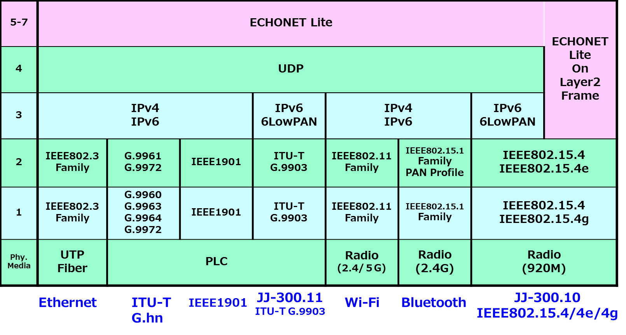

Fig.5 Implementation Guideline of ECHONET Lite

### **Architecture of HEMS and Home Network Services**

Japan is conducting an R&D project regarding HEMSs for achieving energy-efficiency and reduction of the energy consumption by monitoring and controlling devices connected to the home network, such as home appliances and storage batteries, and sensors from the HEMS application on the WAN (including the Internet). It is supported by the Ministry of Internal Affairs and Communications (MIC) of Japan.

The HEMS is one of the home network services; therefore, it is realized on the home network service architecture. Japan proposed this architecture to the ITU-T SG13, based on the achievements of the R&D project of MIC. ITU-T Recommendation Y.2070 which was approved in January 2015 specifies the architecture. It is also seen as an M2M architecture. Fig. 6 shows this architecture.

The functions in this architecture are composed of three categories; the device operation, the application execution and management.

- Device operation:

Functions to monitor and control the devices from the management PF on the WAN.

- Application execution: Functions to configure the virtual devices on the management PF from the application, which results in managing the devices.

- Management:

Functions to enable remote maintenance and fault diagnosis on the home network.



Outside the home (WAN)

Inside the home

(Home Network)

Outside the home (Internet, Cloud computing)

Outside the home (Internet, Cloud computing)

Fig. 6 Home Network Service Architecture

### **5.1.3 Network Traffic Issue**

As xEMS on cloud computing system will become widespread, it is assumed that a huge amount of network traffic will occur between many devices or sensors on customer premises and xEMS. This network traffic, called M2M communication, is different than stream data such as IP-Phone or VOD, and is composed of a large number of short packets. Fig. 7 shows network traffic situation ,involving network congestion and delays, under xEMS on cloud computing system. Huge amounts of small packets from various devices connected to a smart grid place loads on telecommunication networks, including routers. In Japan, several projects are being planned to investigate the impact of such traffic on whole network systems and to find solutions for this impact.

For example, MIC conducted demonstration experiment in terms of expected problems ,such as traffic congestion and delays that may emerge upon deployment of the Smart Grid, regarding telecommunications networks. Toyota City and Kitakyushu City were selected as the sites to conduct the demonstration experiment. Table 3 summarizes these projects.

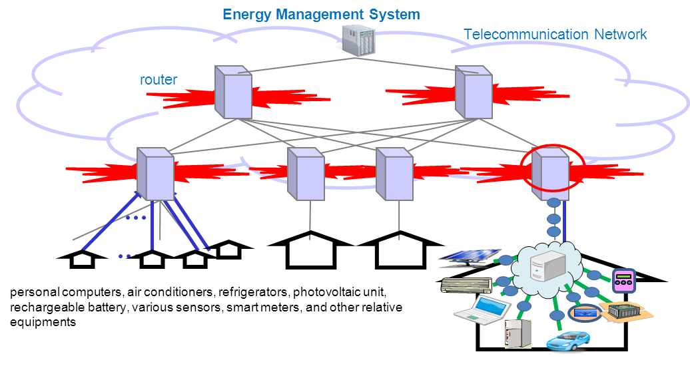

Fig.7 Network Traffic situation in xEMS on cloud computing system

Table 3 Project Summary

|  |  |  |
| --- | --- | --- |
| **Local government** | **Project Summary** | **(1) Number-of-Facilities**  **(2) Number-of-connected Devices** |
| Kitakyushu City  (Fukuoka Prefecture) | Demonstration experiment to establish technology, which enables collective optimized control of multi hop network used for Smart Grid-related communication. | (1) 10 schools  (2) 230 sensors equipped with communication devices |
| Toyota City  (Aichi Prefecture) | Demonstration experiment to establish technology which enables high speed communication with redundancy by transmitting data over multi communications circuits simultaneously. | (1) 47 facilities(32 kindergartens, 11 community center,4 other facilities)  (2) 376 sensors equipped with communication devices |

### **5.1.4 Wireless Mesh Network for Smart Meter System**

Smart meter system is one of the key components of the smart grid system, where the power usage information of each customer needs to be collected in every certain period, such as 30 minutes. The system may also be used for remote control message exchange such as commands to cut off power supply. Therefore, the communication traffic of smart meters is normally a large aggregation of small transactions. The communication networks for smart meter system should support this type of traffic, and low CAPEX and OPEX of networks are important to make smart grid systems deployable.

Considering these requirements for networks specific to smart grid system and the constraints on the available wavelength and bandwidth of the physical layer, many power companies in Japan are planning to adopt and develop wireless mesh network technology, in which each smart meter, a node of a wireless mesh network, can send its own information and relay traffic from adjacent nodes. Currently, many trials and development of wireless mesh networks are being conducted in Japan. Fig.8 shows an example of a wireless mesh network trial for both large and small size mesh networks.

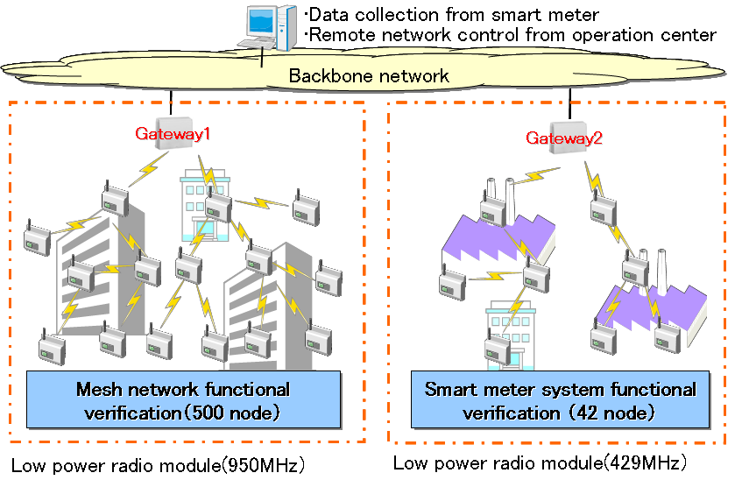

**Fig.8 Wireless Mesh Network trial for Smart Meter System**

### **5.1.5 Reconstruction Assistance through Introduction of Smart Grid**

MIC, Japan is helping to promote smart communities in areas affected by the Great East Japan Earthquake by providing subsidies for introducing related equipment necessary to improve energy efficiency, mainly from the perspective of telecommunications interface. As of December 2013, seven areas projects have been supported through this scheme, as shown in Table 4. An example of smart grid-related equipment installation, initiated thanks to this subsidy, is shown in Fig. 9.

Table 4 Project Summary of each area

|  |  |  |
| --- | --- | --- |
| **Local government** | **Project Summary** | **Number-of-Facilities** |
| Sendai City  (Miyagi Prefecture) | Introducing an integrated management system to control HEMS and photovoltaic systems, installed in municipal housings for affected person, and other related devices. | 4 collective houses(including 176 households)  16 detached houses |
| Aizuwakamatsu City  (Fukushima Prefecture) | Introducing an integrated management system to control HEMS, installed in households. | about 100 detached houses |
| Ashikaga City  (Tochigi Prefecture) | Introducing an integrated management system to control BEMS and photo voltaic systems installed in community facilities. | 52 community facilities(city hall, 10 households and 41 community facilities) |
| Kuji City  (Iwate Prefecture) | Introducing a system to monitor and visualize electricity consumption at elementary schools, junior high schools and community facilities. | 30 facilities(24 schools, 6 community facilities) |
| Tochigi Prefecture | Introducing an integrated management system to control BEMS and photo voltaic systems, installed in community facilities. | All community facilities in Tochigi prefecture  (186 community facilities in total) |
| Noda Village  (Iwate Prefecture) | Introducing an integrated management system to control BEMS, installed in community facilities. | 11 community facilities(village office, 2 schools and 8 community facilities) |
| Date City  (Fukushima Prefecture) | Introducing an integrated management system to control BEMS, installed in community facilities. | 33 community facilities(city hall, 11 schools, 3 community centers and 18 community facilities) |

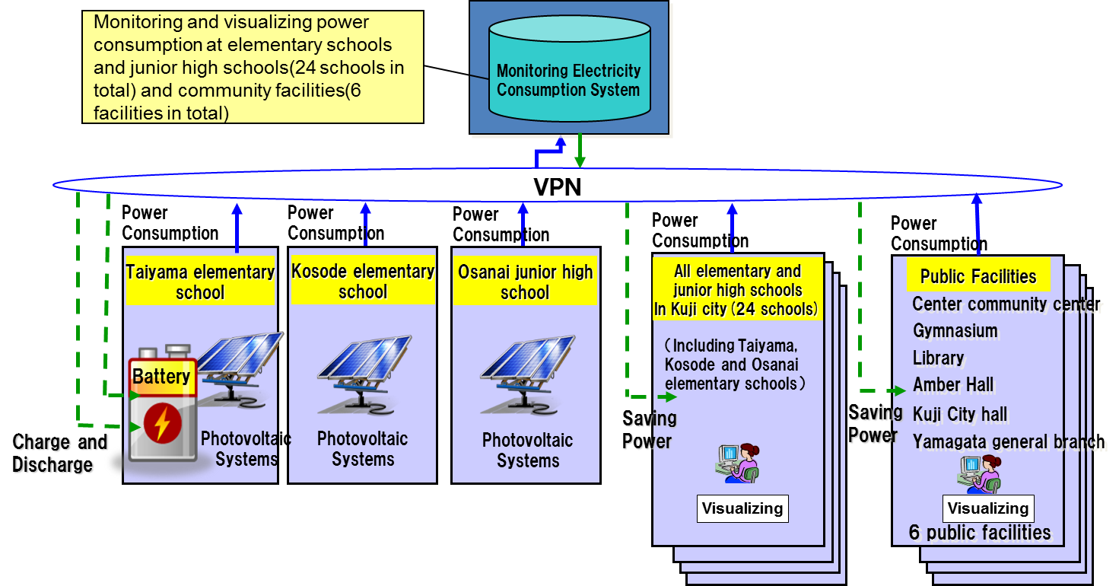

Fig. 9 Outline of the project in Kuji City

## **5.2 Korea**

Korea retains an exceptional power grid and intricate network situation. According to the Korea Electricity Power Cooperation (KEPCO), Korea experiences the shortest outage durations compared to Japan, U.S.A and the U.K. Moreover, the positive quality of the grid has been proven through the minimal loss in transmission and distribution. Overall, Korea holds a reliable power grid network but is isolated in terms of electricity network.

According to Korea Smart Grid Institute, the maximum peak of electricity increases annually and it is expected that the energy consumption will continue to rise in parallel. Thus, the concentration of electricity demand will result in increasing generation capacity. If the generator capacity becomes insufficient, Korea will not be able to avoid blackouts. The peak patterns of electricity consumption in Korea are as follows.

* Never during spring and fall
* Absent during nights and weekends
* For only two and a half hours in the morning during winter(-10)



* For only three and a half hours in the afternoon during summer(+30)



To accommodate these specific time intervals, installing additional facilities may be a waste. To avoid blackouts, new power generators can be built for smart demand management.

Compared to other OECD countries including U.S.A, France and Japan, despite the GDP per person being doubled in Korea, it still records a higher rate of electricity consumption. Even under these circumstances, Korean electricity prices are only half of the OECD average.

In Korea, there has been ten power IT projects accumulating to a sum of 0.25 trillion (KRW) between an 8 year time span. In 2009, the series began with the ground breaking implementation of ‘Jeju Island Smart Grid Test-Bed’ which was followed by the establishment of ‘Smart Grid National Roadmap’ in 2010.

In 2011, “the Act on Promoting SG Establishment and Usage” was established while the Smart Grid Act was enacted. In the same year, Korea was designated as an ISGAN vice-chair country and had the role of the secretariat. In 2012, Korea started Smart Grid Deployment and established a ‘SG Five-year Master Plan.’ Last year, the 2nd phase of SG Jeju Test-bed project finished.

The Jeju Smart Grid Test-bed project is the world’s largest smart grid test-bed at the initial stage. The target of this project is to commercialize technology and business models. The budget totals 249.5 billion (KRW) where, 76.6 billion was invested from the public and the remainder from private.

In its first two years, the infrastructure for the demonstration was constructed while during the last two years, the focus was on integrated operation. Collectively, 168 companies participated in the project including major companies such as KT, SKT, KEPCO and LG electronics. Ten consortia were established in five areas.



Fig. 10 Jeju Smart Grid Test-bed (source: KSGI)

Nine new business models were devised and separated into the three categories of demand response, EV charging and others. Under demand response, there are four specific models listed below:

* Electricity retail
* Demand response
* Consumer-generated power trading service
* Operation of virtual power plant based on EV

There are two business models related to EV charging

* EV quick charger, Charging stand
* Moving/Emergency charging service for EVs

The others category includes:

* Consulting on energy consumption
* EV rental service
* Stable NRE production and better power quality

There are technological obstacles to overcome during the implementation of these models. For example, in relation to electricity retail, AMI, EMS and smart appliances should be able to exchange real-time information between consumers and suppliers which optimizes electricity supply and demand through technology development and trial operation.

With regards to energy storage system, the management technology of discharge and charging for high-capacity battery charge that have different capacity and usage should be further studied in conjunction with distributed degeneration. Amongst the EV business, for quick and standard charging service and delivery of various services for the electric vehicle infrastructure communication, the system should be developed with grid integration technology which connects micro grid, electric car and battery grid to allow electricity to transmit both ways.

In promoting smart grid establishment and usage, there was an enactment of the Special Act on Establishment of Nationwide Smart Grid. This involves the ‘establishment of regulatory basis for stable building of SG,’ ‘establishments, utilization, and protection of SG information’ and ‘establishment of the basis of the systematic building of the SG.’ Furthermore, in accordance with article 5 of ‘the Act on Promoting SG Establishment and Usage,’ the First Five-year Master Plan was formed. The goal of the First Five-year Plan is to achieve the construction of smart grid pilot cites in 7 wider districts by setting up a hierarchical strategy as seen in figure 11.

According to figure 11, to construct smart grid pilot cites in seven wider districts, the foundation of the plan will be built on the implementation strategies through the four approaches of system improvement, market creation, technology development and infrastructure establishment. This leads to the strategic goals of smart service, smart consumer, smart transportation, smart renewable and smart transmission and distribution then ultimately the final objective. This plan predicts the total economic effects to be a total of 9.67 billion dollars (USD).

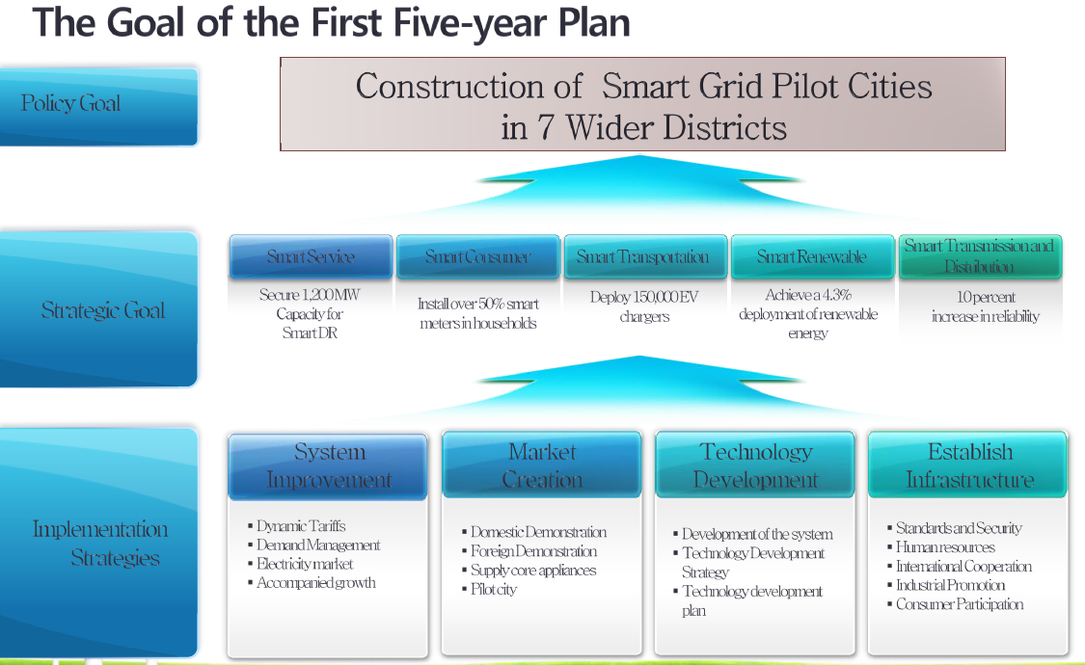

Fig. 11. The Goal of the First five-year Plan (source: KSGI)

Based on these activities, laws and plan, Korea is ready for the next step: Pilot Deployment. This consists of commercialization and visualization of the effects. A total of eight consortia were proposed for the Pilot Deployment project.

For this proposal, service providers, system integration companies, and equipment providers are working collaboratively throughout 14 provinces. Business models are using technology including AMI(Advanced Metering Infrastructure), DR(Demand Response), EMS(Energy Management System), ESS(Energy Storage System), EV charging, V2G and Renewable to Grid.

As a result, not only will new businesses be created but smart grid will also benefit as it will extend to the seven largest cities in Korea. These cities are responsible for the majority of energy consumption, accounting for over 46% of both the national population and GDP in Korea.

## **5.3 China**

In China, there are two power grid corporation, they are, State Grid Corporation of China (SGCC) and China Southern Power Grid Company Limited, which own 80 and 20 percent of the grid system respectively.

China’s own definition of smart grid as characterized by SGCC “Strong Smart Grid” is take the Ultra High Voltage (UHV) power grid as the back bone network, with coordinated development of subordinate grids at all levels and featured by IT-based, automated and interactive. SGCC develops three stages to promote the construction of strong &smart grid: the first stage “planning and pilot” (2009~2010), the second stage “Comprehensive construction” (2011~2015) and the third stage “improvement” (2016~2020). Till to the end of 2014, there have been 305 demonstration projects completed, and these have been put into operation. The projects involve many directions, such as UHV AC/DC Transmission, multi-terminal Flexible HVDC Project, Wind-PV-ES (Energy Storage)-Transmission Demo project, Smart Transformation, Smart Distribution, Energy data acquire system, EV Facilities, Smart Utilization, Comprehensive demonstration projects.

Meanwhile SGCC published “Smart Grid Technology Standard System Planning” and "smart grid key equipment (system) development plan” to promote the R&D of technical standards of strong &smart grid.

### **M2M applied to support smart grid in HAN (Home Area Network)**

1）Sensing and collecting of smart power consumption information

Sensing and collecting of smart power consumption information is generally used by power grid corp. It can accomplish intelligent sensing and collecting of smart power meter information e.g. power, energy consumption, and running time, and transmit and upload the data obtained to the center server through various communication methods.

2）Smart power consumption service

Smart power consumption service is generally used by customers. It can utilize the smart terminals including home interactive terminal, Set top box (STB), mobile-phone and smart socket, which integrating various communication methods, to implement the multiple functions listed below to promote Energy Saving and Exhaust Reducing and consequently improve energy efficiency.

* + Supporting of smart power consumption by adopting power consumption information interaction server, e.g., monitoring of abnormal power consumption and power-saving advice release;
  + Supporting of rapidly and conveniently bidirectional information communication, obtaining information of power consumption and smart controlling between smart power platform and smart home;
  + Supporting of value-added service, including power, water and gas meter reading, emergency call, home security, home sensitive load management, community service, and video service

### **M2M applied to support power transmission and transformation in smart grid**

M2M can be applied into power transmission and transformation in smart grid for comprehensive monitoring and collecting of working and environment state.

A typical application is that according to different measured objects, WSN (wireless sensor network) nodes are installed on various type of power equipment, e.g. power transmission line, transformer, circuit breaker, reactor and etc., to measure various kinds of object information. But the problem of electromagnetic interference should be taken into account. After the needed data is obtained, it can be input into WSN for distributed processing, or can also be input into control center through network gateway for further processing. Generally, the monitored and collected information includes:

* + Information of power transmission line state, e.g. Aeolian [vibration](http://www.iciba.com/vibration/), wind deflection, line galloping, line temperature, line icing and tower inclination
  + Information of power transformation equipment, e.g. transformer oil temperature, phase current, and working state of circuit breaker

Some more details and analysis of Internet of things applied to support power transmission and transformation in smart gird will be given in further study.

Meanwhile, radio frequency identifier (RFID) can be used for inspection system of power transmission, substation, and power distribution in smart grid. All equipment in substation can be identified using RFID tag, and can be managed by RFID-based system. By taking advantage of RFID and global position system (GPS), inspectors can be located and inspection system can instruct inspectors to check the equipment states following the planned route to avoid missing certain equipment.

### **Internet of Things applied to support EV (Electric Vehicle) application in smart grid**

1) Integrated monitoring of EV (Electric Vehicle)

Integrated monitoring of EVs is based on dedicated sensor equipment and networking technologies developed for EVs to enable information monitoring, analyzing and reporting of EVs and battery operating state. It can also provide the center server real-time information of all EVs operating state in the entire domain.

2) Scheduling of EV and charging station/pile

Combined with information collected from dedicated sensors installed at charging stations/piles and battery change facilities, comprehensive analyzing and reporting of information collected from EV sensor networks can be used to accomplish real-time perception of current energy supply state in electric vehicle operating network. It can be used to provide EVs, charging stations and spare batteries for the most cost-effective and highly-efficient charging schedule scheme.

3) Information management platform of EV

The information management platform is used to enable the unified management, encryption and decryption of graphic data and take into account the attribute data of EVs, charging station and other related equipment in the entire platform to provide a friendly and intuitive display.

## **5.4 Thailand**

The ministry of energy of Thailand provided information about Thailand Smart Grid development at the 22nd ASTAP meeting. The detail information can be shown in the following web page:.

<http://www.apt.int/sites/default/files/2013/09/ASTAP-22-INF-07_Smart_Grid_Policy_progress_-_Panupong.pdf>

# 6. Analysis of study items for APT member countries

From reviewing the activities of other SDOs and use case studies, this report proposes further activities or study items for Smart Grid in APT member countries.

The following are thoughts for wider acceptance of M2M systems.

* Standardization is important to
* Make M2M system deployable globally.
* Make the value of data obtained with M2M systems higher by enabling the sharing of the data among different systems.
* Lower the cost of equipment and platform services
* Security technologies to protect privacy are important.
* Technologies to improve maintainability, reliability and availability of M2M systems are also important.
* We need to acquire more experiences through field experiments to develop useful M2M systems.

# 7. Reference Documents List

This clause is to list the references.

[1] ITU-T FG Smart- Deliverable on Smart Grid Terminology, <http://www.itu.int/en/ITU-T/focusgroups/smart/Pages/Default.aspx>

[2] ITU-T Recommendation Y.2240, NGN service integration and delivery environment

[3] ITU-T Recommendation Y.3500, Information technology — Cloud computing ─ Overview and Vocabulary (2014)

[4] Smart Grid Dictionary (3rd edition) : http://www.smartgridlibrary.com/shop-smart-grid-library-books/buysmartgridbookdetails/

[5] ECHONET Consortium, <http://www.echonet.gr.jp/english/index.htm>

[6] http://www.techopedia.com/definition/14827/wireless-mesh-network-wmn

[7] TTC, http://www.ttc.or.jp/e/

[8] ISGAN, http://www.iea-isgan.org/

[9] IEC Electropedia, <http://www.electropedia.org/>

[10] Evaluation of Instrumentation and Dynamic Thermal Ratings for Overhead Lines, <https://www.smartgrid.gov/sites/default/files/doc/files/NYPA-Evaluation-Instrumentation-Dynamic-Thermal-Ratings-Overhead-Lines-Final.pdf>

[11] ITU-T Recommendation Y.2070, Requirements and architecture of home energy management system and home network services

# Appendix I Feedbacks on questionnaire from APT member countries

# 1. Feedback from Japan

|  |  |
| --- | --- |
| ***Title*** | Efforts on smart grid in Ministry of Internal Affairs and Communications |
| ***Description general*** | Promoting projects related to smart grid in terms of ICT, including proposing necessary standardizations to appropriate standardization bodies.  (Though various perspective projects are necessary to deploy smart grid, we would primarily like to explain ICT perspective projects, in this document.). |
| ***Requirement in ICT perspective*** | ICT is indispensable in realizing and deploying smart grid, which is a modernized electrical grid with various effects on energy operations included in its usage. For example, high QOS (Quality Of Service) and reliability are necessary for ICT to realize various services related to smart grid, including peak suppression and demand response. The following functions are requested for ICT, depending on smart grid-related services.    (1) Stable operation of communication networks (in spite of huge amounts of small packets, originating from various devices connected to smart grid), which is necessary especially from the perspective of PPS (Packet Per Second).  (2) Evaluation of permissible packet delay to manage energy operations, which may be effective in energy operation of facilities and components in each building to optimize the balance of supply and demand.  (3) Realizing the interoperability between various devices connected to smart grid networks.  In addition, to confirming the above functions, a demonstration is necessary. |
| ***Trial or Deployment description*** | The Ministry of Internal Affairs and Communications, Japan is currently implementing the following projects or activities, regarding smart grid.   * Supporting local governments to help realize a smart community in areas affected by the Great East Japan Earthquake by providing subsidies for introducing related equipment necessary to improve energy efficiency, mainly from the perspective of telecommunications interface. (Currently, Sendai City, Aizu-wakamatsu City, Ashikaga City and Kuji City, are all supported by this scheme.) * Demonstration experiment in terms of expected problems regarding telecommunications network including traffic congestion and delays which may emerge upon deployment of smart grid. * Research and development on communication technology for cloud energy management systems, which manages and controls power consumption in buildings with their own cloud computing system. Japan proposed a draft recommendation regarding architecture of the HEMS(*1) cooperating with cloud computing to the ITU-T SG13, based on achievements of this R&D project.   - Developing implementation guidelines about lower layer telecommunication technologies harmonized with ECHONET Lite(*2).  (*1) HEMS: Home Energy Management System.  (*2) ECHONET Lite is a communication protocol, which was standardized by the ECHONET Consortium for home area network, focusing particularly on energy related information. It corresponds to the layer above layer 5 in the 7-layer model (OSI reference model). |

# 2. Feedback from Hong Kong, China

|  |  |
| --- | --- |
| T***itle*** | **Pilot scheme on Advanced Metering Infrastructure (AMI) to be launched by China Light and Power (CLP)**  (Announcement has been made by CLP and can be found at the link:  <https://www.clpgroup.com/ourcompany/news/currentrelease/Documents/20121113_en.pdf>) |
| ***Description general*** | CLP will launch a pilot scheme in the first half of 2013 for a system designed to provide customers with timely energy consumption information using smart meters and related technology – a key initiative that could help more people make better informed decisions on their electricity consumption and achieve a greener lifestyle. |
| ***Requirement in ICT perspective*** | The pilot scheme features an Advanced Metering Infrastructure (AMI) system that enables customers to proactively control their own electricity consumption by providing them with timely, detailed information on their energy usage and tips to optimise consumption. Alert signals will be sent to customers if their energy usage approaches selected consumption levels. Detailed consumption data will be made available to customers via various channels such as a dedicated web portal and mobile app for smartphones. |
| ***Trial or Deployment description*** | The pilot scheme will be launched in CLP Power’s supply area, covering a sample of around 3,000 residential customers living in both private and public housing and around 1,400 small to medium-sized enterprise (SME) customers across 15 trade types.  The trial run period will start in the first half of 2013 and run for 18 months, including two summer seasons, the traditional high demand period in Hong Kong.  Customers will be selected to ensure a representative cross-section of varying consumption characteristics. The pilot scheme will measure the system’s operational efficiency, gauge customer receptiveness, assess customer benefits as well as test-run this new technology in Hong Kong in a range of environments with different customer groups. |

# Appendix II Questionnaire sent to APT member countries

# 1.Backgrounds

WG_SG is established during ASTAP#18 meeting, according to the ToR of WG_SG, the objective of WG_SG is:

1. To exchange the regional interests in “smart grid”, in particular ICT (Information and Communication Technologies) amongst APT member countries.
2. To study standardization activities in regards to smart grid in other standardization bodies.
3. To study situations on the efficient use of ICT on smart grid amongst APT member countries.
4. To identify use cases of the smart grid that can be used to derive requirements to ICT/ telecommunication network in each country in the region

And now WG-SG is developing a report on smart grid in APT region, so we’d like to collect the information relevant to the Use case and special interests from APT members, for promoting the grid using ICT, to derive requirements on ICT/telecommunication networks in APT member countries

# 2.Questionnaire

**Question #1:** Use case relevant to smart grid. If your country has any special use cases and would like to share with us, please give the description about the user case and describe them using the following template. As smart grid covers many aspects, the appendix in this questionnaire gives the general description about the smart grid, and use cases relates to different aspects of smart grid are expected simultaneously, i.e. Use case related to smart gird applications/services, communication network construction/evolution, power grid management, smart metering, premises networks, electric vehicles.

|  |  |
| --- | --- |
| ***Title*** | Specific title of use case |
| ***Description general*** | General description for use case of smart grid |
| ***Requirement in ICT perspective*** | Special requirement description in the ICT perspective |
| ***Trial or Deployment description*** | The trial or deployment description. It’s welcome to attach some figure here to show the details |

Example:

|  |  |
| --- | --- |
| ***Title*** | Senior care |
| ***Description general*** | Monitoring behavior of senior person by operation status of home appliances to user in/outside home and to service provider in remote center |
| ***Requirement in ICT perspective*** | 1. Life Pattern Sensor detects operation status of home appliances. 2. Information is transferred to GW. 3. GW understands behavior of senior person. 4. GW recognizes some problems, and then it reports them to service center and/or user. |
| ***Trial or Deployment description*** | Xxx is doing the trial, 5 life Pattern Sensor and 1 GW is deployed in the home network, the figure shows the detail (please insert if there’s any figure) |

**Question #2**: If you have any other suggestion(s) for more efficient working of theWG_SG in the future years, please feel free to express your ideas in the blank below.

Your answers:



# 3. Appendix: General description on smart grid

The "Smart Grid" is a two way electric power delivery network connected to an information and control network through sensors and control devices. This supports the intelligent and efficient optimization of the power network. Based on NIST 7 domain model, ITU-T FG Smart defined the simplified domain model of smart grid in ICT perspective which showing in the following figure. This simplified domain model is composed of 5 domains as follows:

* Grid domain (bulk generation, distribution and transmission)
* Smart metering (AMI)
* Customer domain (smart appliances, electric vehicles, premises networks (Home/ Building/ Industrial Area Network))
* Communication network
* Service provider domain (markets, operators, service providers)



Figure 1. Simplified Smart Grid domain model in ICT perspective

Figure 1 shows five reference points from the network to other four domains, and between smart metering domain and customer domain. Samples functions at each of these reference points are listed below:

* **Reference Point 1** – Between Grid domain and Network: enables exchange of information and control signals between devices in the Grid domain and the Service providers domains, the examples of SCADA and other operations are listed below:
  + Transmission RTU in transmission systems to enable SCADA operations;
  + Transmission IED in transmission systems to interacts with SCADA operations in the Service provider domain;
  + Plant control system interacts with SCADA and EMS in the Service provider domain;
  + Plant control system interacts with ISO/RTO wholesale market in market operations (e.g., the control signals of monitoring, reporting, and telephony between bulk storage domain and markets to enable wholesale markets operations control hence optimizing portfolios of sources);
  + Information and control signals and power generation information between Grid domain (Bulk generation) and Service provider domain (Control and Operations);
  + Grid domain (transmission sensors and measurement devices) provides information from the transmission line to the Service provider domain (transmission operation, protection and control) for dynamic line rating, transmission line maintenance information, monitoring, reporting, and SCADA;
  + Information exchange and coordination between Grid domain (generation) and Service providers domain (transmission operations and control);
  + Distribution sensors and measurement devices provide distribution system information for use by DER.
* **Reference Point 2** - Between Smart metering domain and Network: enables exchange of metering information and interactions through operators and service providers in the Service provider domain towards customers in the Customer domain such as:
  + Management of meters, retrieval of aggregated meter readings from AMI head-end/controller in Operations and Service provider domains;
  + Interact with Customer energy EMS to exchange pricing, data related to demand and response use case, including load shedding information, and any relevant information enabling automation of tasks involved in a better use of energy;
  + Billing in Service provider domain interacts with the meter in Customer domain.
* **Reference Point 3** – Between Customer domain and Network, enables interactions between operators and service providers in the Service provider domain and devices in the Customer domain, such as:
  + A HAN may be established to provide communication between the Customer EMS and smart appliances and intelligent devices;
  + The HAN communicates over this Reference point either through a secure energy service gateway or through public Internet;
  + Energy Services Interface (ESI) / HAN gateway interacts with the metering/ billing / utility back office in the Service provider domain (Operations);
  + ESI / HAN gateway interacts with the load management system / demand-response management system in the Service provider domain (Operations);
  + ESI / HAN gateway interacts with the load management system / demand-response management system in the Service provider domain (Operations);
  + Customer EMS interacts with energy service provider in the Service provider domain;
  + Billing in Service provider domain interacts with customers in the Customer domain;
  + Customer EMS interacts with distribution management system in the Grid domain;
  + Customer EMS interacts with aggregator/ retail energy provider in provider domain;
  + Monitoring and control information exchange for distributed generation and DER at the Customer domain;
  + Devices in the Customer domain, including customer EMS, energy service gateway in the home, customer appliances and equipment interact with Smart meter.
* **Reference Point 4** – Between Service provider domain and Network, enables communications between services and applications in the Service provider domain to all actors in others domains to perform all Smart Grid functions illustrated above.
* **Reference Point 5** – Between Smart metering and Customer domain, through energy service gateway, such as:
  + Smart meter interacts with devices, including customer EMS, energy service gateway in the home, customer appliances and equipment;
  + Smart meter interacts with the billing in the service provider domain;
  + Smart meters form a metering network to ensure reliable communication to the meter head-end through this Reference point.