

**APT REPORT**

**on**

**APT report on FUTURE IMT TECHNOLOGIES**

**No. APT/AWG/REP-47**Edition: March 2014

**Adopted by**

**16th Meeting of APT Wireless Group**

**18 – 21 March 2014  
Pattaya, Thailand**

***(Source: AWG-16/OUT-16)***

**APT report on FUTURE IMT TECHNOLOGIES**

# Introduction

During its 12th meeting held from 10th to 13th April 2012 in Xiamen, People’s Republic of China, APT Wireless Group (AWG) sent out a questionnaire on “DEVELOPMENT OF FUTURE IMT TECHNOLOGIES”. Based on the analysis of the responses to the questionnaire, this Report summarizes the technical challenges and requirements, and investigates the technologies addressing these challenges and requirements.

# Review of technical challenges and requirements

Detailed analysis of the responses to the questionnaire on “DEVELOPMENT OF FUTURE IMT TECHNOLOGIES” is presented in the Annex to this Report.

Based on the analysis, it is observed that “spectrum availability”, “QoS (especially capacity)”, “cost”, “security”, and “support of new services and applications” are the major challenges that should be considered by future IMT technologies.

* ***Spectrum availability***: the spectrum would be scarce and the lack of spectrum becomes the obstacle to the migration to new mobile networks. It indicates that the spectrum enabling technologies should be evolved in future IMT networks to maximize the spectrum availability.
  + The flexible usage of the allocated spectrums and technologies for new spectrums could be studied.
  + The refarming issue would be raised when more operators migrate to 3G/4G systems, and the compatibility of 3G and 4G networks with existing GSM networks should be considered.
  + The joint use of FDD and TDD spectrum could be studied to maximize spectrum availability when more operators own both of them.
* ***QoS (especially capacity)***: Future IMT technologies should guarantee QoS in a large variety of environments.
  + QoS is of the primary concern for system capacity, coverage, latency, peak data rate and, cell edge user throughput.
  + Capacity boosting is heavily desired, especially in city areas with a dense population where a very high throughput would be required. The technique that improves spectrum efficiency and capacity should be studied.
  + Small cell is regarded as one of the important deployments to address capacity, where backhaul would be challenging and needs to be addressed.
  + Coverage enhancement should be studied in rural areas, and some interference coordination/avoidance techniques are needed to improve the coverage.
* ***Cost***: Infrastructure cost and service cost should be reduced by future IMT techniques.
  + The 2G/3G systems would co-exist with the planned 4G systems, and the inter-operability and smooth transition should be considered in future IMT technologies to reduce cost during network evolution.
  + RLAN is regarded as the major complementary RAT that could be used in cooperation with cellular networks. And therefore the inter-working between RLAN and cellular systems could be considered to offload the traffic at hotspots so as to achieve the required capacity with affordable infrastructure deployment.
  + OPEX are required to be reduced, and hence the more advanced techniques should be considered to reduce the operation and maintenance cost of future IMT networks.
  + Network power saving is required to reduce cost, and the building of green networks needs to be addressed in future IMT technology, especially in consideration that the social responsibility of green network building would be widely recognized.
* ***Security***: Security would be a significant issue when mobile internet becomes highly integrated into building the future mobile networks. Therefore the security-related issues should be studied in future IMT technologies.
* ***Support of new application and services***: A variety of services would run on future IMT networks to improve the quality of people’s life, and therefore a large variety of services should be efficiently supported by future IMT technologies.
  + ***Social network applications/SNS,*** whichhas a huge number of online customers and is characterized by small data and data push applications.
  + ***Streaming/video( and music) online/downloading,*** which requireshigh speed/bandwidth and low latency.
  + ***Online gaming,*** which has long-time connections and requires low latency.
  + ***M2M,*** which requires large coverage and has a large number of terminals, very small data, and low mobility and looks for terminal power-saving.
  + ***Positioning,*** which would become a fundamental service for new applications (e.g., proximity detection) and be used for network performance optimization.

On the other hand, the development of mobile terminals is desired and several issues related to terminal are observed.

* ***Terminal issue***
* Global certification specification is required for conformance of radio equipment.
* The technical requirements on mobile terminals are *Low power consumption and long battery life*, *Support of multiple frequency bands,* and *Support of multiple radio access technologies*.

The evolution strategy highly depends on spectrum availability, service and industry progress, and the cost to migrate to future IMT networks. Specifically, the following issues are highlighted.

* ***Spectrum:*** As far as spectrum is concerned, spectrum uncertainty and the shortage of spectrum are the major obstacles. Difficulty on spectrum relocation is noted. How to deploy more spectrums and how to balance the existing licenses need to be addressed in network evolution. And Spectrum global harmonization is preferred.
* ***Service and industry progress:*** This is another issue when operators decide when to evolve their mobile networks. When the traffic volume increases, and/or the maturity of new services increases, and/or the number of commercial networks and terminal availability increase, operators would consider migrating to and deploying new mobile networks.
* ***Cost:*** Low CAPEX and OPEX as well as easy deployment are expected during the evolution.

Future IMT technologies should address the above-mentioned technical challenges and requirements recognized by respondents so as to facilitate the evolution to future mobile broadband networks and to provide improvements on people’s lives.

# Proposed technologies

To address the above-mentioned technical challenges and requirements, the following technologies are proposed to be considered in future IMT networks. The technologies are organized in the sequence of challenges and requirements.

## Spectrum availability

To maximize the spectrum availability, the following technologies might be considered. Other technologies that would help the flexible usage of the allocated spectrum and new spectrums could also be studied.

1. ***FDD/TDD aggregation***

As more operators might own FDD and TDD spectrum during the migration to future IMT network, the aggregation of FDD and TDD spectrum for data transmission would be an efficient solution to increase the spectrum availability.

Considering various deployment possibilities, the FDD and TDD aggregation needs to be able to operate in the following scenarios:

* Multiple carriers on co-located sites, part of which are FDD carriers and the rest are TDD carriers.
* Different types of carriers on different sites, e.g., FDD carrier on macro sites, and TDD carriers on pico sites.

In the design of FDD and TDD aggregation, it is required that the legacy user equipments (UEs) that only support FDD or TDD operations could work in the FDD-TDD aggregated network. And the evolved UE that support FDD and TDD aggregation could enjoy the increased peak data rate by addressing the ACK feedback, the HARQ timing and other design issues in the aggregated network, where the selection of FDD or TDD carrier as the primary carrier would affects the design of those issues.

1. ***Scalable-UMTS (S-UMTS)***

In the migration from 2G (GSM) network to 3G (UMTS) network, the system bandwidth of GSM might not be compatible with UMTS. Therefore the S-UMTS is proposed to address this problem so as to fully utilize the GSM bandwidth when migration to UMTS.

The scalable use of the bandwidth needs to be applicable to the following scenarios:

* The base station with fractional bandwidth carriers (e.g., the carrier with 2.5MHz bandwidth, a half of normal UMTS bandwidth) with all services or some of the carriers serving data only.
* The base station with fractional and normal UMTS bandwidth carriers, with fractional carrier serving all services or data only.

In the design of S-UMTS, some fundamental issues, e.g., the number of chips in various bandwidth needs to be reconsidered. It would have different impacts on system designs. After addressing these issues, the S-UMTS could enable the migration of non-standard bandwidth carrier to 3G (UMTS) networks.

## QoS (especially capacity)

The QoS especially the capacity needs to be improved in the future IMT network, and the following technologies are proposed. Other technologies that could improve the QoS could also be studied.

***3.2.1 3D Beam Forming***

The 3D Beam Forming has the potential to increase the spectrum efficiency and capacity by the additional utilization of the vertical degrees of freedom in adaptive array processing, which is very helpful to steer the beam to the users located in tall buildings in dense urban area, and to better mitigate the inter-user interferences compared to its 2D BF counterpart, such that the system capacity could be improved by multi-user application.

Especially, the 3D BF could mitigate the inter-user interference in both horizontal and vertical dimensions, and consequently the multi-user MIMO (MU-MIMO) could enjoy from the increased number of paired UEs such that the spatial multiplexing gain could be considerably increased. By observing this, one expect that the performance of the 3D BF would relies on the reference signal design that could support the increased number of paired users, and the efficient precoder and channel state information (CSI) measurement and feedback mechanisms should be provided to make these operations of low complexity and of good performance. The reduced-adaptive 3D BF also needs to be evaluated to reduce the cost of the 3D BF base stations.

***3.2.2 Small cell enhancement***

Small cell is regarded as one of important deployment to address capacity, and therefore the small cell enhancement technologies should be studied. One could exploits the spectrum efficiency enhancement by introducing, e.g.,

* higher-order modulation, which utilizes the opportunity of higher SNR due to closer spacings from small cells to the users,
* and reference signal/control channel overhead reduction, given that the users served by small cells usually have low mobility and therefore less channel variations.

On the other hand, the efficient operations of the small cells could be studied, such as

* (small cell adaptive on/off, which adaptively switch off the small cells where the load is low, and therefore reduces the interference to other small cells which contributes to larger system capacity as well as energy efficiency,
* multi-carrier selection, which dynamically select the appropriate carrier to avoid interference on the same carrier to other small cells when the small cells are densely deployed,
* and small discovery, to enable the small cell as early as possible to adapt to the increased load in the specific area.

Especially, when the small cells are densely deployed, the interference needs to be well addressed. Besides the multi-carrier selection mentioned above, other interference suppression techniques could be studied to improve the system performance of small cell deployments.

***3.2.3 Multi-stream aggregation (MSA)***

As the density of cells increase (e.g., the appearing of small cells), it has more opportunities that the multiple cells could simultaneously serve one UE by the data stream aggregation from multiple frequency bands/time frames from the multiple cells. In this way, the QoS (data rate) for that specific UE could be considerably improved.

To enable the MSA, the data splitting scheme among the transmission points (TPs) needs to be studied, where the non-ideal backhaul among the TPs would be assumed. The protocol stack on the accessory TPs needs to be slim to make the multi-stream transmission among TPs flexible and simple. The coordination on the multi-stream transmission from multiple TPs could also be investigated. All the above issues target to enable the MSA concept that provides the increased data rate for the users.

***3.2.4 Coordinated Multi Point operation (CoMP)***

The coordinated multi-point transmission/reception could be used to enhance the coverage in rural area as well as in urban areas. CoMP transmission and reception has the challenge of the information exchange over non-ideal backhaul. It also needs to find efficient way on radio resource coordination among, e.g., power adaptation, time-frequency scheduling, and spatial beamforming, etc. The trade off between complexity and performance improvement by CoMP should be well studied to find out efficient CoMP solution to improve the coverage and other performance of the network.

## Cost

Infrastructure cost and service cost should be reduced by future IMT techniques. The following technologies could be considered. Other cost-effective solutions could be considered in future IMT networks could also be studied.

***3.3.1 Single-radio controller (SRC)***

The SRC is proposed to improve the inter-operability of 2G/3G/4G systems and simplifies the interface of RAN and core network (CN), so as to efficiently reduce the cost during the evolution and network maintenance. It can coordinate multi-mode base station, and it enriched the connotation of SingleRAN, making its evolution from multi-mode base stations to the integration of multi-mode controller RAN era, to achieve a multi-mode terminal, multi-mode base stations, multi-mode controller, multi-mode wireless E2E Single core network strategy.

The SRC involves the following key technologies:

* Joint radio resource management for multiple radio access technologies.
* Joint mobility optimization
* LTE joint radio resource management

***3.3.2 Interworking with RLAN***

The RLAN inter-working needs to be studied due to the expectation that RLAN would be the major complementary RAT that could cooperate with cellular network. RLAN inter-working technologies could help to offload the traffic at hotspot so as to achieve the capacity with affordable infrastructure deployment. To make the interworking efficient, the access network selection algorithm and mechanism need to be developed to make appropriate selection among RLAN and cellular network. The traffic routing/steering mechanism from/to RLAN should also be considered to enhance the interworking efficiency.

***3.3.3 Self organized network (SON)***

The SON technologies could help to reduce the OPEX by self organized operation, and hence could be considered to be one component in future IMT network. The challenge of applying SON concept is the design of efficient algorithms to find and optimize the key network parameters to make sure a high performance network operation quickly after its deployment, especially in dense small cell networks where the number of network nodes (including, the small cells as well as the macro nodes) is huge. The information collection is also important to make the efficient decision. Further, if considering the SON application in the multi-RAT (radio access technology) network, it is even more challenging to coordinate the parameters in different RATs efficiently. These issues need to be well studied to make SON applicable and contribute to the cost reduction of the future IMT network.

***3.3.4 Power saving technologies***

Power saving technologies could reduce the OPEX efficiently and the building of green network is important to construct and contribute to the sustainable world. The power saving technologies include the adaptive on/off the base stations, and their component, and to deploy the high power efficient equipments (e.g., the small cells) and technologies (e.g., the spectrum efficiency improvement techniques such as higher-order modulation). Besides, the power efficiency of the components of the base stations, e.g., the baseband processor, and the power amplifier (PA) needs to be improved to make the power utilization more efficient.

## Security

The mobile internet security needs to be addressed in future IMT networks. The following security related technologies and solutions are proposed to be included:

***3.4.1 Security solutions for MBB network***

The network is continuously evolving to fulfill the requirements caused by mobile broad-band network. New technologies are emerged in the air interface and network, e.g., the above-mentioned technologies. The security aspects of these technologies need to be studied.

***3.4.2 Security solutions for new applications and services, e.g., D2D, M2M.***

A variety of new services will be running over the future IMT networks. D2D and M2M are two examples of these new services. The security aspects of these new services need to be studied.

***3.4.3 Security evaluation technologies which can be used to evaluate the security level of an entity of the mobile network.***

Device security is important for the security of whole IMT network. A world-wide acceptable security evaluation methodology is necessary to evaluate the security of device. It is proposed to study the security evaluation technologies which can be used to evaluate the security level of an entity of the mobile network.

## Support of new application and services

A variety of services would run on the future IMT networks to improve the quality of people’s life, and the following technologies/services are proposed to be focused and studied.

***3.5.1 Device-to-device (D2D) technique***

As the social network applications become part of the people’s life, the D2D would be one efficient solution to support such type of service. And the D2D techniques (including the discovery and communication) need to be studied.

Specifically, the discovery needs to be efficient and capable of discovering large number of neighbouring users in a short time. Also the radio resource allocated to the discovery should be limited to reduce the overhead.

The D2D communication has more to be specified, e.g., the transmission scheme between user and user, and the resource allocation scheme, etc.

***3.5.2 M2M technique***

Huge number of machines would be connected in the future with low cost, andthe cellular network would be one key server to provide the M2M service. In this case, how to support large number of terminals in large coverage areas, and reducing the overhead for efficient transmission of small data, as well as reducing terminal power consumption needs to be studied.

***3.5.3 Video support technique***

The techniques that provide better support of video service needs to be studied, on how to guarantee the high speed with low latency. This is challenging and cross-layer optimization might be studied. The joint optimization might rely on new metrics, such as quality of experience (QoE), which reflects the user experience that is affected by a combination of network metrics such as data rate, jitter, and delays.

***3.5.4 Positioning technique***

It would address the improvement of positioning precise, especially in indoor environment, so as to enable many innovation services based on proximity discovery. The positioning accuracy in indoor environment is very challenging, and novel as well as feasible techniques needs to be developed to enable the application.

# Summary

This Report summarizes the technical challenges and requirements based on the analysis of the response to the questionnaire “DEVELOPMENT OF FUTURE IMT TECHNOLOGIES”, and also investigates the technologies addressing these challenges and requirements.

Annex

**Analysis on the responses to the questionnaire on**

**“DEVELOPMENT OF FUTURE IMT TECHNOLOGIES”**

# Summary of the respondents

Based on the responses received until AWG-13, the respondents are:

1. Socialist Republic of Vietnam (doc. AWG-13/INP-22)
2. eAccess Ltd. (Japan) (doc. AWG-13/INP-39)
3. KDDI Corporation (Japan) (doc. AWG-13/INP-40)
4. CMCC (doc. AWG-13/INP-70)
5. China Telecom (doc. AWG-13/INP-70)
6. China Unicom (doc. AWG-13/INP-70)
7. CATR (doc. AWG-13/INP-70)
8. LG-Ericsson (Korea) (doc. AWG-13/INP-87)
9. Samsung Electronics (Korea) (doc. AWG-13/INP-87)
10. LG Electronics (Korea) (doc. AWG-13/INP-87)
11. LG Uplus (Korea) (doc. AWG-13/INP-87)
12. National Broadcasting and Telecommunications Commission (NBTC) (Thailand) (doc. AWG-13/INP-109)
13. TOT Public Company Limited (TOT) (Thailand) (doc. AWG-13/INP-109)
14. CAT TELECOM PUBLIC COMPANY LIMITED (Thailand) (doc. AWG-13/INP-109)
15. Total Access Communication (Thailand) (doc. AWG-13/INP-109)
16. Ericsson (Thailand) ltd. (Thailand) (doc. AWG-13/INP-109)
17. Malaysian Communications and Multimedia Commision (MCMC) (doc. AWG-13/INP-118)
18. PT Telekomunikasi Indonesia (Indonesia) (doc. AWG-13/INP-127)
19. IDA (Singapore) (doc. AWG-13/INP-128)

In this questionnaire, the organizations to which the questionnaire was sent are divided into four target groups, which are those of regulators, operators, vendors, and others. The figure below illustrates the number of respondents in each target group.

f

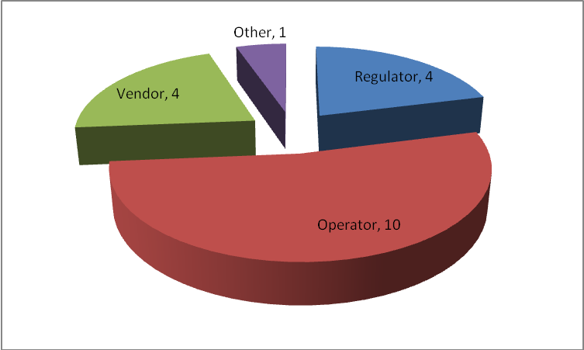

The following lists the names of respondents in each target group:

For Regulators questionnaire, the number of the respondents is 4

1. Socialist Republic of Vietnam (doc. AWG-13/INP-22) - Regulator
2. National Broadcasting and Telecommunications Commission (NBTC) (Thailand) (doc. AWG-13/INP-109) - Regulator
3. Malaysian Communications and Multimedia Commision (MCMC) (doc. AWG-13/INP-118) – Regulator
4. IDA (Singapore) (doc. AWG-13/INP-128) - Regulator

For Operators questionnaire, the number of the respondents is 10

1. eAccess Ltd. (Japan) (doc. AWG-13/INP-39) - Operator
2. KDDI Corporation (Japan) (doc. AWG-13/INP-40) - Operator
3. CMCC (doc. AWG-13/INP-70) – Operator
4. China Telecom (doc. AWG-13/INP-70) – Operator
5. China Unicom (doc. AWG-13/INP-70) – Operator
6. LG Uplus (Korea) (doc. AWG-13/INP-87) – Operator
7. TOT Public Company Limited (TOT) (Thailand) (doc. AWG-13/INP-109) - Operator
8. CAT TELECOM PUBLIC COMPANY LIMITED (Thailand) (doc. AWG-13/INP-109) - Operator
9. Total Access Communication (Thailand) (doc. AWG-13/INP-109) - Operator
10. PT Telekomunikasi Indonesia (doc. AWG-13/INP-127) - Operator

For Vendors questionnaire, the number of respondents is 4

1. LG-Ericsson (Korea) (doc. AWG-13/INP-87) - Vendor
2. Samsung Electronics (Korea) (doc. AWG-13/INP-87) - Vendor
3. LG Electronics (Korea) (doc. AWG-13/INP-87) - Vendor
4. Ericsson (Thailand) ltd. (Thailand) (doc. AWG-13/INP-109) - Vendor

For other institutions questionnaire, the number of respondents is 1

1. CATR (doc. AWG-13/INP-70) – other

# Questionnaire Results

The questionnaire tries to investigate and exploit technical challenges and requirements in terms of network developments and operations, new services and applications, development requirements of mobile terminals, etc. Key impacts on the evolution strategy are also surveyed. The summary answers and observations from the questionnaires are as follows.

1. **General Questions**

In this subsection, information availability among the participants is investigated.

Question 1

Most of the participants are able to easily get the latest information of radio technology and standard progress.

The Regulators normally get the latest information of radio technology and standard progress via participation in the ITU meetings, e.g. ITU-R and ITU-D, and/or publications by various standardization bodies, and/or communication with Telecom Vendors.

The Operators normally get the latest information of radio technology and standard progress via participation in various standardization meetings, international forums, national and international technology workshops, and also from regulators, vendors, internet and published documents.

The Vendors normally get the latest information of radio technology and standard progress via regular participation in international standard organizations.

1. **Mobile Broadband Development**

In this subsection, issues of mobile broadband development are investigated, such as, plans for mobile broadband development, available spectrum for the planned deployment, obstacles that prevent the development, purposes of the deployment, and deployment scenarios and use cases.

Question 2

It is observed that 10 out of 19 respondents have a plan for mobile broadband development while 3 of them do not.

Question 3

Based on the five responses about the total spectrum requirements in the future, the spectrum gap exists among the countries and operators. The spectrum requirements are quite different by 2016; however similar targets are indicated by 2020.

|  |  |  |  |
| --- | --- | --- | --- |
| **Responders** | | **Answers** | **Notes** |
| **Country** | **Organization Name** |  |
| Korea | LG-Ericsson, Korea | Available spectrum  490MHz by 2015  920MHz by 2020 |  |
| Korea | LG-Uplus, Korea | Available spectrum  Now 320MHz  490MHz by 2013  720MHz by 2016  920MHz by 2020 |  |
| Thailand | CAT Thailand | Available spectrum 850MHz by 2015 |  |
| Indonesia | PT Telekomunikasi, Indonesia | 100MHz[1] |  |
| Singapore | IDA, Singapore | Planned for 1GHz of spectrum to be available for mobile/wireless broadband services by 2020 |  |

Question 4

The top 3 major obstacles that prevent mobile broadband service development are spectrum availability, infrastructure cost, and service cost. It can be evidently seen that the scarce spectrum is becoming a bottleneck of mobile broadband development and that the cost is the key issue that slows the pace of mobile network deployment.

In summary, it could be observed that,

* Spectrum availability should be addressed by future IMT technologies.
* Cost, including the infrastructure and service cost, should be reduced by future IMT technologies.

Question 5, 6

The purpose of deploying mobile broadband communication is to satisfy the customer’s increasing demand and improve the quality of people’s life, e.g., to provide economic development and to provide better education and medical services. It indicates that the mobile network deployment would have to consider running a large variety of services on the deployed networks, which in turn implies the requirement of fast support of service deployment.

The responses show that smart phones and tablets are the most expected mobile devices due to their better support of mobility. It indicates that mobile networks should be able to provide a variety of services in a variety of environments, which in turn challenges the provision of QoS guarantees. It is also noted that the embedded sensor devices and embedded vehicle devices receive a lot of attention as well. Inter-connection of these sensor devices would enrich the deployment topologies in mobile broadband development.

In summary, it could be observed that:

* A large variety of services should be efficiently supported by future IMT technologies.
* QoS should be guaranteed in a variety of environments.

Question 7

When mobile internet plays a significant role in developing the global/national social infrastructure, the top 3 issues of concern are *security*, *roaming cost,* and *service inter-operability. Technology inter-operability*, *openness,* and *service neutrality* are also issues of concern for some respondents.



In summary, it could be observed that:

* Security would be a significant issue when mobile internet becomes highly integrated into building future mobile networks.
* Service and technology inter-operability should be supported by future IMT networks.

Question 8

In future mobile broadband networks, *Indoor*, *rural area,* and *city centre* are the most challenging scenario. The detailed demands and challenges are listed below:

* City centre: dense population and huge traffic demand would occur.
* Rural area: large coverage needs to be guaranteed, and a huge number of base stations would lead to high cost of infrastructure.
* Indoor: complicated interference effects need to be handled and cost efficient deployment is desired.

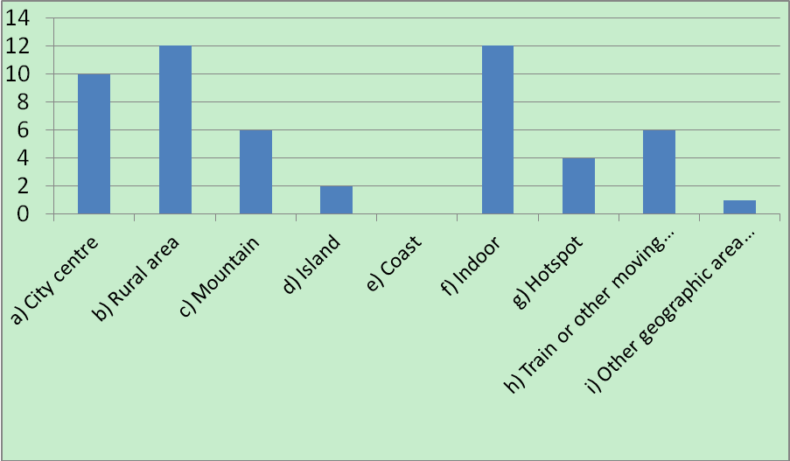

In summary, it could be observed that:

* Capacity are the most challenging thing in city centres, and cost is the challenging issue for the rural areas and indoor environments.

Summary

From the responses in the perspective of developing mobile broadband networks, it is clearly seen that the following issues should be addressed and taken into account as technical requirements and challenges for future IMT networks.

* ***Spectrum availability***: Spectrum would be scarce and various spectrum enabling technologies should be evolved in future IMT networks, e.g., flexible usage of the allocated spectrum, and technologies for new spectrums.
* ***QoS (especially capacity)***: Future IMT technologies should guarantee QoS in a large variety of environment, especially to address rapidly increasing capacity demand in city areas.
* ***Cost***: Infrastructure cost and service cost should be reduced by future IMT techniques. One thing to take into account is an improvement of inter-operability with existing technologies and services.
* ***Security***: Security would be a significant issue when mobile internet becomes highly integrated into building future mobile networks.
* ***Support of new application and services***: A variety of services would run on future IMT networks to improve the quality of people’s life, and therefore a large variety of services should be efficiently supported by future IMT technologies.

1. **Services and Applications**

In this subsection, potential new services and applications are surveyed, which helps clarify the requirement on the support of new applications and services for future IMT technologies.

Question 9-12

The main services & applications in future mobile networks focus on mobile data and traditional voice services. The details and types of those services and applications are shown in the below figure. Moreover social network applications, streaming/video (and music) online/downloading, online gaming, M2M, and web browsing/Internet access services are issues of concern for most of the respondents.

In summary, the main services/applications and their technology demands are:

* + ***Social network applications/SNS,*** whichhave a huge number of online customers and are characterized by small data and data push applications.
  + ***Streaming/video (and music) online/downloading,*** which requirehigh speed/bandwidth and low latency.
  + ***Online gaming,*** which has long-time connection and requires low latency.
  + ***M2M,*** which requires large coverage and has a large number of terminals, very small data, and low mobility and looks for terminal power-saving.

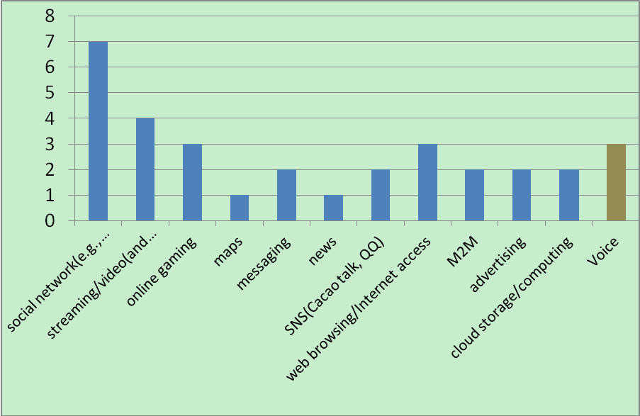

It should be noted that positioning would be a fundamental service in social network applications. Therefore, the positioning service should be provided and improved in future IMT systems.

Question 13-17

Machine-to-machine (M2M) services have already been launched over seven mobile networks, and mainly these M2M services are integrated with existing networks/services.



M2M services launched on mobile networks are working at 800MHz, 900MHz, 1800MHz, and 2100MHz. 2G mobile networks occupy the biggest ratio among the networks based on which M2M services are provided. 3G networks are becoming important infrastructure to bear M2M services.

|  |  |  |  |
| --- | --- | --- | --- |
| **Responders** | | **Answers** | **Notes** |
| **Country** | **Organization Name** |
| Vietnam | Vietnam | 900MHz, 1800MHz, 2100MHz |  |
| Japan | KDDI Japan | 800MHz(UL: 825MHz-830MHz, DL: 870-875MHz)  2100MHz(UL: 1920MHz-1940MHz, 2110MHz-2130MHz) |  |
| China | China | 900MHz | GPRS/EDGE |
| Korea | LG-Ericsson, Korea | 800MHz/1.8GHz  2.1GHz | CDMA  WCDMA |
| Korea | LG Uplus , Korea | 1.8GHz | Korean PCS band |

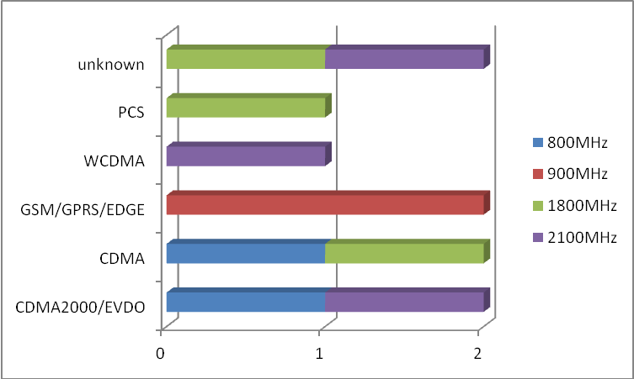

The operators not deploying M2M service have interests in the vehicles, security/safety, healthcare, POS/vending machine, and smart meter service areas. So far, demands for these M2M services’ technology include large coverage, terminal numbers, very small data, low mobility, and terminal power-saving.

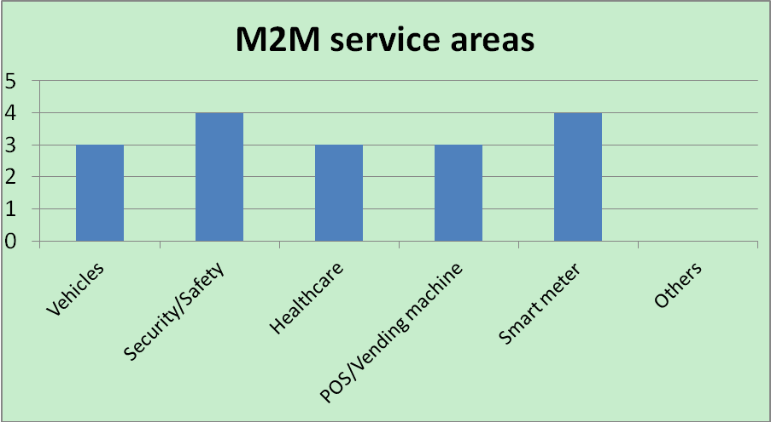

Some operators also think that the most challenging technical issues for the M2M services are cost, security, interoperability, and standardization.

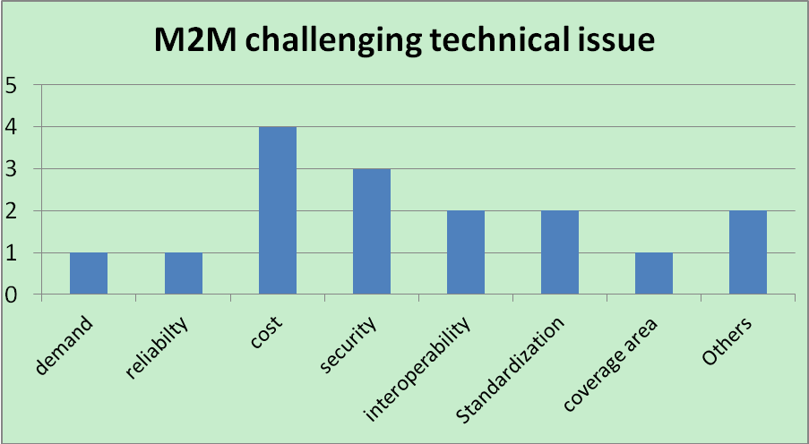

In summary, it could be observed that:

* M2M services have been launched in several areas. The selected operation frequencies for the existing M2M services are 800/900/1800/2100MHz.
* The demand of M2M services are: large coverage, terminal numbers, very small data, low mobility, and terminal power-saving.
* Challenging technical issues of M2M services are cost, security, interoperability, and standardization.

Summary

In this subsection, issues for new services and applications are investigated. From the responses to the questionnaire on services and applications, it is recognized that the following services would be of primary concern for future IMT technologies.

* ***New application and services***:
  + ***Social network applications/SNS,*** whichhave a huge number of online customers and are characterized by small data and data push applications.
  + ***Streaming/video (and music) online/downloading,*** which requirehigh speed/bandwidth and low latency.
  + ***Online gaming,*** which has long-time connection and requires low latency.
  + ***M2M,*** which requires large coverage and has a large number of terminals, very small data, and low mobility and looks for terminal power-saving.

1. **Developments and Operations**

In this subsection, technical challenges and requirements of future IMT technologies are surveyed in terms of mobile network developments and operations.

Question 18

When providing new services and applications, the top 5 challenging technical issues are system capacity (radio access), coverage, latency, peak data rate, and cell edge user throughput.



Question 19-23



Most of the respondents have deployed optical fibre connections widely for mobile network infrastructure. However, the backhaul connection (e.g. lack of optical fibre connection, capacity of wireless link) are still selected by the respondents as the most challenging technical issues when deploying or maintaining mobile networks. This might be because more small cells are expected to be deployed in future networks. In this case, additional backhaul deployment would be needed. The cost and capacity of backhaul would therefore become a constant challenge.

Besides, the power consumption of base stations or other network components also receives attention. This might be because the cost of power consumption occupies a large portion in the cost of network operation. It is also believed that the requirement of green network would be increasingly critical, especially in consideration of widely recognized social responsibility of green network development.

In summary, it is observed that:

* Backhaul connection is challenging in providing mobile broadband networks, in particular, for small-cell deployment.
* The challenge of network power saving or green network development, which receives attention needs to be addressed.

Question 24

In the responses, 2G networks occupy the biggest ratio among existing networks. LTE (FDD) is developing fast and the ratio of LTE networks approaches to that of 3G networks.

One respondent plans to refarm its network from GSM to LTE-FDD around the year 2020. Another respondent plans to maintain its current GSM network in future. Most of the other respondents show no plan for the spectrum currently used by GSM network. However, it could be expected that as more operators migrate to 3G and 4G networks, the spectrum availability problem would raise the refarming issue, and in this case, the compatibility of 3G and 4G networks with the existing GSM networks should be considered.

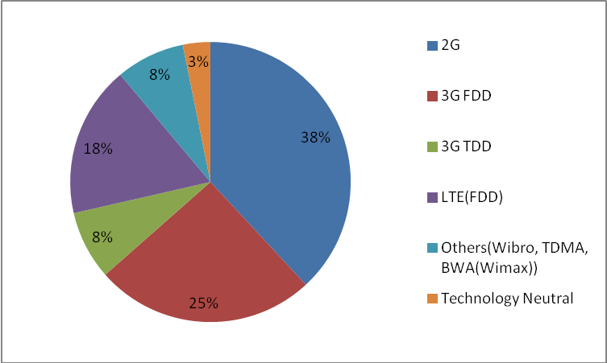

Currently, the bands of 900MHz and 1800MHz are used mainly for 2G networks. LTE (FDD) networks are deployed in the multi-bands of 800MHz, 900MHz, 1500MHz, 1700MHz, 1800MHz, and 2100MHz.

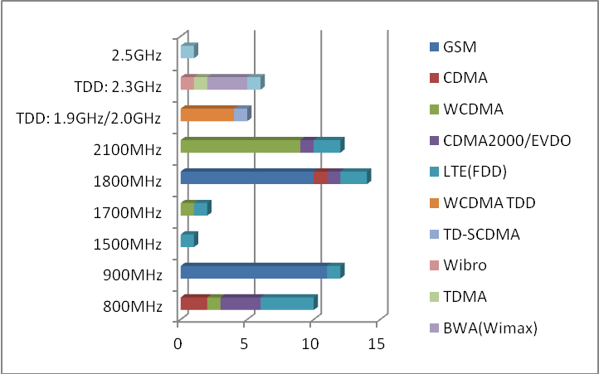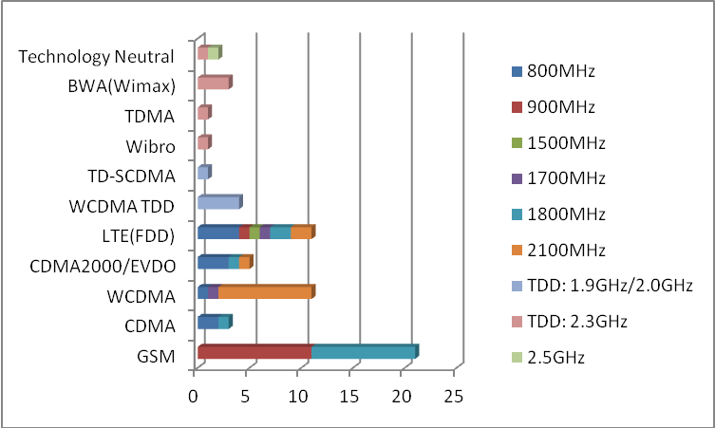

New LTE-FDD and LTE-TDD networks will be built on a large scale at the bands 700MHz, 800MHz, 1800MHz, 2100MHz, 2.3GHz, and 2.5GHz be around the year 2015. It is noted that future new 2100MHz LTE networks come from refarming of CDMA2000 (3G networks).

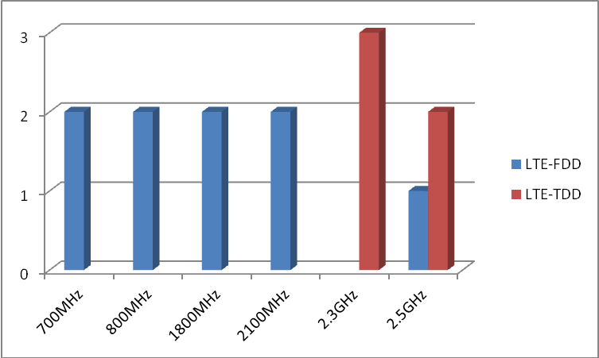

It is also noted that one respondent (operator) shows that it owns both FDD and TDD spectrum when deploying LTE. As their spectrum allocation progresses, it might be that more operators would own both FDD and TDD spectrum. In this case, how to jointly use the FDD and TDD spectrum to maximize the spectrum utilization efficiency could be one of the issues that need to be studied for future IMT networks.

In summary, it is observed that:

* The 2G network is currently the dominant mobile network and would co-exist with 3G and the planned 4G systems in the coming years.
* The inter-operability among multiple technologies and their smooth transition is therefore needed so as to fully utilize the deployed techniques so that the cost could be reduced.
* The issue of refarming 2G networks to 3G and 4G networks would be raised when spectrum availability becomes more serious, and the compatibility of 3G and 4G networks with the existing GSM networks should be considered.
* The joint use of FDD and TDD spectrum could be enabled if the operator owns both of them, to maximize their spectrum availability.

Question 25

[Apparently](http://dict.baidu.com/s?wd=apparently) WiFi is the most commonly used in conjunction with a cellular mobile network. The main purposes of their joint use are data-offloading and coverage/Hotspot.



In summary, it is observed that:

* WiFi would be one of the most commonly used RATs that could be used in cooperation with a cellular network to provide data-offloading in hotspots.
* The inter-working of WiFi and cellular network would therefore be of an interest for future IMT technology providers (developers).

Question 26

Spectrum availability, smooth transition, interference issues, and Quality of Service are the top 4 technical and operational interests among respondents when they are migrating to new cellular technologies (e.g., HSPA, LTE, etc.).



In summary, it is observed that

* Spectrum availability is top consideration in migrating to new technologies.
* Smooth transition is a target to be achieved in addressing interference issues with other systems in the adjacent bands providing guaranteed QoS to meet continuously increasing demands.

Question 27-28

Most of the respondents think that small cell (femtocell/picocell) deployment becomes more important for higher capacity. The aspect of interference is the most challenging technical issue for small cell deployment.





In summary, it is observed that:

* Deployment of small cells would be important to address capacity requirements, where the aspect of interference would be a challenging issue.

Summary

In this subsection, significant issues in mobile development and operation are surveyed in a more detailed manner, which helps to gain deeper insight on the items raised in subsection B. It is observed that the capacity and coverage are the issues of utmost concern in deployment of mobile networks. Small cell deployment is seen as an important way to address capacity requirements. But how to avoid interferences needs to be addressed in future small cell deployment. When considering network deployment, providing backhaul is most challenging. According to some responses, network power savings have been recognized as another challenge that needs to be addressed. Social responsibility of building green networks would also be widely recognized as a challenge.

On the other hand, it is observed that the 2G/3G systems are dominant among existing mobile networks, and they would co-exist with the planned 4G systems during their evolution. Hence the migration to new technologies (4G) and the co-existence of existing 2G/3G systems with the planned 4G systems would be important issues for mobile network operation. To meet capacity requirements, the above-mentioned migration is needed while spectrum availability would be a concern. To achieve the required capacity with affordable cost, existing technologies need to be fully utilized, which in turn requires improvement of inter-operability and smooth transition. RLAN/WiFi is recognized as the primarily complementary RAT that could be used in cooperation with cellular systems to offload the traffic, and hence RLAN/WiFi-cellular interworking should be studied.

Specifically, the following issues are highlighted.

* ***Spectrum availability***: It is the primary concern for those migrating to new technologies. In this case, the issue of refarming of networks from 2G to 3G and 4G would be raised, and the compatibility of 3G and 4G networks with existing GSM networks should be considered. And the joint use of FDD and TDD spectrum could be studied to maximize spectrum availability when more operators own both of them.
* ***Capacity***: It is again emphasized that the system capacity is a primary concern. Deployment of small cells would be important to address this issue. Interference aspects should be addressed in small cell deployment. Backhaul issue would be also challenging and needs to be addressed.
* ***Cost***: In the case of co-existing of 2G/3G/4G and RLAN/WiFi systems, cost could be reduced if inter-operability with existing technologies is improved and inter-working among RLAN/WiFi and cellular systems is enhanced, so that the existing technologies could be fully utilized.
* ***Power saving***: Network power saving is recognized as a challenge in deploying mobile networks, and the building of green networks needs to be addressed in future IMT technology in consideration of social responsibility of green network development to be widely recognized..

1. **Mobile Terminal**

Terminal availability would be an important consideration to develop mobile broadband networks. In this subsection, requirements on developing mobile terminals are reviewed.

Question 29

The respondents show that terminal certification is necessary, and nearly half of them think that global certification specification is required for conformance of radio equipment.



Question 30

The technical requirements or challenging issues on mobile terminals in current mobile network are *Low power consumption and long battery life*, *Support of multiple frequency bands* and *Support of multiple radio access technologies*.



Summary

In this subsection, the issues related to mobile terminals are investigated. It is observed that the following issues are primary concerns.

* ***Terminal issues***
* Global certification specification is required for conformance of radio equipment.
* The technical requirements on mobile terminals are *Low power consumption and long battery life*, *Support of multiple frequency bands* and *Support of multiple radio access technologies*.

1. **Evolution Strategy**

This subsection tries to gain some insights into the key factors that impact on an evolution strategy. The survey includes the major technical and non-technical obstacles in migrating to new cellular technologies, primary factors that decide the progress of migration, and spectrum planning during the migration.

Question 31

Almost all respondents think that new study in AWG on the “GUIDELINE ON IMT NETWORKEVOLUTION STRATEGY” is valuable.



Question 32

Spectrum uncertainty is thought as the main technical obstacle to migration plans to new cellular technologies

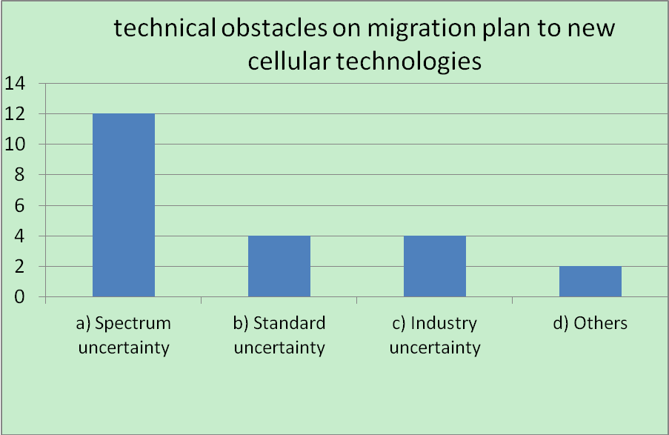

Question 33

Traffic volume, service/application and technology/industry progress are considered as the most influential mobile network factors for operators in deciding if mobile networks should be evolved or not



Question 34

Technology references and existing evolution examples are the types of information helpful to consider and decide mobile network evolution.



Question 35

Shortage of spectrum becomes the most significant technical obstacle preventing mobile network evolution. The second significant obstacle is the difficulty of spectrum relocation, i.e. expiration of existing licenses and limited IMT spectrum availability due to the occupancy by other services. One response also shows concern about the issue of co-existence with existing services. The issues on how to obtain more spectrums and how to balance existing licenses need more consideration or guideline for mobile network evolution.

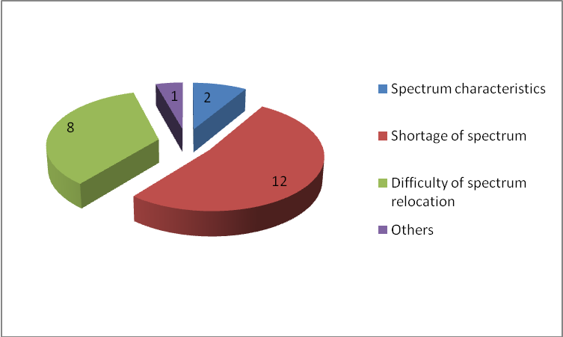

Question 36

The responses show that at least two principles determine operators’ spectrum planning. Spectrum global harmonization is very beneficial for operators’ spectrum planning. Cost is also considered, e.g. Low CAPEX and OPEX, to make deployment easier.

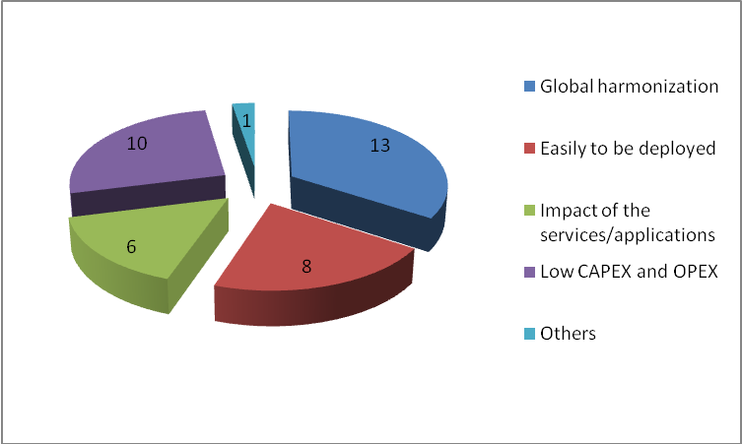

Question 37

Maturity of commercial networks and terminal availability are the main factors for industry progress that influence operators’ decision on spectrum management and network deployment



Summary

In this subsection, issues of concern in evolution strategy are investigated. It is observed that there are three major issues that impact on evolution strategy.

* ***Spectrum:*** As far as spectrum is concerned, spectrum uncertainty and the shortage of spectrum are the major obstacles. Difficulty on spectrum relocation is noted. How to deploy more spectrums and how to balance existing licenses need to be addressed in network evolution. Spectrum global harmonization is preferred.
* ***Service and industry progress:*** This is another issue when operators decide when to evolve their mobile networks. When the traffic volume increases, and/or the maturity of new services increases, and/or the number of networks and terminal availability increase, operators would consider migrating to and deploying new mobile networks.
* ***Cost:*** Low CAPEX and OPEX, as well as easy deployment are expected during network evolution.

1. **Others**

Question 38

Generally, one of the roles of the Task Groups of IMT in APT Wireless Group (TG-IMT) is to support APT country members by providing information about IMT activities and assisting them in harmonizing APT considerations toward the work related on IMT technologies. In this context, global harmonization in terms of standardization and spectrum allocation is an important working direction. One potential detailed work is to provide the information on evolving IMT technology that APT members should consider in planning their spectrum allocation in the future as well as the information on global technology deployment expected with a view to harmonizing IMT implementation within the region.

Also some specific study areas were proposed, e.g. to conduct studies on co-existence of different technologies deployed in common border areas during the evolution/migration phase. For example, when some countries proceed to roll out LTE in the 1800MHz band, co-existence with GSM in the common border areas may cause significant impact on the quality of services and/or disrupt services during the evaluation period (as different countries may roll out new networks in a different timeframe). Another example is to study how to ensure LTE to be deployed in the 2.5GHz band and to co-exist with adjacent S-band radars.

# RESPONSES TO QUESTIONNAIRES

Note: the responses are organized based on the input organization and classified in colour, operator in red, vendor in green, regulator in purple, and other in red.

1. **General Questions**
2. Do you easily get the latest information of radio technology and standard progress?

|  |  |  |  |  |
| --- | --- | --- | --- | --- |
| **Responders** | | **Answers** | | **Notes** |
| **Country** | **Organization Name** | **a)** | **b)** |
| **No.** | **Yes, in which channel?** |
| China | CMCC |  | X | From the communication with Vendor and the standard meeting |
| CT |  | X | Meeting attendance and following |
| CU |  | X | ITU-R; APG; AWG; CCSA |
| CATR | X |  |  |
| Indonesia | PT Telekom |  | X | International forums e.g. CDG, WIMAX Forum, APT, ITU-T. |
| Japan | eAccess, |  | X | We send delegates to ARIB and 3GPP meetings. |
| KDDI |  | X | 3GPP, 3GPP2, AWG, ITU-R, WiMAX-Forum |
| Korea | LG-Ericsson |  | X | International Standardization Organization (3GPP / ITU-R ... etc) |
| Samsung |  | X |  |
| LG |  | X | By participating in standard meeting regularly |
| LG Uplus |  | X | By participating in national and international technology workshop |
| Malaysia | MCMC |  | X | ITU-R and ITU-D |
| Singapore | IDA |  | X | Publications by various standardisation bodies |
| Thailand | NBTC | X |  |  |
| TOT |  | X | Through web searching |
| CAT |  | X | Regulator, Vendor, Internet, Published Documents |
| DTAC | X |  |  |
| Ericsson(th) |  | X | Internal Ericsson |
| Vietnam | ARFM |  | X | ITU meeting, Telecom Vendor |

1. **Mobile Broadband Development**
2. Do you have a mobile broadband deployment plan of your country?

|  |  |  |  |  |
| --- | --- | --- | --- | --- |
| **Responders** | | **Answers** | | **Notes** |
| **Country** | **Organization Name** | **a)** | **b)** |
| **Yes.** | **No.** |
| China | CMCC |  | X |  |
| CT |  | X |  |
| CU | X |  |  |
| CATR |  | X |  |
| Indonesia | PT Telekom | X |  |  |
| Japan | eAccess, |  |  | No responses |
| KDDI |  |  | No responses |
| Korea | LG-Ericsson, | X |  |  |
| Samsung |  |  | No responses |
| LG |  |  | No responses |
| LG Uplus | X |  |  |
| Malaysia | MCMC | X |  |  |
| Singapore | IDA | X |  |  |
| Thailand | NBTC | X |  |  |
| TOT | X |  |  |
| CAT | X |  |  |
| DTAC |  |  | No responses |
| Ericsson(th) |  |  | No responses |
| Vietnam | ARFM | X |  |  |

1. If the answer to Q2 is Yes, what kind of mobile broadband deployment plans do you have?

|  |  |  |  |  |  |  |  |
| --- | --- | --- | --- | --- | --- | --- | --- |
| **Responders** | | **Answers** | | | | | **Notes** |
| **Country** | **Organization Name** | **a)** | **b)** | **c)** | **d)** | **e)** |  |
| **Area coverage by 2015 and by 2020?** | **Population coverage by 2015 and by 2020?** | **Available spectrum by 2015 and by 2020?** | **Number of forecasted mobile broadband users by 2015 and by 2020?** | **Other** |
| China | CMCC | N/A | N/A | N/A | N/A | N/A | No response |
| CT | N/A | N/A | N/A | N/A | N/A | No response |
| CU |  |  |  |  | To be confirmed |  |
| CATR | N/A | N/A | N/A | N/A | N/A | No response |
| Indonesia | PT Telekom | National coverage | More than 40% | 100MHz | More than 80 millions | N/A |  |
| Japan | eAccess, | N/A | N/A | N/A | N/A | N/A | No responses |
| KDDI | N/A | N/A | N/A | N/A | N/A | No responses |
| Korea | LG-Ericsson, | Aleady nation-wide LTE network deployed by 3 Korean Operators | Aleady nation-wide LTE network deployed by 3 Korean Operators | 490MHz by 2015 and 920MHz by 2020 for mobile communication on the plan | N/A | N/A |  |
| Samsung | N/A | N/A | N/A | N/A | N/A | No responses |
| LG | N/A | N/A | N/A | N/A | N/A | No responses |
| LG Uplus | N/A | N/A | *Note 1* | N/A | N/A | *Note 1* |
| Malaysia | MCMC | N/A | Detail Business Plan (DBP) – mobile broadband roll out plan for 5 years | N/A | N/A | N/A |  |
| Singapore | IDA | E.g., Proposed island-wide coverage within a specified period of time after the 4G spectrum rights are issued | N/A | Planned for 1GHz of spectrum to be available for mobile/wireless broadband services by 2020 | N/A | N/A |  |
| Thailand | NBTC | N/A | 85% of population by 2015. | N/A | *Note 2* | 2.1 GHz band within 2012 *Note 2* | *Note 2* |
| TOT | N/A | 80% by 2015 and 95% by 2020 | N/A | N/A | N/A |  |
| CAT | 69 % by 2015 | 90 % by 2015 | 850 MHz by 2015 | 16 million by 2015 | N/A |  |
| DTAC | N/A | N/A | N/A | N/A | N/A | No responses |
| Ericsson(th) | N/A | N/A | N/A | N/A | N/A | No responses |
| Vietnam | ARFM | All communes by 2015 and all hamlets by 2020 | 85% of population, 95% of population | N/A | N/A | N/A |  |
| *Note 1*: The Korea Communications Commission (KCC) plans to implement the Mobile Gwanggaeto the Great Plan for the creation of the world's most spacious mobile broadband network. On top of the existing mobile 320MHZ band, the KCC plan to allocate an additional 600MHZ of bandwidth by 2020.   |  |  |  |  | | --- | --- | --- | --- | |  | Short Term(~2013) | Mid Term(2014~2016) | Long Term(2017~2020) | | Frequency Band  (Bandwidth) | 700㎒ Band(40㎒)  2.1㎓ Band(60㎒)  1.8㎓ Band(70㎒) | 2.6㎓ Band(30㎒)  2㎓ Band(40㎒)  3.5㎓ Band(160㎒) | Additional Frequency Band  (200㎒) | | Total BW | 170 MHz | 230 MHz | 200 MHz |   *Note 2*:  Thailand NBTC response as below:   * 1. Area coverage by 2015 and by 2020? N/A   2. Population coverage by 2015 and by 2020? 85% of population by 2015.   3. Available spectrum by 2015 and by 2020? N/A   4. Number of forecasted mobile broadband users by 2015 and by 2020?   The forecasts which National Telecommunications Commission have been working on foresee significant growth, in particular in data traffic:   * 1. Other   Thailand has plan to grant the license to use IMT spectrum in 2.1 GHz band within this year (2012). From draft regulation, the roll out of service using 2.1 GHz frequency band must cover 50% and 80% of population within 2 and 4 years respectively. Moreover, the service must be provided in every province throughout the country. | | | | | | | |

1. If the answer to Q2 is No, what are the most significant obstacles preventing mobile broadband service development in your country? Please raise top three items.

|  |  |  |  |  |  |  |  |  |  |  |  |
| --- | --- | --- | --- | --- | --- | --- | --- | --- | --- | --- | --- |
| **Responders** | | **Answers** | | | | | | | | | **Notes** |
| **Country** | **Organization Name** | **a)** | **b)** | **c)** | **d)** | **e)** | **f)** | **g)** | **h)** | **i)** |  |
| **infrastructure cost** | **service cost** | **device cost** | **maturity of local technology management** | **spectrum availability** | **spectrum relocation** | **shortage of subscribers** | **shortage of local content** | **Other s** |
| China | CMCC | X | X |  |  | X |  |  |  |  |  |
| CT | X |  |  |  | X |  |  | X |  |  |
| CU |  |  |  |  |  |  |  |  |  | No response |
| CATR | X | X |  |  | X |  |  |  |  |  |
| Indonesia | PT Telekom |  |  |  |  |  |  |  |  |  | No response |
| Japan | eAccess, |  |  |  |  |  |  |  |  |  | No response |
| KDDI |  |  |  |  |  |  |  |  |  | No response |
| Korea | LG-Ericsson, |  |  |  |  |  |  |  |  |  | No response |
| Samsung |  |  |  |  |  |  |  |  |  | No response |
| LG |  |  |  |  |  |  |  |  |  | No response |
| LG Uplus |  |  |  |  |  |  |  |  |  | No response |
| Malaysia | MCMC |  |  |  |  |  |  |  |  |  | No response |
| Singapore | IDA |  |  |  |  |  |  |  |  |  | No response |
| Thailand | NBTC |  |  |  |  |  |  |  |  |  | No response |
| TOT |  |  |  |  |  |  |  |  |  | No response |
| CAT |  |  |  |  |  |  |  |  |  | No response |
| DTAC |  |  |  |  |  |  |  |  |  | No response |
| Ericsson(th) |  |  | X |  | X | X |  |  |  |  |
| Vietnam | ARFM |  |  |  |  |  |  |  |  |  | No response |

1. What do you expect by deploying mobile broadband communication?

|  |  |  |  |  |  |  |  |  |  |
| --- | --- | --- | --- | --- | --- | --- | --- | --- | --- |
| **Responders** | | **Answers** | | | | | | | **Notes** |
| **Country** | **Organization**  **Name** | **a)** | **b)** | **c)** | **d)** | **e)** | **f)** | **g)** |  |
| **better education service** | **better medical services** | **job creation** | **emergency infrastructure development** | **benefits to ecnonomy development** | **increase of customer satisfaction** | **Others** |
| China | CMCC | X | X |  | X | X | X |  |  |
| CT | X | X | X | X | X | X |  |  |
| CU |  |  |  |  | X | X |  |  |
| CATR | X | X | X |  | X | X |  |  |
| Indonesia | PT Telekom | X | X | X | X | X | X |  |  |
| Japan | eAccess, |  |  |  |  |  |  |  | No response |
| KDDI |  |  |  |  |  |  |  | No response |
| Korea | LG-Ericsson |  |  | X |  | X | X |  |  |
| Samsung |  |  |  |  |  |  |  | No response |
| LG |  |  |  |  |  |  |  | No response |
| LG Uplus |  |  |  |  |  | X |  |  |
| Malaysia | MCMC |  |  | X |  | X | X | X | g): increase broadband coverage and penetration rate |
| Singapore | IDA |  |  |  |  | X | X | X | g): Innovation of services |
| Thailand | NBTC | X | X | X |  | X | X |  |  |
| TOT | X | X | X |  | X |  |  |  |
| CAT | X | X | X | X | X | X |  |  |
| DTAC | X | X |  | X | X | X |  |  |
| Ericsson(th) | X |  | X |  | X |  |  |  |
| Vietnam | ARFM | X |  |  | X | X | X |  |  |

1. What kind of mobile/wireless devices are you expecting to see more in the next 5 years? Please select top three devices.

|  |  |  |  |  |  |  |  |  |  |  |  |
| --- | --- | --- | --- | --- | --- | --- | --- | --- | --- | --- | --- |
| **Responders** | | **Answers** | | | | | | | | | **Notes** |
| **Country** | **Organization Name** | **a)** | **b)** | **c)** | **d)** | **e)** | **f)** | **g)** | **h)** |  | |
| **feature phones** | **smart phones** | **tablets** | **notebook PCs** | **netbook PCs** | **embedded sensor devices** | **embedded devices in vehicles** | **Others** |
| China | CMCC |  | X | X | X |  |  | X |  |  | |
| CT |  | X |  |  |  | X | X |  |  | |
| CU |  | X | X |  | X |  |  |  |  | |
| CATR |  | X | X |  |  | X |  |  |  | |
| Indonesia | PT Telekom |  | X | X |  |  |  |  | X | h): Wireless routers | |
| Japan | eAccess, |  | X | X | X |  | X | X |  |  | |
| KDDI |  | X | X |  |  |  |  | X | h): embedded devices in all kinds of machine, like vehicles, smart meter and so on | |
| Korea | LG-Ericsson |  | X | X |  |  | X |  |  |  | |
| Samsung |  |  |  |  |  |  |  |  | No response | |
| LG |  |  |  |  |  |  |  |  | No response | |
| LG Uplus |  | X | X |  |  |  | X |  |  | |
| Malaysia | MCMC | X | X | X |  |  |  |  |  |  | |
| Singapore | IDA |  | X | X |  |  |  |  | X | h): M2M devices | |
| Thailand | NBTC |  | X | X |  |  |  | X |  |  | |
| TOT |  | X | X | X |  | X | X |  |  | |
| CAT |  | X | X | X |  |  |  |  |  | |
| DTAC |  | X | X |  |  | X | X |  |  | |
| Ericsson(th) |  | X | X | X |  |  | X |  |  | |
| Vietnam | ARFM |  | X | X |  |  |  |  |  |  | |

1. When mobile internet takes a part of the significant role for developing the global/national social infrastructure, what would be your concerns?

|  |  |  |  |  |  |  |  |  |  |  |  |
| --- | --- | --- | --- | --- | --- | --- | --- | --- | --- | --- | --- |
| **Responders** | | **Answers** | | | | | | | | | **Notes** |
| **Country** | **Organization Name** | **a)** | **b)** | **c)** | **d)** | **e)** | **f)** | **g)** | **h)** |  | |
| **openness** | **security** | **service neutrality** | **service inter-operability** | **technology neutrality** | **technology inter-operability** | **roaming cost** | **Others** |
| China | CMCC | X | X | X |  |  | X |  |  |  | |
| CT | X | X | X | X | X | X | X |  |  | |
| CU | X | X |  | X |  |  | X |  |  | |
| CATR |  | X |  | X |  |  | X |  |  | |
| Indonesia | PT Telekom |  | X |  |  |  | X |  | X | h): Pricing | |
| Japan | eAccess, |  | X |  |  |  |  | X |  |  | |
| KDDI | X | X | X | X | X | X | X |  | h): above all | |
| Korea | LG-Ericsson |  | X | X |  |  | X |  |  |  | |
| Samsung |  |  |  |  |  |  |  |  | No response | |
| LG |  |  |  |  |  |  |  |  | No response | |
| LG Uplus |  |  |  |  |  |  |  |  | No response | |
| Malaysia | MCMC |  | X |  |  |  |  | X |  |  | |
| Singapore | IDA |  | X |  | X |  |  | X |  |  | |
| Thailand | NBTC | X | X |  | X |  |  |  |  |  | |
| TOT |  | X | X | X |  | X | X |  |  | |
| CAT |  | X |  |  | X |  |  |  |  | |
| DTAC |  |  |  | X |  |  |  |  |  | |
| Ericsson(th) |  |  |  | X |  | X | X |  |  | |
| Vietnam | ARFM |  | X |  |  |  |  | X |  |  | |

1. Which geographic area or usage scenario is technically most challenging for you when developing mobile broadband? Please select at most three areas and provide detail description of the challenge.

|  |  |  |  |  |  |  |  |  |  |  |  |
| --- | --- | --- | --- | --- | --- | --- | --- | --- | --- | --- | --- |
| **Responders** | | **Answers** | | | | | | | | | **Notes** |
| **Country** | **Organization Name** | **a)** | **b)** | **c)** | **d)** | **e)** | **f)** | **g)** | **h)** | **i)** |  |
| **City centre** | **Rural area** | **Mountain** | **Island** | **Coast** | **Indoor** | **Hotspot** | **Train or other moving vehicles** | **Other geographic area or usage scenario** |
| China | CMCC | X | X |  |  |  | X |  |  |  | a): Dense population and very huge demand on network throughput; b): High cost of infrastructure; f): complicate interference environment and user's concern on the radiation. |
| CT | X |  |  |  |  | X |  |  |  | a): dense population; f): N/A. |
| CU |  | X | X |  |  | X | X | X |  | b): cost; c): bad radio transmission; f): Signal transmission loss by walls; g): very large number of users; h): large number of handoffs. |
| CATR | X | X |  |  |  | X |  |  |  | a): Dense population; b): Requirement of large coverage and a few people; f): Very large number of users. |
| Indonesia | PT Telekom |  | X |  | X |  |  |  | X |  | b): Requires very large coverage and huge number of BTS; d): Requires high speed backhaul; h): Large number of handoffs at same time. |
| Japan | eAccess, | X |  | X |  |  | X |  |  |  | a): large number of users and very large traffic; c): high cost due to bad radio transmission; f): very high cost for deployment and operation |
| KDDI | X | X |  |  |  |  | X |  |  | a): dense population , very large number of users …; b): high capacity backhaul …; g): dense population, very large number of users … |
| Korea | LG-Ericsson, | X |  |  |  |  | X |  | X |  | a): Interferences under hierarchical cell structure for HetNet; f): Outdoor to Indoor HO, Access control policy to indoor cell, Security, etc; h): Coverage, Large number of HO at the same time |
| Samsung |  |  |  |  |  |  |  |  |  | No response |
| LG |  |  |  |  |  |  |  |  |  | No response |
| LG Uplus | X |  |  |  |  | X |  | X |  | a): How to mitigate interferences between the macrocell and the small cell is the most challenging issue since it is indispensible to deploy large amount of small cells in this area to cope with the explosive growth of traffic demands of the future cost-effectively; f): How to deploy indoor mobile broadband network cost-effectively?; h): How to achieve the high capacity wireless backhaul for mobile hotspot in case of the train? |
| Malaysia | MCMC | X | X |  |  |  |  |  |  |  | a): signal interference due to multiple spectrum usage in a dense area; b): backhaul availability and capacity |
| Singapore | IDA |  |  |  |  |  | X |  | X | X | f): High rise building; h): Transmission backhaul infrastructure restriction at the train track and large number of handoffs at the same time; i): Tunnels (road and train) |
| Thailand | NBTC |  | X | X |  |  |  | X |  |  | b): It needs large coverage for rural area; c): It needs large coverage for Mountain; g): There might be a very large number of user. Congestion will occur. |
| TOT | X | X |  |  |  | X | X | X |  | a): quality and Capacity vs. Number of users; b): number of connected people; f): Right of way and landlord or properties' owner; g):N/A; h): Quality of Experience while the train is in motion. |
| CAT |  | X | X | X |  |  |  |  |  | CAT: b): large coverage / backhaul; c): backhaul / power supply / terrain; d): backhaul / power supply. |
| DTAC |  | X | X |  |  | X |  |  |  | DTAC: b): Cost effective solution to extend the coverage; c): Site location; f): Both coverage and capacity constraint. Need indoor specific solutions which are cost effective. |
| Ericsson(th) | X | X |  |  |  | X |  |  |  | Ericsson(th): a): Spectrum availability to serve very large number of users; b): Business case for rural coverage; f): site sharing. |
| Vietnam | ARFM |  | X | X |  |  | X |  |  |  | b): large area with low population density, poor inhabitants; c): remote area with very low population density, very poor inhabitants; f): poor coverage indoor |

1. **Services and Applications**
2. What are the new services or applications that have gained popularity among large number of users in your mobile network in past few years? If necessary, please provide detail description.

|  |  |  |  |
| --- | --- | --- | --- |
| **Responders** | | **Answers** | **Notes** |
| **Country** | **Organization Name** |  |
| China | CMCC | Weibo, video and audio download, application from mobile market platform |  |
| CT | N/A | No response |
| CU | N/A | No response |
| CATR | Weibo (APP) on the smartphones |  |
| Indonesia | PT Telekom | Video user-generated content, messaging, social network application |  |
| Japan | eAccess | Recently, Smartphone-based messaging applications are getting popular, which traffic is not too large but the number of signalling events on the radio network and on the core network is very large. |  |
| KDDI | The number of smartphone has been growing very rapidly for the last few years. The smartphone users use any internet application, like streaming, games, news, maps, social networking, music and so on, on their mobile devices in the same manner as they do in fixed connection. Those applications have gained popularity in our mobile network. |  |
| Korea | LG-Ericsson | Free chatting service on mobile communication (ex: Cacao talk), Facebook, Twitter, Mobile game … etc |  |
| Samsung | N/A | No response |
| LG | N/A | No response |
| LG Uplus | Mobile SNS, VoD, and Game |  |
| Malaysia | MCMC | Social networking applications such as Facebook, Twitter, YouTube, etc. |  |
| Singapore | IDA | TBD |  |
| Thailand | NBTC | N/A | No response |
| TOT | Mobile broadband services and Mobile Internet access. |  |
| CAT | N/A | No response |
| DTAC | Mobile data |  |
| Ericsson(th) | Face book application, Youtube application and Web browsing |  |
| Vietnam | ARFM | Mobile internet |  |

1. What are the services or applications that generate large amount of mobile data traffic in your mobile network?

|  |  |  |  |
| --- | --- | --- | --- |
| **Responders** | | **Answers** | **Notes** |
| **Country** | **Organization Name** |  |
| China | CMCC | Weibo, video and audio download |  |
| CT | N/A | No response |
| CU | N/A | No response |
| CATR | Some instant communication software, such as QQ |  |
| Indonesia | PT Telekom | Social network application, video user-generated content |  |
| Japan | eAccess | Video streaming consist a large portion of the traffic similar to the fixed broadband network. |  |
| KDDI | The smartphone users generates a large amount of mobile data traffic. The percentage of the number of smartphone user is only 20% in the whole KDDI subscribers, however the traffic genarated by smartphone occupies 80% of the whole traffic in our mobile network. The services and applications used by smartphone are streaming, game, news ,maps. social networking, music and so on as described in answer to Question 9. |  |
| Korea | LG-Ericsson | Multi-media streaming & downloading service, Mobile advertisement |  |
| Samsung | N/A | No response |
| LG | N/A | No response |
| LG Uplus | VoD and Web services |  |
| Malaysia | MCMC | Video streaming and downloading |  |
| Singapore | IDA | Mobile data services such as downloading/streaming big media files. |  |
| Thailand | NBTC | N/A | No response |
| TOT | Social Networking and online games. |  |
| CAT | Internet, Social Apps |  |
| DTAC | video, social network |  |
| Ericsson(th) | Youtube application, VDO communications |  |
| Vietnam | ARFM | Mobile internet |  |

1. What would be the basic services & applications in the future in your mobile network?

|  |  |  |  |
| --- | --- | --- | --- |
| **Responders** | | **Answers** | **Notes** |
| **Country** | **Organization Name** |  |
| China | CMCC | Internet access |  |
| CT | N/A | No response |
| CU | N/A | No response |
| CATR | Instant communication software, browser, voice calls |  |
| Indonesia | PT Telekom | Internet connectivity, mobile internet TV |  |
| Japan | eAccess | email, messaging, web browsing and map related applications. |  |
| KDDI | Any internet application, like streaming, games, news, maps, social networking, music and so on, would be the basic services and application. In addition, the potential service, like M2M communication services and allocation, e-health, e-education and other e-government could be the basic services and applications as well. |  |
| Korea | LG-Ericsson | U-health, VoIP, M2M, N-screen service, Mobile office, Mobile game … etc |  |
| Samsung | N/A | No response |
| LG | N/A | No response |
| LG Uplus | VoLTE, VoD and Web services |  |
| Malaysia | MCMC | N/A | No response |
| Singapore | IDA | Future Services   * Cloud Services * Intelligent transport service * Virtual assistance with natural language * Web 3.0 (Intelligent web)   Basic Services (Existing)   * Internet Gaming * TV/Movie/Music download/streaming * Social Networking * Mobile payment * Mobile VoIP * E-Mailing |  |
| Thailand | NBTC | N/A | No response |
| TOT | Voice and data are still basic services. Managed services are playing a major role in the future as well. |  |
| CAT | Voice, Internet |  |
| DTAC | Mobile data |  |
| Ericsson(th) | Web browsing, VDO communications |  |
| Vietnam | ARFM | Mobile entertainment (music, movie streaming), Cloud computing |  |

1. What would be the expected profitable services and applications in the future in your mobile network?

|  |  |  |  |
| --- | --- | --- | --- |
| **Responders** | | **Answers** | **Notes** |
| **Country** | **Organization Name** |  |
| China | CMCC | N/A | No response |
| CT | N/A | No response |
| CU | N/A | No response |
| CATR | Cloud storage |  |
| Indonesia | PT Telekom | Internet, social network, chatting, advertising |  |
| Japan | eAccess | There may not be chances for operators to charge for services and applications. |  |
| KDDI | The same answer to Question11. |  |
| Korea | LG-Ericsson | Mobile advertisement, Multi-media streaming, N-screen service, Mobile game, M2M |  |
| Samsung | N/A | No response |
| LG | N/A | No response |
| LG Uplus | VoLTE, M2M |  |
| Malaysia | MCMC | N/A | No response |
| Singapore | IDA | TBD |  |
| Thailand | NBTC | N/A | No response |
|  | TOT | Data, Mobile Internet, and online gaming |  |
|  | CAT | Voice, Internet |  |
|  | DTAC | Voice and Data services |  |
|  | Ericsson(th) | Internet access, M2M applications |  |
| Vietnam | ARFM | Mobile entertainment (music, movie streaming), Cloud computing |  |

1. Have you already launched machine-to-machine (M2M) services over your mobile network?

|  |  |  |  |  |
| --- | --- | --- | --- | --- |
| **Responders** | | **Answers** | | **Notes** |
| **Country** | **Organization Name** | **a)** | **b)** |
| **Yes.** | **No.** |
| China | CMCC | X |  |  |
| CT | X |  |  |
| CU | X |  |  |
| CATR |  | X |  |
| Indonesia | PT Telekom |  | X |  |
| Japan | eAccess |  | X |  |
| KDDI | X |  |  |
| Korea | LG-Ericsson | X |  |  |
| Samsung |  |  | No response |
| LG |  |  | No response |
| LG Uplus | X |  |  |
| Malaysia | MCMC |  |  | No response |
| Singapore | IDA | X |  |  |
| Thailand | NBTC |  |  | No response |
| TOT |  | X |  |
| CAT |  | X |  |
| DTAC |  | X |  |
| Ericsson(th) |  |  | No response |
| Vietnam | ARFM | X |  |  |

1. If the answer to Q13 is Yes, please provide the detailed information on your M2M services.

|  |  |  |  |  |  |  |  |  |  |
| --- | --- | --- | --- | --- | --- | --- | --- | --- | --- |
| **Responders** | | **Answers** | | | | | | | **Notes** |
| **Country** | **Organization Name** | **a)** | **b)** | **c)** | **d)** | **e)** | **f)** | **g)** |  |
| **What kind of service:** | **Specific issue on network operation:** | **Frequency bands:** | **Service area, Coverage area:** | **Relationship to existing mobile network/service (integration and/or separation to existing service/network, etc) :** | **Terminal devices:** | **Other information:** |
| China | CMCC | fleet management, smart meter | high overhead caused by large amount | ordinary mobile comm band | Some Cities | integrated with existing network | independent terminal | N/A |  |
| CT | telemeter | N/A | N/A | city | N/A | module | N/A |  |
| CU | N/A | N/A | 1.9GHz; 2.1GHz | N/A | N/A | N/A | N/A |  |
| CATR | N/A | N/A | N/A | N/A | N/A | N/A | N/A | No response |
| Indonesia | PT Telekom | N/A | N/A | N/A | N/A | N/A | N/A | N/A | No response |
| Japan | eAccess | N/A | N/A | N/A | N/A | N/A | N/A | N/A | No response |
| KDDI | KDDI MRMS | Expanding roaming Partner network | *Note 1* | 1x/EV-DO: 99.9% of population | integrated network | 3G(1x/EV-DO) data Module with GPS, OTA etc | N/A | *Note 1:* KDDI’s detailed response |
| Korea | LG-Ericsson, | Telematics, Remote metering, Wireless security, Wireless POS | None | 800Mhz/1.8Ghz CDMA, 2.1Ghz WCDMA | Nation-wide | Integration with existing service/network | Telematics terminal, Remote metering devices, Wireless security device(CCTV, Sensor relaying G/W, etc), Wireless POS device | N/A |  |
| Samsung | N/A | N/A | N/A | N/A | N/A | N/A | N/A | No response |
| LG | N/A | N/A | N/A | N/A | N/A | N/A | N/A | No response |
| LG Uplus | Automatic Meter Reading, Vehicle Control, Credit Card Charging etc. | N/A | 1.8GHz Korean PCS band | Nationwide | Integration to existing network | N/A | N/A |  |
| Malaysia | MCMC | N/A | N/A | N/A | N/A | N/A | N/A | N/A | No response |
| Singapore | IDA | N/A | N/A | N/A | N/A | N/A | N/A | Initial deployment stage, Operators are exploring business opportunities to provide M2M services. |  |
| Thailand | NBTC | N/A | N/A | N/A | N/A | N/A | N/A | N/A | No response |
| TOT | N/A | N/A | N/A | N/A | N/A | N/A | N/A | No response |
| CAT | N/A | N/A | N/A | N/A | N/A | N/A | N/A | No response |
| DTAC | N/A | N/A | N/A | N/A | N/A | N/A | N/A | No response |
| Ericsson(th) | N/A | N/A | N/A | N/A | N/A | N/A | N/A | No response |
| Vietnam | ARFM | banking | POS | 900 MHz, 1800 MHz, 2100 MHz | nationwide | integration | N/A | N/A |  |
| *Note 1:*   1. What kind of service :  * KDDI provides the KDDI MRMS (Module Remote Management Service). * It provides the remote control, real time management, remote surveillance between the customer and machines with CDMA2000/EV-DO communication module. * It also offers the renewal function of product Firmware and IOT test program. Once a device passes KDDI's IOT program, the client can be confident that the device is compliant with a KDDI system. It could provide easy deployments of product with CDMA2000/EV-DO communication module.  1. Specific issue on network operation : Expanding roaming Partner network 2. Frequency bands: UL: 825 MHz ~ 830 MHz、DL: 870 MHZ ~ 875 MHz, UL: 1920 MHz ~ 1940 MHz、DL: 2110 MHZ ~ 2130 MHz 3. Service area, Coverage area : 1x/EV-DO : 99.9% of the population is covered 4. Relationship to existing mobile network/service (integration and/or separation to existing service/network, etc) : We provide M2M services over the integrated network 5. Terminal devices: We can provide 3G(1x/EV-DO) data　Module with GPS, OTA etc | | | | | | | | | |

1. If the answer to Q13 is No, do you have interests to introduce M2M services in your mobile network? Please select any of following areas where M2M services will be deployed.

|  |  |  |  |  |  |  |  |  |
| --- | --- | --- | --- | --- | --- | --- | --- | --- |
| **Responders** | | **Answers** | | | | | | **Notes** |
| **Country** | **Organization Name** | **a)** | **b)** | **c)** | **d)** | **e)** | **f)** |  |
| **Vehicles** | **Security/Safety** | **Healthcare** | **POS/Vending machine** | **Smart meter** | **Others** |
| China | CMCC |  |  |  |  |  |  | No response |
| CT |  |  |  |  |  |  | No response |
| CU |  |  |  |  |  |  | No response |
| CATR |  | X |  |  |  |  |  |
| Indonesia | PT Telekom | X | X |  |  | X |  |  |
| Japan | eAccess |  |  | X | X |  |  |  |
| KDDI |  |  |  |  |  |  | No response |
| Korea | LG-Ericsson, |  |  |  |  |  |  | No response |
| Samsung |  |  |  |  |  |  | No response |
| LG |  |  |  |  |  |  | No response |
| LG Uplus |  |  |  |  |  |  | No response |
| Malaysia | MCMC |  |  |  |  |  |  | No response |
| Singapore | IDA |  |  |  |  |  |  | No response |
| Thailand | NBTC |  |  |  |  |  |  | No response |
| TOT | X | X | X | X | X |  |  |
| CAT |  | X | X |  | X |  |  |
| DTAC | X |  |  | X | X |  |  |
| Ericsson(th) |  |  |  |  |  |  | No response |
| Vietnam | ARFM |  |  |  |  |  |  | No response |

1. Regarding M2M services, what do you think is the most challenging technical issue?

|  |  |  |  |
| --- | --- | --- | --- |
| **Responders** | | **Answers** | **Notes** |
| **Country** | **Organization Name** |  |
| China | CMCC | lack of user demand |  |
| CT | N/A |  |
| CU | reliability; cost |  |
| CATR | security and cost |  |
| Indonesia | PT Telekom | Interoperability systems |  |
| Japan | eAccess | cost performance |  |
| KDDI | Low cost device/Easy Built-in |  |
| Korea | LG-Ericsson, | Trouble shooting (difficult to find out where the problem is among end-to-end network components) |  |
| Samsung | N/A | No response |
| LG | N/A | No response |
| LG Uplus | N/A | No response |
| Malaysia | MCMC | N/A | No response |
| Singapore | IDA | To have a standard definition for M2M services. |  |
| Thailand | NBTC |  | No response |
|  | TOT | Security and interoperability |  |
|  | CAT |  | No response |
|  | DTAC | Standardization |  |
|  | Ericsson(th) |  | No response |
| Vietnam | ARFM | Security, Coverage area |  |

1. If the answer to Q13 is Yes, do you have any issues to be solved or handled in AWG?

|  |  |  |  |
| --- | --- | --- | --- |
| **Responders** | | **Answers** | **Notes** |
| **Country** | **Organization Name** |  |
| China | CMCC | no |  |
| CT | N/A | No response |
| CU | N/A | No response |
| CATR | N/A | No response |
| Indonesia | PT Telekom | N/A | No response |
| Japan | eAccess | N/A | No response |
| KDDI | N/A | No response |
| Korea | LG-Ericsson | None |  |
| Samsung | N/A | No response |
| LG | N/A | No response |
| LG Uplus | N/A | No response |
| Malaysia | MCMC | N/A | No response |
| Singapore | IDA | AWG could help to define/classify the different types of application/services for M2M. Once there is a clear understanding on M2M and potentially different sub-classes of applications/services, AWG could help estimate amount of spectrum for M2M in years beyond 2015 and what are the likely new frequency bands could be used (harmonised) in the future. |  |
| Thailand | NBTC | N/A | No response |
| TOT | N/A | No response |
| CAT | N/A | No response |
| DTAC | N/A | No response |
| Ericsson(th) | N/A | No response |
| Vietnam | ARFM | N/A | No response |

1. **Developments and Operations**
2. What are the most challenging technical issues in your mobile network when providing new service or application?

|  |  |  |  |  |  |  |  |  |  |  |  |  |
| --- | --- | --- | --- | --- | --- | --- | --- | --- | --- | --- | --- | --- |
| **Responders** | | **Answers** | | | | | | | | | | **Notes** |
| **Country** | **Organization Name** | **a)** | **b)** | **c)** | **d)** | **e)** | **f)** | **g)** | **h)** | **i)** | **j)** |
| **Latency** | **Peak data rate** | **Coverage** | **System capacity(Radio Access)** | **System capacity(Core network)** | **Security** | **Terminal capability** | **Cell edge user throughput** | **High mobility** | **Other technical issue:** |
| China | CMCC |  | X | X | X |  |  | X |  |  |  |  |
| CT | X | X | X | X | X | X | X | X |  |  |  |
| CU | X |  |  | X |  |  |  |  |  |  |  |
| CATR | X | X |  | X |  | X | X |  |  |  |  |
| Indonesia | PT Telekom | X |  | X | X |  | X | X |  |  |  |  |
| Japan | eAccess |  | X | X | X | X |  |  | X |  |  |  |
| KDDI | X | X | X | X | X | X | X | X | X |  | j): above all |
| Korea | LG-Ericsson |  |  |  | X |  |  |  |  |  |  |  |
| Samsung |  |  |  |  |  |  |  |  |  |  | No response |
| LG |  | X | X | X | X |  |  | X |  |  |  |
| LG Uplus |  | X | X | X | X |  |  | X |  |  |  |
| Malaysia | MCMC |  |  | X | X | X |  |  |  |  |  |  |
| Singapore | IDA | X | X | X | X | X | X |  | X |  | X | j): Coordination of use of spectrum with neighbouring countries at common border areas (either same technology or different technologies are deployed at the borders) |
| Thailand | NBTC |  |  |  |  |  |  |  |  |  |  | No response |
| TOT |  |  | X | X |  | X |  | X | X |  |  |
| CAT | X |  | X | X |  |  |  |  |  |  |  |
| DTAC | X |  |  | X | X |  | X |  |  |  |  |
| Ericsson(th) | X |  | X | X |  |  |  |  |  |  |  |
| Vietnam | ARFM |  | X | X | X |  |  |  |  |  |  |  |

1. What is the most challenging technical issue when you deploy or maintain the mobile network? Please provide a detail description.

|  |  |  |  |  |  |  |  |  |
| --- | --- | --- | --- | --- | --- | --- | --- | --- |
| **Responders** | | **Answers** | | | | | **Notes** | |
| **Country** | **Organization Name** | **a)** | **b)** | **c)** | **d)** | **e)** |  |
| **Backhaul connection (e.g. lack of optical fibre connection, capacity of wireless link)** | **Size of base station or other network component** | **Power consumption of base station or other network component** | **Coverage** | **Other technical issue:** |
| China | CMCC |  |  | X | X |  |  |
| CT | X |  |  |  |  |  |
| CU | X |  |  |  |  |  |
| CATR |  |  |  | X |  |  |
| Indonesia | PT Telekom | X | X | X | X |  |  |
| Japan | eAccess | X |  |  | X |  |  |
| KDDI | X | X | X | X |  |  |
| Korea | LG-Ericsson |  |  |  | X |  |  |
| Samsung |  |  |  |  |  | No response |
| LG |  |  |  |  |  | No response |
| LG Uplus |  |  |  |  |  | No response |
| Malaysia | MCMC | X |  |  | X |  | a): limited backhaul connection at rural areas and insufficient capacity at urban areas |
| Singapore | IDA |  |  |  |  |  | No response |
| Thailand | NBTC |  |  |  |  |  | No response |
|  | TOT | X |  | X | X |  |  |
|  | CAT | X |  |  |  |  |  |
|  | DTAC | X |  |  |  |  |  |
|  | Ericsson(th) | X |  |  | X |  |  |
| Vietnam | ARFM | X |  |  | X |  |  |

1. Optical fibre connections for your mobile network infrastructure

|  |  |  |  |  |  |  |  |
| --- | --- | --- | --- | --- | --- | --- | --- |
| **Responders** | | **Answers** | | | | **Notes** | |
| **Country** | **Organization Name** | **a)** | **b)** | **c)** | **d)** |  |
| **Optical fibre not used or not required** | **Optical fibre widely available** | **Optical fibre available only in limited area** | **Other case:** |
| China | CMCC |  | X |  |  | all participants answered |
| CT |  | X |  |  |  |
| CU |  | X |  |  |  |
| CATR |  | X |  |  |  |
| Indonesia | PT Telekom |  | X |  |  |  |
| Japan | eAccess |  | X |  |  |  |
| KDDI |  |  |  |  |  |
| Korea | LG-Ericsson |  | X |  |  |  |
| Samsung |  |  |  |  | No response |
| LG |  |  |  |  | No response |
| LG Uplus |  | X |  |  |  |
| Malaysia | MCMC |  |  | X |  |  |
| Singapore | IDA |  | X |  |  |  |
| Thailand | NBTC |  |  |  |  | No response |
| TOT |  |  | X |  |  |
| CAT |  | X |  |  |  |
| DTAC |  | X |  |  |  |
| Ericsson(th) |  |  | X |  |  |
| Vietnam | ARFM |  |  | X |  |  |

1. If the answer to Q20 is a), please provide the reason why not. (e.g., deployment difficulty for a geographical reason).

|  |  |  |  |
| --- | --- | --- | --- |
| **Responders** | | **Answers** | **Notes** |
| **Country** | **Organization Name** |  |
| China | CMCC | N/A |  |
| CT | N/A |  |
| CU | N/A |  |
| CATR | N/A |  |
| Indonesia | PT Telekom | N/A |  |
| Japan | eAccess | N/A |  |
| KDDI | N/A |  |
| Korea | LG-Ericsson | N/A |  |
| Samsung | N/A |  |
| LG | N/A |  |
| LG Uplus | N/A |  |
| Malaysia | MCMC | N/A |  |
| Singapore | IDA | N/A |  |
| Thailand | NBTC | N/A |  |
| TOT | N/A |  |
| CAT | N/A |  |
| DTAC | N/A |  |
| Ericsson(th) | N/A |  |
| Vietnam | ARFM | N/A |  |

1. If the answer to Q20 is b) or c), how wide coverage do you deploy mobile network using optical fibre?

|  |  |  |  |
| --- | --- | --- | --- |
| **Responders** | | **Answers** | **Notes** |
| **Country** | **Organization Name** |  |
| China | CMCC | base station and core network |  |
| CT | Most of our country |  |
| CU | N/A | No response |
| CATR | There is no optical fibre available in the rural of some provinces. |  |
| Indonesia | PT Telekom | Covers major big cities in Indonesia |  |
| Japan | eAccess | basically for all base stations in urban and suburban areas |  |
| KDDI | The almost area except very rural area (e.g,. montain, small island) is covered. |  |
| Korea | LG-Ericsson | Nation-wide |  |
| Samsung | N/A | No response |
| LG | N/A | No response |
| LG Uplus | Optical fibres are used for most of the LTE backhaul, and for the interfce between DU and RRH. |  |
| Malaysia | MCMC | Currently the coverage for fiber network mostly available only in the urban areas, whereas the coverage at rural areas is very limited |  |
| Singapore | IDA | Singapore has a national programme (Next Generation NBN) to roll-out optical fibre network. |  |
| Thailand | NBTC | N/A | No response |
| TOT | N/A | No response |
| CAT | Almost whole country |  |
| DTAC | 90% |  |
| Ericsson(th) | N/A | No response |
| Vietnam | NBTC | N/A |  |

1. If the answer to Q20 is c), what is the most challenging issue to deploy optical fibre network?

|  |  |  |  |
| --- | --- | --- | --- |
| **Responders** | | **Answers** | **Notes** |
| **Country** | **Organization Name** |  |
| China | CMCC | N/A |  |
| CT | N/A |  |
| CU | N/A |  |
| CATR | N/A |  |
| Indonesia | PT Telekom | N/A |  |
| Japan | eAccess | N/A |  |
| KDDI | N/A |  |
| Korea | LG-Ericsson | N/A |  |
| Samsung | N/A |  |
| LG | N/A |  |
| LG Uplus | N/A |  |
| Malaysia | MCMC | Cost of deployment at rural areas |  |
| Singapore | IDA | N/A |  |
| Thailand | NBTC | N/A |  |
| TOT | Access to right of way and properties owners. |  |
| CAT | N/A |  |
| DTAC | N/A |  |
| Ericsson(th) | N/A |  |
| Vietnam | NBTC | Optical fiber deployment in big city and to remote area |  |

1. What cellular technologies are currently used or planned to be used for your mobile network? Please provide detail information, for example, based on the following table format.

|  |  |  |  |  |
| --- | --- | --- | --- | --- |
| **Responders** | | **Answers** | | **Notes** |
| **Country** | **Organization Name** |  |
| Vietnam | Vietnam | 900MHz  (UL: 880MHz-915MHz,  DL: 925MHz-960MHz) | Currently used: GSM.  Planned: LTE-FDD, around the year 2020. |  |
| 1800MHz  (UL: 17170MHz-1785MHz,  DL: 1805MHz-1880MHz) | Currently used: GSM.  Planned: LTE-FDD, around the year 2020. |  |
| TDD:  2300MHz-2400MHz | Planned: LTE-TDD, around the year 2015 |  |
| 2.5GHz  (UL: 2500MHz-2570MHz,  DL: 2620MHz-2690MHz) | Planned: LTE-FDD, around the year 2015 |  |
| TDD:  2575MHz-2615MHz | Planned: LTE-TDD, around the year 2015 |  |
| Japan | eAccess Japan | 1700MHz  (UL: 1749.9MHz-1764.9MHz,  DL: 1844.9MHz-1859.9MHz) | Currently used: DC-HSPA, LTE(FDD) |  |
| 700MHz  (UL: 738MHz-748MHz,  DL: 793MHz-803MHz) | Planned: LTE(FDD) |  |
| Japan | KDDI Japan | 800MHz  (UL: 815MHz-825MHz,  DL: 860MHz-870MHz) | Currently used: LTE(FDD) | The commercial LTE service will be launched earlier than December of 2012. |
| 800MHz  (UL: 825MHz-830MHz,  DL: 870MHz-875MHz) | Currently used: CDMA2000, EVDO |
| 1500MHz  (UL: 1437.9MHz-1447.9MHz,  DL: 1485.9MHz-1495.9MHz) | Currently used: LTE(FDD) |
| 2100MHz  (UL: 1920MHz-1940MHz,  DL: 2110MHz-2130MHz) | Currently used: CDMA2000. EVDO  Planned: LTE(FDD) |
| 700MHz  (UL: 718MHz-728MHz,  DL: 773MHz-783MHz) | Planned: LTE(FDD) |
| China | China | 2100MHz  (UL: 1940MHz ~ 1955MHz,  DL: 2130 MHZ ~ 2145MHz) | Currently used: WCDMA(China Unicom) |  |
| 800MHz  (UL: 825 MHz ~ 835 MHz,  DL: 870 MHZ ~ 880 MHz) | Currently used: CDMA2000/EV-DO(China Telecom) |  |
| 900MHz  (UL: 889 MHz ~ 909 MHz,  DL: 934 MHZ ~ 954 MHz) | Currently used: GSM(China Mobile) |  |
| 900MHz  (UL:909MHz~915MHz,  DL:954MHz~960MHz) | Currently used: GSM(China Unicom) |  |
| 1800MHz  (UL:1710MHz~1735MHz,  DL:1805MHz~1830MHz) | Currently used: GSM(China Mobile) |  |
| 1800MHz  (UL: 1735MHz ~ 1755MHz,  DL: 1830MHZ ~1850MHz) | Currently used: GSM(China Unicom) |  |
| TDD:  1880MHz~1900MHz  2010MHz ~ 2025 MHz | Currently used: TD-SCDMA(China Mobile) |  |
| 2100MHz  (UL:1920MHz ~ 1935MHz,  DL: 2110MHz~2025MHz) | Planned: LTE FDD(China Telecom) |  |
| TDD:  2570MHz~2620MHz | Planned: LTE TDD, around 2013(China Mobile) |  |
| Korea | LG-Ericsson  Korea | 800MHz  (UL: 819 MHz ~ 824 MHz,  DL: 864 MHZ ~ 869 MHz)  800MHz  (UL: 829 MHz ~ 849 MHz,  DL: 874 MHZ ~ 894 MHz)  900MHz  (UL: 905 MHz ~ 915 MHz,  DL: 950 MHZ ~ 960 MHz) | Currently used: LTE |  |
| 800MHz  (UL: 824 MHz ~ 829 MHz,  DL: 869 MHZ ~ 874 MHz) | Currently used: CDMA |  |
| 1800MHz  (UL: 1745 MHz ~ 1765 MHz,  DL: 1840 MHZ ~ 1860 MHz) | Currently used: LTE |  |
| 1800MHz  (UL: 1770 MHz ~ 1780 MHz,  DL: 1860 MHz~ 1870 MHz) | Currently used: CDMA |  |
| 2100MHz  (UL: 1920 MHz ~ 1930 MHz,  DL: 2110 MHZ ~ 2120 MHz) | Currently used: LTE |  |
| 2100MHz  (UL: 1930 MHz ~ 1980 MHz,  DL: 2120 MHZ ~ 2170 MHz) | Currently used: WCDMA |  |
| TDD:  2300 MHz ~ 2390 MHz | Currently used: Wibro  Planned: 2360 MHz ~ 2390MHz : Unused |  |
| TDD:  2580 MHz ~ 2620 MHz | Frequency auction was announced at Oct. 2011 but not fixed yet |  |
| Korea | LG Uplus ,korea | 800MHz  (UL: 839 MHz ~ 849 MHz,  DL: 884 MHZ ~ 894 MHz) | Currently used: LTE(FDD)  Planned: LTE(FDD) |  |
| 1800MHz  (UL: 1770 MHz ~ 1780 MHz,  DL: 1860 MHZ ~ 1870 MHz) | Currently used: CDMA2000,EV-DO  Planned: LTE, around the year 2016 |  |
| 2100MHz  (UL: 1920 MHz ~ 1930 MHz,  DL: 2110 MHZ ~ 2120 MHz) | Currently used: LTE(FDD)  Planned: LTE(FDD) |  |
| Thailand | ToT, Thailand | 2100MHz  (UL: 1965 MHz ~ 1980 MHz,  DL: 2155 MHZ ~ 2170 MHz) | Currently used: HSPA+ |  |
| TDD: 2306 MHz ~ 2370 MHz | Currently used: TDMA (Only for fixed wireless network)  Planned: WiMAX or LTE |  |
| Thailand | CAT, Thailand | 800MHz  (UL : 824-839 MHz,  DL : 869-884 MHz) | Currently used: CDMA, HSPA |  |
| Thailand | Total Access, Thailand |  |  | Not valid answer |
| Malaysia | Malaysia | 900MHz  (UL: 880 MHz ~ 886 MHz,  DL: 925 MHz ~ 931 MHz) | Currently used: E-GSM 900 |  |
| 900MHz  (UL: 888 MHz ~ 890 MHz,  DL: 933 MHz ~ 935 MHz) | Currently used: E-GSM 900 |  |
| 900MHz  (UL: 886 MHz ~ 888 MHz,  DL: 931 MHz ~ 933 MHz) | Currently used: E-GSM 900 |  |
| 900MHz  (UL: 905 MHz ~ 915 MHz,  DL: 950 MHz ~ 960 MHz) | Currently used: P-GSM 900 |  |
| 900MHz  (UL: 890 MHz ~ 905 MHz,  DL: 935 MHz ~ 950 MHz) | Currently used: P-GSM 900 |  |
| 1800MHz  (UL: 1710 MHz ~ 1735 MHz,  DL: 1805 MHz ~ 1830 MHz) | Currently used: GSM 1800 |  |
| 1800MHz  (UL: 1735 MHz ~ 1760 MHz,  DL: 1830 MHz ~ 1855 MHz) | Currently used: GSM 1800 |  |
| 1800MHz  (UL: 1760 MHz ~ 1785 MHz,  DL: 1855 MHz ~ 1880 MHz) | Currently used: GSM 1800 |  |
| 2100MHz  (UL: 1950 MHz ~ 1965 MHz,  DL: 2140 MHz ~ 2155 MHz) | Currently used: UMTS (WCDMA) 2100 |  |
| 2100MHz  (UL: 1965 MHz ~ 1980 MHz,  DL: 2155 MHz ~ 2170 MHz) | Currently used: UMTS (WCDMA) 2100 |  |
| 2100MHz  (UL: 1920 MHz ~ 1935 MHz,  DL: 2110 MHz ~ 2125 MHz) | Currently used: UMTS (WCDMA) 2100 |  |
| 2100MHz  (UL: 1935 MHz ~ 1950 MHz,  DL: 2125 MHz ~ 2140 MHz) | Currently used: UMTS (WCDMA) 2100 |  |
| TDD:  2020 MHz ~ 2025 MHz | Currently used: UMTS (WCDMA) 2100 |  |
| TDD:  2010 MHz ~ 2015 MHz | Currently used: UMTS (WCDMA) 2100 |  |
| TDD:  1915 MHz ~ 1920 MHz | Currently used: UMTS (WCDMA) 2100 |  |
| TDD:  2015 MHz ~ 2020 MHz | Currently used: UMTS (WCDMA) 2100 |  |
| TDD:  2300 MHz ~ 2330 MHz | Currently used: BWA (WiMAX) |  |
| TDD:  2330 MHz ~ 2360 MHz | Currently used: BWA (WiMAX) |  |
| TDD:  2360 MHz ~ 2390 MHz | Currently used: BWA (WiMAX) |  |
| Indonesia | PT Telekomunikasi Indonesia | 800MHz  (Uplink 830 – 835 MHz,  Downlink 875 – 880 MHz) | Currently used: CDMA2000-1x  Planned: CDMA2000-1x+EVDO |  |
| 900MHz  (Uplink 900 - 907.5 MHz,  Downlink 945.2 - 952.4 MHz) | Currently used: GSM  Planned: GSM |  |
| 1800MHz  (UL: 1772.25 – 1730,  DL: 1817.5 – 1825) | Currently used: GSM  Planned: GSM |  |
| 1800MHz  (UL: 1745 – 1750,  DL: 1840 – 1845) | Currently used: GSM  Planned: GSM |  |
| 1800MHz  (UL: 1765 – 1775,  DL: 1860 – 1870) | Currently used: GSM  Planned: GSM |  |
| 2100MHz  (UL: 1940 – 1950,  DL: 2130 – 2140) | Currently used: WCDMA + HSDPA  Planned: HSPA |  |
| Singapore | IDA, Singapore | 900MHz  (UL: 882 MHz ~ 887 MHz,  DL: 927 MHZ ~ 932 MHz) | Currently used: EGSM  Planned: Technology Neutral |  |
| 900MHz  (UL: 890 MHz ~ 915 MHz,  DL: 935 MHz ~ 960 MHz) | Currently used: GSM900  Planned: Technology Neutral |  |
| 1800MHz  (UL: 1710 MHz ~ 1785 MHz,  DL: 1805 MHz ~ 1880 MHz) | Currently used: GSM 1800, LTE (FDD)  Planned: Technology Neutral |  |
| TDD:  1900 MHz ~ 1920 MHz | Planned: Technology Neutral |  |
| 2100MHz  (UL: 1920 MHz ~ 1980 MHz,  DL: 2110 MHz ~ 2170 MHz) | Currently used: WCDMA, HSPA, HSPA+  Planned: Technology Neutral |  |
| TDD:  2300 MHz ~ 2350 MHz | Currently used: Technology Neutral  Planned: Technology Neutral |  |
| 2.5GHz  (UL: 2500 MHz ~ 2570 MHz,  DL: 2620 MHz ~ 2690 MHz) | Currently used: Technology Neutral  Planned: Technology Neutral |  |
| TDD:  2570 MHz ~ 2620 MHz | Currently used: Technology Neutral  Planned: Technology Neutral |  |

1. In addition to the cellular technologies listed in Q24, what kind of other Radio Access Technologies(RATs) (e.g. WiFi,) are used for your mobile network? Please provide detail information on the RATs and their purposes in your mobile network?

|  |  |  |  |  |
| --- | --- | --- | --- | --- |
| **Responders** | | **Answers** | | **Notes** |
| **Country** | **Organization Name** | **a)** | **b)** |
| **Other RATs** | **Purposes** |
| China | CMCC | WiFi | data offload |  |
| CT | WiFi | Traffic offload |  |
| CU | WLAN | complentary for 3G service |  |
| CATR | WiFi | distribute the data service |  |
| Indonesia | PT Telekom | N/A | N/A | No response |
| Japan | eAccess | WiFi | Hotspot |  |
| KDDI | WiFi | Data Off-load | b): Data Off-load< Additional Comment: KDDI provides the handset supporting both WiMAX and CDMA2000 handset for the purpose of data off-load. WiMAX service is provided by UQ communications, which is one of affiliated companies of KDDI, WiMAX is MVNO service in this case.> |
| Korea | LG-Ericsson | WiFi | Data offload from mobile network |  |
| Samsung | N/A | N/A | No response |
| LG | N/A | N/A | No response |
| LG Uplus | WiFi | Traffic Offloding |  |
| Malaysia | MCMC | N/A | N/A | No response |
| Singapore | IDA | Enhanced small cell for LTE | Increase capacity and enhance coverage |  |
| Thailand | NBTC | WiFi | Hot spot and offload data from Mobile Network |  |
| TOT | RLAN | Data Offloading |  |
| CAT | N/A | N/A | No response |
| DTAC | Wifi | Hot spot |  |
| Ericsson(th) | Wifi | To offload heavy traffic and complement typical data usage in celluar technologies |  |
| Vietnam | NBTC |  |  | No response |

1. What are your main technical and operational concerns when migrating to new cellular technologies (e.g., HSPA, LTE and etc.)? If necessary please provide detail descriptions.

|  |  |  |  |  |  |  |  |  |  |
| --- | --- | --- | --- | --- | --- | --- | --- | --- | --- |
| **Responders** | | **Answers** | | | | | | | **Notes** |
| **Country** | **Organization Name** | **a)** | **b)** | **c)** | **d)** | **e)** | **f)** | **g)** |  |
| **Spectrum availability** | **Smooth transition** | **Network deployment** | **Network management and operation** | **Quality of Service** | **Interference issues with other systems in the adjacent bands** | **Other concerns:** |
| China | CMCC |  | X |  | X |  |  |  |  |
| CT | X | X | X | X | X | X |  |  |
| CU | X |  |  |  |  | X |  |  |
| CATR | X |  |  |  |  |  |  |  |
| Indonesia | PT Telekom |  |  |  |  |  |  |  | No response |
| Japan | eAccess | X |  |  |  |  | X |  |  |
| KDDI | X | X | X | X | X | X |  | g): Above all |
| Korea | LG-Ericsson | X |  |  |  |  |  |  |  |
| Samsung |  |  |  |  |  |  |  | No response |
| LG |  |  |  |  |  |  |  | No response |
| LG Uplus |  |  |  |  |  |  |  | No response |
| Malaysia | MCMC |  |  |  |  |  |  |  | No response |
| Singapore | IDA | X | X | X |  | X | X | X | g): Availabilty of equipment in the market |
| Thailand | NBTC | X | X |  |  | X |  |  | No response |
| TOT |  |  | X | X | X |  |  |  |
| CAT | X |  |  |  | X |  |  |  |
| DTAC | X | X |  |  |  |  |  |  |
| Ericsson(th) | X | X |  |  |  | X |  |  |
| Vietnam | NBTC |  | X |  |  |  | X | X | g): low CAPEX, high investment efficency |

1. Do you think smaller cell size (femto cell/pico cell) deployment becomes more important for higher capacity?

|  |  |  |  |  |
| --- | --- | --- | --- | --- |
| **Responders** | | **Answers** | | **Notes** |
| **Country** | **Organization Name** | **a)** | **b)** |
| **Yes.** | **No.** |
| China | CMCC | X |  |  |
| CT | X |  |  |
| CU | X |  |  |
| CATR |  | X |  |
| Indonesia | PT Telekom | X |  |  |
| Japan | eAccess | X |  |  |
| KDDI | X |  |  |
| Korea | LG-Ericsson | X |  |  |
| Samsung |  |  | No response |
| LG | X |  |  |
| LG Uplus |  |  | No response |
| Malaysia | MCMC |  |  | No response |
| Singapore | IDA | X |  | No response |
| Thailand | NBTC |  |  | No response |
| TOT | X |  |  |
| CAT | X |  |  |
| DTAC | X |  |  |
| Ericsson(th) | X |  |  |
| Vietnam | NBTC | X |  |  |

1. If the answer to Q27 is Yes, please provide the challenging technical issues.

|  |  |  |  |
| --- | --- | --- | --- |
| **Responders** | | **Answers** | **Notes** |
| **Country** | **Organization Name** |  |
| China | CMCC | interference coordination issue |  |
| CT | interference |  |
| CU | Interference; deployment cost and profit Model |  |
| CATR | N/A | No response |
| Indonesia | PT Telekom | Interference |  |
| Japan | eAccess | Backhaul cost and deployment easiness |  |
| KDDI | The technical challenges to deploy small cells is how to mitigate interference between small cells and how to deploy the pico cell more efficiently (i.e. how to determine "hot spot" (the place where huge traffic are generated) |  |
| Korea | LG-Ericsson | Interference, HO, Access control, etc |  |
| Samsung | N/A | No response |
| LG | Different from the other cell types, femto cell is most likely to be deployed without operators' direct intervention and hence it can incur a lot of uncontrollable interference to the surrounding network. In case of Pico cell if deployed in the same frequency layer with macro cell, there will be some inevitable interference from macro cell due to different transmission power level between pico and macro layer. Hence, appropriate interference mitigation technique would be crucial in order to maintain communication quality of users in the area where femto cells and pico cells are deployed within the coverage of macro cells. For the co-existence of macro and pico, several techniques are now being developed from specification point of view, but some additional novel techniques may be required for femto and macro co-existence. Also, in order to cope with dynamic topology change due to highly likely deployment scenario of plug and play type implementation of femto cells, more consideration on SON would be indispensable. |  |
| LG Uplus | N/A | No response |
| Malaysia | MCMC | N/A | No response |
| Singapore | IDA | Inter-cell interference |  |
| Thailand | NBTC |  | No response |
| TOT | Interference between adjacent cells. |  |
| CAT | coverage & capacity |  |
| DTAC | Capacity requirement will force operator to shrink the coverage to increase the capacity. |  |
| Ericsson(th) |  | No response |
| Vietnam | NBTC | Technical conformity of femto cell. |  |

1. **Mobile Terminal**
2. Do you think Global Terminal Certification is necessary to introduce new terminals for new services into your mobile network?

|  |  |  |  |  |  |  |  |  |
| --- | --- | --- | --- | --- | --- | --- | --- | --- |
| **Responders** | | **Answers** | | | | | **Notes** | |
| **Country** | **Organization Name** | **a)** | **b)** | **c)** | **d)** | **e)** |  |
| **No terminal certification is required.** | **Domestic level certification program is enough.** | **Global certification specification is required for conformance of radio equipment.** | **Global specifications and test program (including testing organizations) are required** | **Other case** |
| China | CMCC |  |  | X |  |  |  |
| CT |  |  | X |  |  |  |
| CU |  |  | X |  |  |  |
| CATR |  |  | X |  |  |  |
| Indonesia | PT Telekom | X |  |  |  |  |  |
| Japan | eAccess |  | X |  |  |  |  |
| KDDI |  | X |  |  |  |  |
| Korea | LG-Ericsson |  | X |  |  |  |  |
| Samsung |  |  |  |  | X | e): Global terminal certification is essential for global circulation of terminal.  It is understood that terminal certification requires regulatory compliance and conformity compliance. Global standard programs such as 3GPP and GCF usually define and develop procedures for compliances tests, and thus there are no specific demands on global terminal certification program. However, some part of regulatory compliance tests are to be managed under nation-specific requirements thus harmonization among countries in terms of these requirements may be needed. |
| LG |  |  |  |  | X | e): Specifications on global certification usually defined by specification group or forum such as 3GPP, GCF and PTCRB would be minimum requirement for introduction of new terminals. In addition, there may be several regulatory compliance requirements that are sometimes different among different countries, imposing the necessity of harmonization among countries with regard to these aspects. Otherwise, mobile vendors have to consider independent certification requirements for each different country, which certainly would not be desirable from UE vendor’s perspective |
| LG Uplus |  |  |  |  | X | e): Specifications on global certification usually defined by specification group or forum such as 3GPP, GCF and PTCRB would be minimum requirement for introduction of new terminals. In addition, there may be several regulatory compliance requirements that are sometimes different among different countries, imposing the necessity of harmonization among countries with regard to these aspects. Otherwise, mobile vendors have to consider independent certification requirements for each different country, which certainly would not be desirable from UE vendor’s perspective |
| Malaysia | MCMC |  |  |  |  |  | No response |
| Singapore | IDA |  |  | X | X |  |  |
| Thailand | NBTC |  |  | X |  |  |  |
| TOT |  |  | X |  |  |  |
| CAT |  |  | X |  |  |  |
| DTAC |  |  | X |  |  |  |
| Ericsson(th) |  |  |  |  | X |  |
| Vietnam | NBTC |  |  |  | X |  |  |

1. What are the technical requirements or challenging issues on mobile terminals in your mobile network?

|  |  |  |  |  |  |  |  |
| --- | --- | --- | --- | --- | --- | --- | --- |
| **Responders** | | **Answers** | | | | **Notes** | |
| **Country** | **Organization Name** | **a)** | **b)** | **c)** | **d)** |  |
| **Low power consumption and long battery life** | **Support of multiple frequency bands** | **Support of multiple radio access technologies** | **Others** |
| China | CMCC | X | X | X |  |  |
| CT | X | X | X |  |  |
| CU | X |  |  |  |  |
| CATR | X |  |  |  |  |
| Indonesia | PT Telekom |  | X |  |  |  |
| Japan | eAccess |  | X |  |  |  |
| KDDI | X | X | X |  | d) : Above all |
| Korea | LG-Ericsson | X |  |  |  |  |
| Samsung |  | X | X |  |  |
| LG | X | X | X |  |  |
| LG UPlus |  |  | ,b) and c); |  | No response |
| Malaysia | MCMC |  |  |  |  | No response |
| Singapore | IDA | X | X | X |  |  |
| Thailand | NBTC |  | X | X |  |  |
| TOT |  |  | X |  |  |
| CAT | X | X | X |  |  |
| DTAC | X | X | X |  |  |
| Ericsson(th) | X | X | X |  | Not sure whether c) has been chosen |
| Vietnam | NBTC | X | X | X |  |  |

1. **Evolution Strategy**

The following questions are designed to know the motivations and requirements of the administrators and operators on a possible new study on the “GUIDELINE ON IMT NETWORK EVOLUTION STRATEGY”, which is aimed to facilitate the administrators and operators to plan its activities.

1. Do you think the possible new study in AWG on the “GUIDELINE ON IMT NETWORKEVOLUTION STRATEGY” is valuable?

|  |  |  |  |  |
| --- | --- | --- | --- | --- |
| **Responders** | | **Answers** | | **Notes** |
| **Country** | **Organization Name** | **a)** | **b)** |
| **Yes.** | **No.** |
| China | CMCC | X |  |  |
| CT | X |  |  |
| CU | X |  |  |
| CATR | X |  |  |
| Indonesia | PT Telekom | X |  |  |
| Japan | eAccess | X |  |  |
| KDDI | X |  |  |
| Korea | LG-Ericsson | X |  |  |
| Samsung |  |  | No response |
| LG |  |  | No response |
| LG Uplus | X |  |  |
| Malaysia | MCMC |  |  | No response |
| Singapore | IDA | X |  |  |
| Thailand | NBTC | X |  |  |
| TOT | X |  |  |
| CAT | X |  |  |
| DTAC | X |  |  |
| Ericsson(th) | X |  |  |
| Vietnam | NBTC | X |  |  |

If the answer to Q31 is YES, please answer to the following Q32-37 below.

1. If you do not have any clear future migration plan to new cellular technologies, what are the technical obstacles preventing your plan?

|  |  |  |  |  |  |  |  |
| --- | --- | --- | --- | --- | --- | --- | --- |
| **Responders** | | **Answers** | | | | **Notes** | |
| **Country** | **Organization Name** | **a)** | **b)** | **c)** | **d)** |  |
| **Spectrum uncertainty** | **Standard uncertainty** | **Industry uncertainty** | **Others** |
| China | CMCC | X | X |  |  |  |
| CT | X |  |  |  |  |
| CU | X |  |  |  |  |
| CATR | X |  |  |  |  |
| Indonesia | PT Telekom |  |  | X |  |  |
| Japan | eAccess | X |  |  |  |  |
| KDDI |  |  |  |  | No response |
| Korea | LG-Ericsson | X |  |  |  |  |
| Samsung |  |  |  |  | No response |
| LG |  |  |  |  | No response |
| LG Uplus | X |  |  |  |  |
| Malaysia | MCMC |  |  |  |  | No response |
| Singapore | IDA |  |  |  | X | d): The question is not specified |
| Thailand | NBTC | X | X | X |  |  |
| TOT | X | X | X |  |  |
| CAT | X |  |  |  |  |
| DTAC | X |  |  |  |  |
| Ericsson(th) | X | X | X |  |  |
| Vietnam | NBTC |  |  |  | X | d): market uncertainty |

1. What are the mobile network factors that you considered the most influencing to decide on if the mobile network should be evolved or not?

|  |  |  |  |  |  |  |  |  |  |
| --- | --- | --- | --- | --- | --- | --- | --- | --- | --- |
| **Responders** | | **Answers** | | | | | | **Notes** | |
| **Country** | **Organization Name** | **a)** | **b)** | **c)** | **d)** | **e)** | **f)** |  |
| **Coverage** | **Mobile penetration** | **Traffic volume** | **Service and application** | **Technology and industry progress** | **Others** |
| China | CMCC |  |  |  | X | X |  |  |
| CT | X | X | X | X | X |  |  |
| CU |  |  |  | X | X |  |  |
| CATR | X |  |  |  |  |  | a): If the new cellular technology only cover a small area, some other technologies can replace it, such as WiFi. |
| Indonesia | PT Telekom |  |  |  |  | X |  |  |
| Japan | eAccess |  |  | X |  | X |  |  |
| KDDI | X | X | X | X | X |  | f) :Above all but “mobile penetration” |
| Korea | LG-Ericsson |  |  | X |  |  |  | c): New technology needed to solve the traffic explosion at first |
| Samsung |  |  |  |  |  |  | No response |
| LG |  |  |  |  |  |  | No response |
| LG Uplus |  |  | X | X | X |  |  |
| Malaysia | MCMC |  |  |  |  |  |  | No response |
| Singapore | IDA |  |  | X |  | X |  |  |
| Thailand | NBTC | X | X | X | X | X |  | a): to enable people throughout the access to high performance mobile network; d): appropriate services and applications are depended on the potential of service provided. |
| TOT |  |  |  | X | X |  | d): Compatability issues; f): TCO |
| CAT |  |  | X |  |  |  |  |
| DTAC |  | X | X | X |  |  |  |
| Ericsson(th) |  |  | X | X | X |  |  |
| Vietnam | NBTC |  |  | X |  | X |  | c): low traffic volume; e): high CAPEX and expensive terminal |

1. What type of information is helpful to consider and decide the mobile network evolution?

|  |  |  |  |  |  |
| --- | --- | --- | --- | --- | --- |
| **Responders** | | **Answers** | | | **Notes** |
| **Country** | **Organization Name** | **a)** | **b)** | **c)** |
| **Technology reference** | **Existing evolution example** | **Others** |
| China | CMCC | X |  |  |  |
| CT | X | X |  |  |
| CU | X | X |  |  |
| CATR |  | X |  |  |
| Indonesia | PT Telekom | X | X |  |  |
| Japan | eAccess |  |  | X | c) : availability of wide variety of terminals |
| KDDI | X | X |  | c) : Above all |
| Korea | LG-Ericsson |  | X |  |  |
| Samsung |  |  |  | No response |
| LG |  |  |  | No response |
| LG Uplus |  |  |  | No response |
| Malaysia | MCMC |  |  |  |  |
| Singapore | IDA | X |  | X | c): Usage trends |
| Thailand | NBTC | X | X | X | a): the existence of technology in the market in the concerned spectrum band ; c): International Experience |
| TOT |  |  |  | No response |
| CAT | X |  |  |  |
| DTAC | X | X |  |  |
| Ericsson(th) | X | X |  |  |
| Vietnam | NBTC | X | X |  |  |

1. What are the most significant technical obstacles preventing your spectrum planning for mobile network evolution?

|  |  |  |  |  |  |  |  |
| --- | --- | --- | --- | --- | --- | --- | --- |
| **Responders** | | **Answers** | | | | **Notes** | |
| **Country** | **Organization Name** | **a)** | **b)** | **c)** | **d)** |  |
| **Spectrum characteristics** | **Shortage of spectrum** | **Difficulty of spectrum relocation** | **Others** |
| China | CMCC |  | X |  |  |  |
| CT |  | X |  |  |  |
| CU |  | X | X |  |  |
| CATR |  | X |  |  |  |
| Indonesia | PT Telekom |  | X |  |  |  |
| Japan | eAccess |  | X |  |  |  |
| KDDI | X | X | X |  | d): Above all |
| Korea | LG-Ericsson |  |  | X |  |  |
| Samsung |  |  |  |  | No response |
| LG |  |  |  |  | No response |
| LG Uplus |  |  |  |  | No response |
| Malaysia | MCMC |  |  |  |  | No response |
| Singapore | IDA |  | X | X | X | c): Migration of licensees to appropriate bands; d): Co-existence with existing services (including adjacent services) |
| Thailand | NBTC | X |  | X |  | c): part of spectrum in IMT family is now belong to public organisations both in telecommunication and broadcasting which may be the obstacle for mobile network evolution |
| TOT |  | X |  |  |  |
| CAT |  | X |  |  |  |
| DTAC |  | X | X |  |  |
| Ericsson(th) |  | X | X |  |  |
| Vietnam | NBTC |  |  | X |  | c) < different in expiration of existing licenses > |

1. What are the principles that you take into account during your spectrum planning?

|  |  |  |  |  |  |  |  |  |
| --- | --- | --- | --- | --- | --- | --- | --- | --- |
| **Responders** | | **Answers** | | | | | **Notes** | |
| **Country** | **Organization Name** | **a)** | **b)** | **c)** | **d)** | **e)** |  |
| **Global harmonization** | **Easily to be deployed and used** | **Impact of the services/applications in the adjacent bands** | **Low CAPEX and OPEX** | **Others** |
| China | CMCC | X |  | X | X |  |  |
| CT | X | X | X | X |  |  |
| CU | X | X |  | X |  |  |
| CATR |  | X |  |  |  |  |
| Indonesia | PT Telekom |  |  | X |  |  |  |
| Japan | eAccess | X |  |  | X |  |  |
| KDDI | X | X | X | X |  | e): Above all |
| Korea | LG-Ericsson | X |  |  |  |  |  |
| Samsung |  |  |  |  |  | No response |
| LG |  |  |  |  |  | No response |
| LG Uplus | X |  |  | X |  |  |
| Malaysia | MCMC |  |  |  |  |  | No response |
| Singapore | IDA | X |  | X |  | X | e): Readiness of technologies and products |
| Thailand | NBTC | X | X | X | X |  |  |
| TOT |  | X |  | X |  |  |
| CAT | X | X |  |  |  |  |
| DTAC | X |  |  |  |  |  |
| Ericsson(th) | X | X |  | X |  |  |
| Vietnam | NBTC | X |  |  | X |  |  |

1. What are the industry progress factors that influence your decision on spectrum management and network deployment?

|  |  |  |  |  |  |  |  |
| --- | --- | --- | --- | --- | --- | --- | --- |
| **Responders** | | **Answers** | | | | **Notes** | |
| **Country** | **Organization Name** | **a)** | **b)** | **c)** | **d)** |  |
| **Maturity of commercial-lization network** | **Terminal availability** | **Terminal price** | **Others** |
| China | CMCC | X | X |  |  |  |
| CT | X | X | X |  |  |
| CU | X | X | X |  |  |
| CATR | X | X | X |  |  |
| Indonesia | PT Telekom | X |  |  |  |  |
| Japan | eAccess |  | X |  |  |  |
| KDDI | X | X | X | X | d): In addition to above all, all kinds of factor such as user demand are influenced |
| Korea | LG-Ericsson | X |  |  |  |  |
| Samsung |  |  |  |  | No response |
| LG |  |  |  |  | No response |
| LG Uplus | X | X |  |  |  |
| Malaysia | MCMC |  |  |  |  | No response |
| Singapore | IDA | X | X |  |  |  |
| Thailand | NBTC | X | X | X |  |  |
| TOT | X | X | X |  |  |
| CAT | X | X | X |  |  |
| DTAC | X | X |  |  |  |
| Ericsson(th) | X | X |  |  |  |
| Vietnam | NBTC | X | X | X |  |  |

1. **Others**
2. What is your expectation or suggestions for the IMT Task Group of APT Wireless Group? How could we facilitate your technical activity most effectively and efficiently?

|  |  |  |  |
| --- | --- | --- | --- |
| **Responders** | | **Answers** | **Notes** |
| **Country** | **Organization Name** |  |
| China | CMCC | N/A | No response |
| CT | N/A | No response |
| CU | N/A | No response |
| CATR | N/A | No response |
| Indonesia | PT Telekom | N/A | No response |
| Japan | eAccess | N/A | No response |
| KDDI | N/A | No response |
| Korea | LG-Ericsson | N/A | No response |
| Samsung | N/A | No response |
| LG | N/A | No response |
| LG Uplus | N/A | No response |
| Malaysia | MCMC | N/A | No response |
| Singapore | IDA | IMT Task Group to consider conducting studies on co-existence of different technologies deployed at common border areas during the evolution/migration phase. For example, when some countries proceed to roll out LTE in 1800MHz band, will co-existence with GSM at common border areas cause any significant impact on quality of services and / or disrupt services during the evaluation period (as different countries may roll out new networks at different timeframe).  Another example is to study how to ensure LTE to be deployed in 2.5GHz band that could co-exist with adjacent S-band radar. |  |
| Thailand | NBTC | The information on evolving IMT technology that APT members should be considered in planning the spectrum allocation in the future together with information on globally deploying technology expected with a view to harmonizing IMT implementation within the region. |  |
| TOT | Global Harmonization in terms of standardization and spectrum allocations. |  |
| CAT | N/A | No response |
| DTAC | N/A | No response |
| Ericsson(th) | To support APT country members with information about IMT activities and assist in developing common APT views and positions toward works related on IMT aspects |  |
| Vietnam | NBTC | N/A | No response |

____________

1. This answer does not provide the exact meaning on the spectrum requirement and the target year.