APT REPORT ON

FREQUENCY ARRANGEMENTs FOR IMT in the BAND 470 – 698 MHz

No. APT/AWG/REP-79
Edition: September 2017

Adopted by

22nd Meeting of APT Wireless Group
25 – 29 September 2017
Busan, Republic of Korea

(Source: AWG-22/OUT-20)

APT report on FREQUENCY ARRANGEMENTs FOR IMT in the BAND 470 – 698 MHz

1 Introduction

The 470-694 MHz frequency range is allocated to the broadcasting service and mobile service on a co-primary basis in Region 3. The frequency band 470-698 MHz, or parts thereof, was identified by WRC-15 in 7 countries in Region 3 through new footnote No. 5.296A for use by those administrations as listed wishing to implement terrestrial IMT systems. In addition, there is interest from other significant markets to do the same. Elsewhere, USA, Mexico and several other countries in Region 2 also identified this band for IMT through footnotes 5.295 and 5.308A. It is noted that resolves 2 of Resolution 224 (Rev.WRC-15) encourages “administrations to take into account results of the existing relevant ITU-R studies, when implementing IMT applications/systems”.

Spectrum below 1 GHz is exceptionally well suited for mobile broadband applications. In particular, the unique propagation characteristics of the bands below 1 GHz allow for wider area coverage, which in turn requires fewer infrastructures and facilitates service delivery to rural or sparsely populated areas. In this regard, the 700MHz ecosystem is growing swiftly: there are over 34 commercial networks deployments. The APT700 band plan coming out from region 3 played a huge role in its success globally. Outside of APAC, countries in Region 2 have adopted or plan to adopt the APT700 band plan (3GPP band 28) for LTE system deployments. The lower duplexer of APT700 plan has also been adopted for Region 1 since the conclusion of WRC-15.

As the utilisation the 700MHz spectrum increases over time, it is desirable to look at additional spectrum that could be considered as a companion to 3GPP Band 28. Therefore the use of parts of the 600MHz band for the mobile broadband service would provide a vital means of delivering high quality, wide area broadband services including in rural areas and deep inside buildings. The timely availability of frequency arrangements is essential for the development of IMT specifications and standards and the early consideration by Administrations in the footnotes referred to above of suitable frequency arrangements.

2 Scope
This Report covers aspects related to the harmonized frequency arrangement for the band 470-698 MHz. The objective is to develop possible harmonized frequency arrangement on 470-698 MHz in Asia Pacific Region based on the frequency allocation and arrangement in ITU and other Regions, for those countries in the APT region that wish to implement IMT in the existing primary mobile allocation in Region 3

3 Vocabulary of terms
APT Asia Pacific Telecommunity
IMT International Mobile Telecommunications
WRC World Radiocommunication Conference
3GPP Band 28 UL 703-748 MHz DL 758-803 MHz
3GPP Band 71 UL 663 – 698 MHz DL 617-652 MHz

4 References
Final Acts of the World Radiocommunication Conference (WRC-15)
Recommendation ITU-R M.1036-5, “Frequency arrangements for implementation of the terrestrial component of International Mobile Telecommunications (IMT) in the bands identified for IMT in the Radio Regulations (RR)”.
APT Report APT/AWG/REP50, “APT survey report on frequency bands in relation to study on WRC-15 Agenda Item 1.1”.

5 Key Considerations for Frequency Arrangements
To maximize the benefits for APT countries, the frequency arrangements for IMT should be harmonized to the maximum practical extent to facilitate interoperability, for economies of scale and to enable seamless roaming by users. As far as practical, these arrangements should also reflect the importance of efficient usage of the spectrum.
In the ITU-R WP5D New Zealand, Mexico and Pacific Islands nations submitted a joint input (Document 162), proposing a band plan for the 600 MHz band. The proposed frequency arrangement is based on a reverse FDD configuration, where the frequency range 617-652 MHz is for base-station transmitter and the frequency range 663-698 MHz is for mobile-station transmitter.
The US arrangement for 614-698 MHz after the FCC incentive auction is identical, it includes 7 blocks of 2 x 5 MHz of licensed spectrum in a FDD arrangement, and it does not include channel 37 (608 - 614 MHz plus guard bands).
The interest from many other countries using the same provides for a harmonization and possible healthy ecosystem.
The preference towards reverse FDD configuration is to ensure compatibility with existing frequency arrangements in the band above 698 MHz and the flexibility in implementing measures to protect lower adjacent services in the band below 617 MHz.
The 600MHz band specification has been included in Release 15 of 3GPP and approved in its RAN#77 meeting. The band is defined as Band 71 and its frequency band arrangements matches the proposed APT band plan below. The related document 3GPP TR 36.755 is attached in the appendix.

6 APT Harmonized Band Plan for IMT
The recommended harmonized band plan for implementation of IMT in the band 470-698 MHz is provided in Fig. 1. It is noted that it has been developed with the consideration of a sharing/coexistence study with the Broadcasting and Radio astronomy services and other applications in the Mobile service.
- Reverse FDD configuration
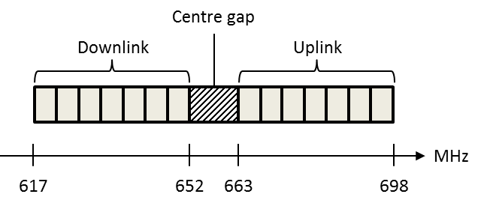
Figure 1: Harmonised band plan for 470-698 MHz band

_______________

APPENDIX

3GPP SPECIFICATION ON
600 MHZ BAND FOR LTE

____________

https://gsacom.com/paper/gsa-apt700-global-status-regulatory-deployments-devices/

