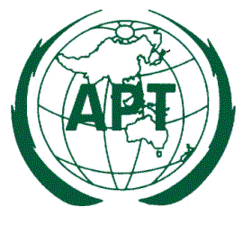

DRAFT APT RECOMMENDATION ADOPTION FORM

To adopt a Draft APT Recommendation you are requested to indicate “YES” (in case you support) or “NO” (in case you don’t support) in the “Adoption” column of the table. Please leave blank in case you don’t have any comment. In case if you indicate “NO” for a particular Draft Recommendation please indicate reason in the “Remarks” column.

Please return the completed form on or before 15 June 2017 to the APT Secretariat by email: aptawg@apt.int or fax +66 2 573 7479.

.
Table 1: Adoption of the Draft APT Recommendations

Title of Draft APT Recommendation | Source Document No. | Adoption  (YES/NO) | Remarks
Draft APT Recommendation on Frequency Arrangements in the Range 694-894 MHz for Broadband Public Protection and Disaster Relief (PPDR) | AWG-21/OUT-21
Draft APT Recommendation on Licensed Shared Access (LSA) | AWG-21.OUT-30 (Rev.1)

The undersign authorizes the Asia-Pacific Telecommunity to count the adoption of the Draft APT Recommendations in the name of my Administration for which my Administration has indicated as supporting in the table above.

Signature: _ _ _ _ _ _ _ _ _ _ _ _ _ _ _ _ _ _ _ _ _ _

Name: _ _ _ _ _ _ _ _ _ _ _ _ _ _ _ _ _ _ _ _ _ _

Designation: _ _ _ _ _ _ _ _ _ _ _ _ _ _ _ _ _ _ _ _ _ _

Administration: _ _ _ _ _ _ _ _ _ _ _ _ _ _ _ _ _ _ _ _ _ _

Country: _ _ _ _ _ _ _ _ _ _ _ _ _ _ _ _ _ _ _ _ _ _

Telephone: _ _ _ _ _ _ _ _ _ _ E-mail: _ _ _ _ _ _ _ _ _ _ _

_______________________

