 | ASIA-PACIFIC TELECOMMUNITY  The 15th Meeting of APT Wireless Group (AWG-15)  27 – 30 August 2013, Bangkok, Thailand | Document:  AWG15/OUT-14  30 June 2013

WORKING GROUP TECHNOLOGY ASPECTS

questionNaire oN road sensor network

- Background
At the AWG-15 meeting, it was agreed to survey the usage of road sensor network in Asia-Pacific
region.
RSN (Road Sensor Network) means a specific type of wireless sensor network which is installed at the road for ITS applications. Road sensors may be loop detector, magnetic sensors, radar and
CCTV camera. These are used for vehicle motion detection, traffic status monitoring and weather
conditions, and so on.
Loop detectors are currently used and reliable technology for vehicle detection, which has high cost in maintenance. However, magnetic sensor network will be a new technology for vehicle detection,
which has lower cost in installation and maintenance. And CCTV camera is currently used
technology for road situation monitoring, vehicle plate number detection, which has a lower
performance in bad weather condition. Radar is a reliable technology for vehicle speed detection
and object ranging in bad weather condition. Thus, sensor fusion of road radar and CCTV will
provide more accurate and reliable technology. Concept of RSN is shown in Fig. 1.

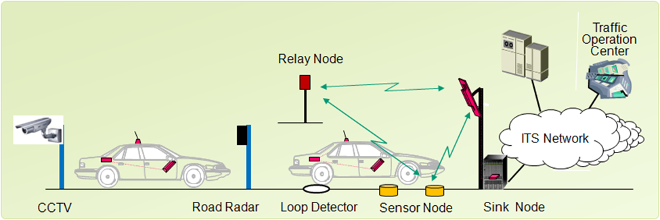
Fig. 1 Concept of RSN

Road radars and magnetic sensor network are related to radio spectrum and standardization.
However, CCTV camera is not related to that. The attachment of this questionnaire shows one
example of Road Sensor Network (RSN) Technology.

- Purpose of Survey
This survey is to collect information of current utilization and future plan on road radar and
magnetic sensor network in APT countries. The result of this survey will be used to develop a
report of utilization and future plan on RSN in APT countries.

- Timetable
Meeting | Date | Work to be Completed
AWG-16 | March 2014 | - Responses to questionnaire and preparation of draft Report.
AWG-17 | September  2014 | - Collect additional responses and finalize the Report  - Consideration of input contribution for ITU-R SG5 WP5A

Attachment: Road Sensor Network (RSN) Technology in Korea

Questions

Question 1: What frequency band(s) is/are used for road sensor network in your country as of
2013 ?

Question 2: What frequency bands are allocated for road sensor network technology on your
frequency allocation table in your country?

Question 3: Which technologies and/or standards is/are being used in the frequency band(s)
mentioned in Question 1? (For example, such as ZigBee)

Question 4: If above question 1 and 2 were answered, would you provide the summary
of technologies and/or standards used in the frequency band(s) mentioned in Question 1 and 2?

Question 5: If above question 1, 2 and 3 were answered, would you provide the summarized
current status of application deployment used in the frequency band(s) mentioned in Question 1
and 2? (For example, parking management system, road condition detection system)

Answers to Questions 1, 2, 3, 4 and 5:

Frequency Band(MHz)  (Q1, Q2) | Technology/  Standard  (Q3, Q4) | Application  (Q5) | Deployment or plan  Year(Q5) | Other  Comment

Question 6: In addition to the answers above, would you provide the future plan for the designation of ITS frequency band(s)?

Answer to Question 6:

Frequency Band(MHz) | Technology/  Standard | Service | Deployment or plan  Year | Other  Comment

_________________

