 | ASIA-PACIFIC TELECOMMUNITY  The 16th Meeting of APT Wireless Group (AWG-16)  18 – 21 March 2014, Pattaya, Thailand | Document:  AWG-16/OUT-15  21 March 2014

WORKING GROUP TECHNOLOGY ASPECTS

QUESTIONNAIREON Fixed WIRELESS SYSTEMS

Background

In addition to the increase in demand for backbone wireless communication systems for mobile backhaul due to the rapid traffic increase in mobile networks, fixed wireless systems are expected to be widely used in diverse applications including FWA (Fixed Wireless Access), disaster mitigation purposes, infrastructure-related networks, and high-resolution image transmission.

Reflecting such an increase in demand for fixed wireless systems, active discussion for developing technical standards on fixed wireless systems is being carried out at ITU-R SG5 WP5C and other international standardization organizations, such as ECC (Electronics Communications Committee).
In the Asia-Pacific region, however, while some countries are starting research and development in anticipation of future market development, specific activities for technology standardization have not yet taken place.

Considering the circumstances above, to progress research on frequency use, relevant technologies and future needs for fixed wireless communication in the Asia-Pacific region is critical in order to promote the incorporation of fixed wireless systems in a wide range of application fields, to expand the market, and at the same time, to realize effective use of a wide range of frequency bands in micro and millimeter waves.

At the AWG-15 held in Bangkok, August 2013, an ad-hoc investigation group was established under Working Group Technology Aspects for discussing about the establishment of a new task group that handles fixed wireless systems. The establishment of the new Task Group (TG-FWS) was approved at the closing plenary of AWG-15. At the same time, Terms of References and work plan of TG-FWS were approved as AWG-15 output documents.

Given such circumstances and in accordance with the work plan, TG-FWS would like to gather information regarding current usage, demand and market forecast, standardization, guidelines, future plans and research and development status for fixed wireless systems from APT countries.
Please respond to the questions below.

A new APT report will be developed based on the information obtained through this survey questionnaire.

Identification of Your Organization

Name of the organization : <please type your answer here>
Name of contact person : <please type your answer here>
Email Address : <please type your answer here>

My organization is:
  - Regulator
  - Operator
  - Vender
  - Other <please describe your answer here>

NOTE: You do not necessarily have to respond to all the questions in this Questionnaire. Please provide any relevant information and your considerations as much as possible.

Questions

Note: Please fill in the answers on the answer sheet.

I. About the current situation in your country

- Do you currently utilize fixed wireless systems in your country? Examples include: mobile backhaul, FWA, fixed wireless communication during emergency situations (for example, when a natural disaster strike), high-definition video transmission, and communications channel in the communications infrastructure.

If yes, answer Q2 focusing on the current status of frequency and Q3 focusing on the application.
If no, proceed to Q4.

- Please fill in information about the assigned frequency range, bandwidth (min, max), utilization, transmission rate, type of network, number of stations, way of assigning frequency, licensing of the different systems, licensing fee basis and maximum transmission power.

Use the letters below to answer.

- Utilization
- transport/trunking network (communications channel in the communications infrastructure)
- FWA (a system that connects offices or homes directly with the provider wirelessly)
- mobile backhaul (a communications channel that allows large amounts of data to be sent)
- temporary network (wireless communications during emergency situations, etc.)
- others

*Note: Private or Public network should be categorized into “e: others”.

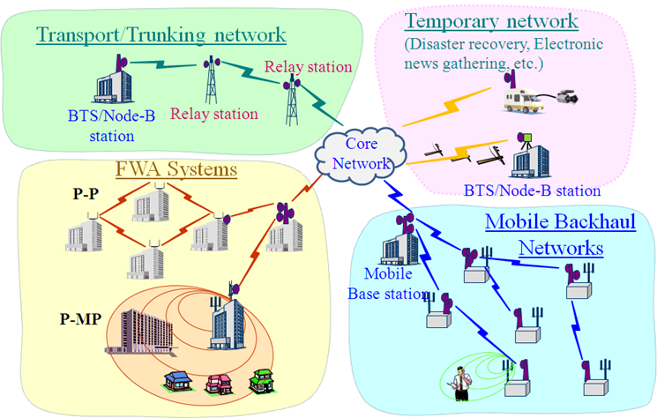
Figure: Various utilizations of fixed wireless systems

- Transmission rate
- below 50 Mbps
- 51-100 Mbps
- 101-500 Mbps
- 501-1000 Mbps
- 1001-2000 Mbps
- above 2000 Mbps

- Type of network
- P-P Network
- P-MP Network
- MP-MP Network

- Way of assigning frequency
- first come first served
- auction
- assignment through comparative inspection
- others

- Licensing
- individual licensing
- light licensing (definition given by ECC Report 80)
- license free
- others

- Factor of licensing fee basis (multiple answers allowed)
- bandwidth regardless of frequency
- frequency band
- fee is increasing if you use multiple polarization wave
- Location of radio stations

If there are any references about (4) Way of assigning frequency, (5) Licensing or (6) Licensing fee basis, please provide the information to the box after the Q2 answer table. Additionally, if your answer of (5) Licensing is ‘b: light licensing’, please provide details of the method.

- Please fill in about applications, frequency range, market trends, product names and references (websites/reports, etc.) of the Utilization(1).

- Utilization
- transport/trunking network (communications channel in the communications infrastructure)
- FWA (a system that connects offices or homes directly with the provider wirelessly)
- mobile backhaul (a communications channel that allows large amounts of data to be sent)
- temporary network (wireless communications during emergency situations, etc.)
- others

- Market trends
- Expanding
- Shrinking
- Stable

II. Demand and market forecast

- Will there be any demand for fixed wireless systems in your country in the future?

If yes, answer Q5. If no, proceed to Q6.

- What kind of utilizations of fixed wireless systems do you expect in your country? Fill in about the utilization, needed transmission rate and forecasted market size (no. of stations).

III. Standardization, guidelines, systems

- Concerning fixed wireless, are you currently participating in any kind of international standardization activity? For example, IEEE, ITU or similar standardization organizations. If you are currently active, please write the organization’s name.

- Is there any organization in your country that handles standardization, guidelines and/or systems concerning fixed wireless? If there is, please write the organization name and contact information.

- Are there any standards, guidelines and/or systems for fixed wireless in your country? If there are, please write the available references.

IV. Future plans

- Do you have any plans (or possibilities) for assigning new frequency ranges for fixed wireless systems in the future? Please answer yes or no.

If yes, answer Q10. If no, proceed to Q11.

- Please fill in about the planned (or possible) frequency ranges, utilization, and time planning.

- If there is any preferable frequency range for fixed wireless transmission in consideration of your country’s conditions, such as geography and climate, please write it down. Also, tell us the reason for it being preferable.

- What are your preferred fixed systems in your country in the future, fixed wireless systems or fiber-optic systems or others?

- Fixed wireless transmission will be the priority use.
- Fiber-optic transmission will be the priority use if fiber-optic cable could be laid.
- Use each method depending on purposes. (Please write examples for each use.)
- Others (Please write examples specifically.)

V. Research and development

- Are there any organizations that are currently conducting research and development in the fixed wireless field in your country?

If yes, answer Q14. and Q15. If no, proceed to Q16.

- Please fill in about the frequency range, bandwidth, transmission rate, and target application used in the research.

- If there are any references (reports or websites) where there is information about the research (network architecture, antennas, transmission method, use of high frequencies, etc.) please write it down.

- In the future, do you have any plans to conduct research about network architecture, antennas, transmission method, or use of high frequencies in fixed wireless transmission in your country?

VI. Others

- Are there any information or technology trends about fixed wireless transmission that you would like to share with the other APT members? If there are, please write it on the answer sheet.

Thank you for your cooperation!!

Answer sheet

I. About the current situation in your country.

Q1
Mark yes or no.
Yes / No

Q2
Please use the letters provided in the Question sheet. An example is provided for reference.
Frequency band | freq range  [GHz] | BW  [MHz] | util  (1) | trans  rate  (2) | type of  NW  (3) | No. of stations | way of assign freq  (4) | licensing  (5) | fee  (6) | Max trans  power[dBm]
Example | 10.15-10.65 | 5.0  30.0 | a | c | b | 100 | a | b | a,c | 40
2GHz
(2.010-2.690)
3 GHz
(3.400-4.200)
6 GHz
(5.850-7.075)
7 GHz
(7.075-7.900)
8 GHz
(7.900-8.500)
9 GHz
(9.800-10.00)
10 GHz
(10.0-10.68)
11 GHz
(10.7-11.7)
12 GHz
(11.7-12.7)
13 GHz
(12.7-13.25)
14 GHz
(14.25-14.5)
15 GHz
(14.4-15.35)
18 GHz
(17.7-19.7)
23 GHz
(21.2-23.6)
27 GHz
(24.25-29.5)
31 GHz
(31.0-31.3)
32 GHz
(31.8-33.4)
38 GHz
(36.0-40.5)
42 GHz
(40.5-43.5)
52 GHz
(51.4-52.6)
57 GHz
(55.78-59.0)
60 GHz
(59.0-66.0)
70/80 GHz
(71-76/81-86)
95 GHz
(92.0-94/94.1-100)

If there are any references about (4)Way of assigning frequency, (5)Licensing or (6)Licensing fee basis, please write it down.
Additionally, if your answer of (5)Licensing is ‘b: light licensing’, please provide details of the method.

Q3
Please use the letters provided in the Question sheet. (Note: Insert more lines as needed)
 | Please provide applications of the Utilization | Frequency range  [GHz] | Market  trends  (2) | Product name | References  (websites/reports, etc)
Example | Emergency communication | 10.15-10.65 | a | AAAAAA | http://*******************
a: transport/trunking
network
b: FWA
c: mobile backhaul
d: temporary network
e: others

II. Demand and market forecast

Q4
Yes / No

Q5 (Note: Insert more lines as needed)
 | Utilization | Transmission rate  [Mbps] | Market size  (no. of stations)
Example | River flood monitoring | 10 | 100
1
2
3

III. Standardization, guidelines, systems

Q6

Q7

Q8

IV. Future plans

Q9
Yes / No

Q10 (Note: Insert more lines as needed)
 | Frequency range  [GHz] | Utilization | Time planning | Plan or possibility
Example | 10.15-10.65 | Mobile backhaul | 2014/1: assignment  2014/6: in operation | Plan
1
2
3

Q11
[preferable frequency range]

[reason]

Q12
[choice: a, b, c or d]

[write specifically if c or d]

V. Research and development

Q13
Yes / No

Q14 (Note: Insert more lines as needed)
 | Frequency range  [GHz] | Bandwidth  [MHz] | Transmission rate  [Mbps] | Target application
Example | 81.0-86.0 | 5000 | 3000 | Mobile backhaul
1
2
3

Q15

Q16
Yes / No

VI. Others

Q17

Annex 8 to Document 5C/235, “Preliminary draft new Report ITU-R F.[FSUSE-TRENDS]- Fixed service use and future trends”,http://www.itu.int/md/R12-WP5C-C-0235/en

